**STRATEGIES FOR COEXISTING: JUVENILE PINK AND CHUM SALMON DIETS AND INTERACTIONS IN A CHALLENGING SECTION OF COASTAL MIGRATION**

by

Vanessa Rose Zahner

B.Sc., The University of British Columbia, 2015

A THESIS SUBMITTED IN PARTIAL FULFILLMENT OF

THE REQUIREMENTS FOR THE DEGREE OF

MASTER OF SCIENCE

in

THE FACULTY OF GRADUATE AND POSTDOCTORAL STUDIES

(Oceanography)

THE UNIVERSITY OF BRITISH COLUMBIA

(Vancouver)

Current draft version: February, 2021

© Vanessa Rose Zahner, 2021

The following individuals certify that they have read, and recommend to the Faculty of Graduate and Postdoctoral Studies for acceptance, a thesis/dissertation entitled:

|  |
| --- |
| **STRATEGIES FOR COEXISTING: JUVENILE PINK AND CHUM SALMON DIETS AND INTERACTIONS IN A CHALLENGING SECTION OF COASTAL MIGRATION** |

|  |  |  |
| --- | --- | --- |
| submitted by | Vanessa Rose Zahner | in partial fulfillment of the requirements for |
| the degree of | Master of Science | |
| in | Oceanography | |

**Examining Committee:**

|  |
| --- |
| Evgeny A. Pakhomov, Earth and Ocean Sciences |
| Supervisor |
| Brian P.V. Hunt, Institute for the Oceans and Fisheries |
| Supervisor |
| Colin K. Levings, Institute for Resources, Environment and Sustainability |
| Supervisory Committee Member |
| Michelle Tseng, Zoology |
| Additional Examiner |

# Abstract

The cultural and ecological contributions of salmon cannot be understated, as these keystone species have underpinned coastal ecosystems and societies from time immemorial. Despite this millennia-long intimate relationship with Pacific salmon, returns of stocks have become unpredictable and difficult to manage from overfishing and multiple complex stressors. Research has shown that juvenile salmon feeding is a crucial factor for growth and recruitment, and the ocean conditions driving prey availability are tightly coupled with survival of salmon. Pink and chum are abundant co-migratory species of salmon that may exert competitive pressure for food resources during their vulnerable early marine phase. However, competition research on juvenile pink and chum salmon is limited, especially within the complex British Columbia coast. This research aimed to fill gaps in understanding of juvenile pink and chum foraging strategies and interactions in areas of good and poor foraging conditions during their coastal outmigration. The research goals of this thesis were to: 1) characterize diets, trophic niche, and interactions of juvenile pink and chum salmon in areas of contrasting foraging conditions in southern B.C. and 2) describe the relationship between the interannual and seasonal variations in diet and prey size with the trophic interactions of juvenile pink and chum salmon during their outmigration period. In the Discovery Islands and Johnstone Strait regions, there were foraging deserts and oases, where juvenile salmon mean stomach fullness values ranged from < 0.5% to > 5 % body weight. In good foraging conditions, juvenile pink and chum salmon both consumed the same high-quality prey with limited competition, but under poor foraging scenarios, salmon diets differed. Chum salmon consistently consumed gelatinous prey and pink salmon relied more heavily on copepods and nearshore zooplankton, differing in niche in response to competitive interactions. These foraging strategies of opportunistic specialization may indeed provide a resilience for salmon to face the challenges of a shifting climate. Therefore, pink and chum salmon can be monitored as indicators for ecosystem health and zooplankton availability. Salmon reflect the health of humans and natural systems and require understanding and care to view them holistically as they migrate through diverse, challenging habitats.

# Lay Summary

Salmon are important to people and ecosystems, they bring nutrients to habitats and those who eat them, and they have been interconnected with human societies for thousands of years. However, salmon populations have been declining lately, and scientists don’t exactly know why. A big mystery is the ocean phase of their life cycle, especially those first few vulnerable months. One incredibly important factor for salmon’s survival is getting enough to eat to grow quickly. This research looked at young pink and chum salmon to see if the species ate differently and how that changed over time as salmon swam throughout the Inside Passage region of southern B.C. Frequently, there wasn’t enough food, when chum salmon ate jellyfish and pink salmon ate smaller zooplankton. But other areas had a lot of food where both species ate nutritious prey. Salmon diets reflect ecosystem health and holistic perspectives are recommended to help salmon.

# Preface

This thesis research was the independent, original and unpublished work of Vanessa Rose Zahner. Co-supervisors Dr. Evgeny Pakhomov and Dr. Brian Hunt helped shape the initial project ideas and layout of fish sample sites. The research was done in collaboration with the Hakai Institute’s Juvenile Salmon Program to gain a better understanding of the early marine migration of salmon. Hakai field crews at Quadra Island Station and Salmon Coast Field Station collected juvenile outmigrating salmon and lab crews performed necessary dissections. The fish sampling was approved by UBC’s Animal Care Committee, Protocol A19-0025, and under the DFO license numbers: XR 42 2015 and XR 92 2016. Sample processing for zooplankton taxonomy was performed by Andrea Le, Samantha James, Jihyun Kim and Jessica Schaub. All of the salmon stomach content processing, data analysis and writing was done solely by Vanessa Rose Zahner. The raw dataset of salmon diets and code for analysis are freely accessible at: <https://github.com/vanzahner/pink-chum-diets>. (NEEDS HAKAI PACKAGE DOI – currently in progress: <https://hecate.hakai.org/geonetwork/srv/eng/catalog.search#/metadata/89b3c6d8-983b-48f4-a0b5-04eea65602f6>)

In this thesis the language of animacy is utilized, for example, salmon are referred to as: salmon *who* experience certain conditions, rather than salmon *that* experience certain conditions. This distinction is made to not to anthropomorphize salmon but to recognize salmon as beings rather than objects, to acknowledge their connection to humans as our relatives, not as resources. The use of this language in no way, shape or form detracts from the objectivity of this scientific study but learns from Indigenous ecologists and scholars who advocate for this worldview to be represented within the sciences (Cajete, 2018; Kimmerer, 2017; Reid, 2020; Whyte et al., 2016).

# Table of Contents

Abstract iii

Lay Summary v

Preface vi

Table of Contents vii

List of Tables x

List of Figures xii

List of Symbols xvi

List of Abbreviations xvii

Acknowledgements xviii

Dedication xix

Chapter 1: Introduction 1

1.1 Historical salmon coexistence 1

1.2 Current state of salmon stocks 2

1.3 Salmon life history and early marine migration 4

1.4 Salmon feeding and competition in the ocean 5

1.5 Study region 7

1.6 Study aims 8

1.7 Figures 10

Chapter 2: Juvenile pink and chum salmon divide prey resources in response to poor foraging conditions 12

2.1 Introduction 12

2.2 Methods 17

2.2.1 Field sampling 17

2.2.2 Zooplankton and salmon stomach content analysis 19

2.2.3 Data analysis 20

2.3 Results 21

2.3.1 Environmental conditions and zooplankton 21

2.3.2 Salmon diet composition 23

2.3.3 Salmon biology, gut fullness, and condition 25

2.3.4 Diet overlap between pink and chum salmon 26

2.4 Discussion 27

2.4.1 Pink and chum salmon niches and competition 27

2.4.2 Feast or famine: salmon feeding and condition 31

2.4.3 Species competition or coexistence? 34

2.4.4 Limitations and future directions 35

2.5 Conclusion 37

2.6 Tables 39

2.7 Figures 43

Chapter 3: Salmon trophic interactions shift with prey phenology and migration timing 50

3.1 Introduction 50

3.2 Methods 56

3.2.1 Field sampling 56

3.2.2 Zooplankton and salmon stomach content analysis 58

3.2.3 Data analysis 59

3.3 Results 61

3.3.1 Environmental conditions and zooplankton 61

3.3.2 Salmon diet composition 63

3.3.3 Diet diversity and overlap between juvenile salmon 66

3.3.4 Salmon health 67

3.3.5 Salmon and prey size 68

3.4 Discussion 70

3.4.1 Oceanographic seasonality and prey phenology 70

3.4.2 Seasonality of salmon diet composition 71

3.4.3 Interannual variability in prey size 73

3.4.4 Salmon health implications 74

3.5 Conclusion 76

3.6 Tables 78

3.7 Figures 83

Chapter 4: Conclusion 93

4.1 Knowledge gap of juvenile pink and chum salmon competition 93

4.2 Diets of juvenile pink and chum salmon in contrasting foraging conditions 94

4.3 Trophic interactions of pink and chum salmon during outmigration 95

4.4 Lessons and calls to action 97

4.5 Figures 101

References 102

Appendix 125

# List of Tables

Table 2.1 Survey dates, salmon sample sizes, dates, environmental surface data, and zooplankton biomass by size fraction. 38

Table 2.2 Zooplankton relative abundance (expressed as percent) at each site, summarized by the main groups. 39

Table 2.3 Diet composition summary by average relative wet weight (expressed as percent) of the main groups of prey for pink (PI) and chum (CU) salmon at each site. 40

Table 2.4 Salmon biological data including wet weight (WW), fork length (FL), gut fullness index (GFI), showing mean and standard error, the number of empty stomachs, and percent dietary overlap between pink and chum salmon at each site. 41

Table 3.1 Sampling details for study: Site ID for the Discovery Islands (D07) and Johnstone Strait (J07), sampling date and year, number of pink and chum salmon stomachs analyzed, temperature (Temp.), salinity (Sal.) and size fractionated and total zooplankton biomass. The 2000 μm size fraction biomass values were divided by non-gelatinous (Non-Gel.) and gelatinous (Gel.) zooplankton. 77

Table 3.2 Zooplankton relative abundance (expressed as percent) by major groups. 78

Table 3.3 Diet composition summary (% wet weight) of juvenile salmon by date and year. 79

Table 3.4 SIMPER results of prey taxa driving differences between regions of A) pink salmon diet composition and B) chum salmon diet composition (by transformed relative wet weights). Group classification is included to the left of species or highest taxonomic resolution of prey, DI is relative biomass in the Discovery Islands, and JS is relative biomass in Johnstone Strait. Average is the average contribution to dissimilarity and Sum is the cumulative contribution of prey to region dissimilarity, only taxa contributing to 70% of dissimilarity were included. 80

Table 3.5 Summarized salmon biological data for 2015-2016 in DI-JS: fork length (FL), wet weight (WW), condition factor K, gut fullness (GFI), number of empty stomachs, diet overlap of species, and richness (number of prey taxa), expressed as mean ± standard deviation. 81

Table A.1 Peak outmigration timing of pink and chum salmon calculated as the date when 50% of fish have passed through the area of Discovery Islands and Johnstone Strait, 2015–2019, as well as average values for both regions and years. 124

Table A.2 Indicator value (Ind. val.) analysis for temporal (Chapter 3) clusters. Clusters were defined by site, species and dates, with “+” symbol denoted that other samples were also present as well. “Pink/Chum” means both species were well represented within that cluster and “2015/2016” indicated that multiple sampling dates were in the cluster. Only significant values are shown (p < 0.05). 125

# List of Figures

Figure 1.1 Combined thesis study sites in Discovery Islands and Johnstone Strait. Chapter 2’s spatial sites are shown as circles, and Chapter 3’s temporal diet sites are marked by X’s. Note: D07 samples in mid-June 2016 is included in both chapters, shown by the circle with an X. 10

Figure 1.2 Conceptual diagram of thesis aims to compare juvenile pink and chum salmon diets under good and poor feeding conditions in stratified (“STRAT.”) and mixed ocean conditions. Stratified waters only occur in southern Discovery Islands, but other listed conditions occur in both Discovery Islands and Johnstone Strait regions, according to previous research. Species interactions of salmon is included in both chapters, and Chapter 2 is space, and Chapter 3 is time. The chapters build off each other, as Chapter 3 includes both region and date components. 11

Figure 2.1 Map of salmon survey stations in the Discovery Islands and Johnstone Strait. Inset map (left) shows the British Columbia coast with the study region highlighted in red. 43

Figure 2.2 Average relative biomass of the main prey groups for juvenile pink (top) and chum salmon (bottom), at each site along the migration route. The ‘Other’ group includes prey such as cyclopoids, fish, polychaetes and pteropods. 44

Figure 2.3 Non-metric multidimensional scaling (NMDS) ordination of juvenile pink and chum salmon diet composition. Each point represents one salmon stomach, colored by site, where open circles represent pink and filled circles, chum. “Stress” indicates how well the distances between points were retained when displayed in two-dimensions and for this plot, stress was 0.17. 45

Figure 2.4 Cluster analysis of juvenile pink and chum diet composition (average linkage clustering and Bray-Curtis dissimilarity). 46

Figure 2.5 Boxplot of pink and chum salmon condition factor K across the study sites. Box plots show the mean (black bar), interquartile range (boxes), 1.5*inter-quartile range (whiskers), and points indicate extreme values of salmon condition. The red dotted line separates fish in good condition (high weight to length ratio, > 1) and in poor condition (low weight to length, < 1). 47

Figure 2.6 Gut fullness index (GFI) of juvenile pink and chum salmon. Box plots show the mean (black bar), interquartile range (boxes), 1.5*inter-quartile range (whiskers), and points indicate extreme values of salmon GFI. The overlaid dark red line indicates dietary overlap between pink and chum salmon (secondary y-axis). 48

Figure 2.7 Cumulative prey taxonomic richness curves for juvenile pink and chum, salmon at each site location. Note: All sampling events included 10 salmon, but not all stomachs had prey in them (n = 12 empty stomachs total). 49

Figure 3.1 Map of sampling sites for Discovery Islands (D07) and Johnstone Strait (J07) during May to July 2015-2016. Inset map (left) shows B.C. coast with study location in red. 83

Figure 3.2 Diet composition of major prey groups by relative biomass of juvenile pink (“PI”, outlined in pink) and chum (“CU”, outlined in dark green) salmon during outmigration in 2015-2016 at the Discovery Islands site D07 and Johnstone Strait site J07. 84

Figure 3.3 Non-metric multidimensional scaling (NMDS) ordination plot of diet composition of pink (open circles) and chum (filled circles) salmon in Discovery Islands (red) and Johnstone Strait (blue) during outmigration (May to July) of 2015 and 2016. Vectors were overlaid to show direction and magnitude of main taxonomic prey groups driving dissimilarity, overlapping labels not shown (Euphausiidae, Balanomorpha, Echinodermata, Cladocera, Decapoda). 85

Figure 3.4 Cluster dendrogram of temporal diet data, with outliers in grey and main clusters colored by region (details in appendix). 86

Figure 3.5 Gut fullness indices (GFI) for juvenile pink and chum salmon in DI-JS, 2015-2016, with overlap shown in dark red. 87

Figure 3.6 Juvenile salmon condition during outmigration in 2015-2016 for Discovery Islands and Johnstone Strait combined. The red dotted line separates fish in good condition (high weight relative to length, >1) and fish in poor condition (low weight relative to length, <1). Significant differences are indicated by ** p < 0.01, *** p < 0.001 and **** p < 0.0001 for species and years. 88

Figure 3.7 Cumulative prey curves for Discovery Islands (red) and Johnstone Strait (blue) juvenile pink (open circles) and chum salmon (closed circles) during 2015 and 2016. 89

Figure 3.8 Juvenile salmon diet composition by prey size class (mm). Only digestive state 1 “fresh” zooplankton prey were included to calculate mean relative biomass by date and species. For each sampling event, “PI” is pink on the left, and “CU” is chum on the right. 90

Figure 3.9 Predator and prey size relationships by species, date and region. A) chum salmon predator prey relationships, colored by sampling date (light is early season and dark is late season) and B) pink salmon predator prey relationships, colored by sampling date. 91

Figure 3.10 Fork length distributions of A) all pink and chum salmon collected throughout 2015-2019 and B) study salmon in 2015-2016. 92

Figure 4.1 Conceptual diagram of combined thesis results on juvenile salmon diet variability. Stratified surface conditions from the southern Discovery Islands (D07) are labelled as “Strat.” Mixed ocean conditions with poor feeding are represented by sites D09, D11, J06, J08, and J07. Whereas the good feeding conditions in mixed waters represented J02, northern Johnstone Strait. Diet overlap between species and predator-prey ratios revealed that size was an important factor in stratified conditions, large fish ate larger prey, and species separated niche under poor feeding. No species or size differences were found at the migration route terminus feeding hot spot. 101

Figure A.1 Discovery Islands subcluster for temporal (Chapter 3) juvenile salmon diets, labelled and colored with survey date. 128

Figure A.2 Johnstone Strait subcluster for temporal (Chapter 3) juvenile salmon diets, labelled and colored with survey date. 129

Figure A.3 Micrograph of a blue macroplastic (5.8 mm) found in a juvenile pink salmon stomach in the Discovery Islands, before the stomach contents were removed. 130

# List of Symbols

± Plus-minus

μm Micrometre (10-6 m)

‰ Parts per thousand

°C Degrees Celsius

# List of Abbreviations

AHC Agglomerative hierarchical clustering

B.C. British Columbia

BW Body weight

DI Discovery Islands

FL Fork length

GFI Gut fullness index

JS Johnstone Strait

mg Milligrams (10-3 g)

mm Millimetres (10-3 m)

NMDS Non-metric multidimensional scaling

PSI Percent similarity index

SE Standard error

WW Wet weight

YSI Yellow Springs Instrument

# Acknowledgements

I have so many communities to thank for lifting me up to where I could finish this thesis. I can’t say háw’aa enough to my family, friends, mentors, lab mates, and my brilliant colleagues. Firstly, I want to give thanks to all my Haida ancestors and relatives, who are resilient stewards to Haida Gwaii, where my love for oceans and salmon was encouraged to flourish into this work. I’m thankful for the Yahgujaanas matriarchs like my mum and Naanii Sandy who taught me how to be strong so that I would never give up on my goals, no matter how many challenges I faced. I’d also like to give a big thanks to my husband Adam, for always keeping me happy and healthy throughout this arduous process, the way you can make me laugh in any situation is so amazing. Big háw’aa to my in-laws Nancy, Martin, Ben, and Christina as well, I’m grateful for the fun we had in Vancouver and Rupert, it helped me to have even more family members cheering me on!

I’m really thankful for my friendships as well, my Haida cousins, the 2018 Ocean Bridge cohort, inspiring Indigenous scholars/scientists, my lab mates, and fellow students from the IOF. There are too many of you to name but I hope you know how much you helped me through this. Times we spent trying to change things for the better while having fun will always stay with me. Going to beach cleanups, protests, concerts, comedy shows, bars, and conferences, and doing fieldwork was a blast that made me realize science can be so fun and there’s a place for me in it. I’m also deeply thankful to those who got me through the really hard times, who listened to my rants, helped ease my stress, and were there for me when Danielle and Micah had passed away. I’d also like to dedicate this thesis to Micah and Dani who did such impactful ocean conservation work that made the world a better place and they continue to inspire me to keep going forward.

I also want to thank both my mentors Brian and Evgeny, for creating such welcoming lab groups where I fostered such great friendships, and for your endless support and encouragement. I so appreciate being brought into the lab, where I was able to weirdly fall in love with fish guts. I couldn’t have asked for better supervisors, who helped me every step of the way in my career. I’m especially grateful for the extra support and fun times in the midst of the COVID pandemic, our PEL Zoom coffee hours/beers o’clock and distanced picnics in the park really helped me out. And the willingness and openness to discuss EDI matters in our lab had made me feel truly seen. I’m also so glad we were involved in outreach and student-to-student mentorship opportunities like the Emerging Indigenous Scholars Summer Camp, it was a highlight of my entire program. And thank you to committee member Colin and external Michelle for helping to shape the thesis!

I also want to say háw’aa to Andrea, the First Nations House of Learning, and SAGE, for creating spaces that felt like a home away home and affirming that my perspective is valuable. I’m also grateful to my funders, Old Massett Village Council, Irving K. Barber Scholarship Society, HaiCo, Indspire, New Relationship Trust, Dofasco Inc., and UBC. I also need to raise my hands and give thanks as I was a guest on xʷməθkʷəy̓əm, Skwxwú7mesh, and səlilwətaɬ territory while I was gaining my education. And that the fieldwork and placement of my research sites were situated in the traditional territorial waters of the Kwakwaka’wakw. And háw’aa to the amazing Xaad kíl teachers and learners from Xaad Kíl Nee who helped me write my dedication. And I want to extend a huge háw’aa to SGidGang.Xaal *Shoshannah Greene*, who designed the beautiful art on the following dedication page to visualize the salmon-human relationship. And on that note, I also want to say háw’aa to the salmon themselves. I hope that I honored their gifts through this work, I acknowledge that all that we have is because the salmon have sustained us.

# Dedication

*Naanii Sandy*

*Kuniisii*

*Sah’laana*

*Damaan uu dii dalang ‘waadluwaan tl’aa dagwiiGeilgang*

*Haw’aa dalang ‘waadluwaan ahl kil ‘laagang*



## Introduction

### Historical salmon coexistence

Since time immemorial, humans have coexisted with Pacific salmon (*Oncorhynchus* spp.), with archaeological evidence dating back to 11,500 years for anadromous salmon use (Halffman et al., 2015). Both salmon and humans existed in areas of glacial refugia during the last major ice age, co-evolving and adapting into the expanse of complex river and lake systems of the modern age (Haggan et al., 2006). Therefore, salmon stocks have evolved to their unique environments over thousands of years and humans played a role in shaping that evolution and understood the cyclical patterns of salmon (Lepofsky & Caldwell, 2013). However, in the past 200 hundred years, humans have altered salmon habitats, the climate, and the size and health of salmon stocks due to over-exploitation (Gustafson et al., 2007; Newell, 1993; NRC, 1996). Therefore, understanding salmon survival is more complex than ever in the face of threatened stocks and climate change. Much deeper knowledge of salmon life history is needed to improve fisheries management, specifically the early marine stage and its impact on population dynamics.

Furthermore, more research is needed on species-specific life history, feeding strategies and behaviour, as each species has unique characteristics and diverse specializations to survive. All modern species of Pacific salmonids, pink (*O. gorbuscha*), chum (*O. keta*), sockeye (*O. nerka*), chinook (*O. tshawytscha*), coho (*O. kisutch*) salmon and steelhead (*O. mykiss*) evolved at least 6 million years ago (Stearley & Smith, 1993). Unlike the single salmon species in the Atlantic Ocean (*Salmo salar*), Pacific salmon radiated into different species in a highly dynamic environment, filling multiple ecological niches in newly created habitats (Montgomery, 2000). The evolutionary history of Pacific salmon species still remains largely unknown and species-specific strategies and adaptations may provide insight into conditions mediating their survival. Salmon have demonstrated phenomenal resilience in the face of climate shifts and many external pressures, but as the threats increase and climate warms at an unprecedented rate, salmon remain vulnerable and may not adapt at these same rates. If humans are to continue to rely on salmon for ecosystem services, sustenance, and economy, we must understand and conserve their diversity.

### Current state of salmon stocks

Salmon populations are naturally variable and fluctuate significantly from year to year. Historically, Indigenous peoples dealt with these challenges in salmon production by complex social systems based on sharing resources and diversifying food harvests of other marine animals (Campbell & Butler, 2010). For over 5,000 years, salmon stocks persisted in high abundance despite intense fishing pressure by First Nations, due to place-based selective fisheries and cultural practices of sustainability (Atlas et al., 2020). However, in the late 1800’s, colonization of the coast brought a shift away from traditional management practices to the current paradigm of centralized control and the canning industry began to intensely harvest salmon (Newell, 1993). Modern fishing pressures have also decreased overall size and age at maturity for salmon, eliminating large, fecund individuals from populations, reducing resiliency and biodiversity (Jeffrey et al., 2017).

Certain salmon stocks have experienced local declines as a result of fishing pressure, landslides, freshwater habitat alteration from harmful logging practices, and hydroelectric dams (Grant et al., 2019). Currently, 41 salmon stocks are currently listed as endangered (24), threatened (10) or of special concern (4) in British Columbia (SARA, 2021). Most of the endangered and threatened stocks are sockeye (16) and chinook (22), as well as coho (1) and steelhead (2), who spend more of their life cycles in freshwater than pink and chum salmon. However, salmon populations of all species have begun to decline throughout their entire range, indicating higher mortality and variability in the ocean phase, in addition to the freshwater stage. While the exact cause of salmon declines cannot yet be pinned down, one important factor is human-induced climate change, as rising temperatures affects salmon physiology and prey choices by altering food web structures (Groot et al., 1995; Mackas et al., 2007). Salmon also tend to shift northward in distribution with climate cycles, which likely causes detrimental effects on stocks near the southern ranges of species and may perturb northern ecosystems (Carothers et al., 2019; Herbold et al., 2018; Nielsen et al., 2013).

Salmon declines have catastrophic impacts on riparian and aquatic systems, and human health and wellbeing, particularly for Indigenous communities whose lives are intertwined with salmon (Garibaldi & Turner, 2004; Janetski et al., 2009; Marushka et al., 2019; Schindler et al., 2003). Therefore, salmon research must take a multi-faceted ecosystem level approach and investigate species and stocks who are often overlooked but contribute greatly to crucial ecosystem services (Borja et al., 2020). In order to properly manage such complex species, scientists have to gain understanding into the stressors salmon face at each point in the life cycle to quantify major bottlenecks in survival (Beamish, 2017). For example, the early marine phase has been shown to mediate salmon cohort survival through significant size-selective mortality.

### Salmon life history and early marine migration

Pacific salmon are semelparous, anadromous fish, meaning they are born in freshwater, migrate to the ocean to grow, and return to spawn in the same freshwater system and then die. Although there are always exceptions to these general trends of salmon, such as the freshwater-only kokanee salmon (same species as sockeye, *O. nerka*), and the iteroparous and anadromous salmonid, steelhead, who spawns multiple times, with multiple marine migrations (Quinn, 2018). Different species and types of salmon have different life histories, where species spend various amounts of time in freshwater, estuaries, and the ocean and return to spawn at different times of year. Pink and chum salmon are both species who migrate to the ocean shortly after fry emerge from the gravel where they were born, and chum salmon spend a lot of time rearing in estuary environments (Levings, 2016). In comparison, sockeye, chinook and coho salmon spend months to years in freshwater. Although, ocean-type sockeye tend to migrate into the marine environment around the same time as pink and chum (Groot & Margolis, 1991).

The life cycle timing of pink and chum salmon in southern British Columbia includes spawning in fall and migrating toward the ocean environment in early spring (Quinn, 2018). Pink salmon are the only salmon species who have obligate two-year life cycles, with genetically distinct odd-year and even-year stocks (Oke et al., 2019). Chum salmon on the other hand, have more flexible life histories, living around 3 to 4 years or longer, depending on the ocean conditions. The first few months at sea are an important life phase of salmon, where populations will experience significant mortality and individuals must grow quickly enough to survive this period (Beamish et al., 2003). Pink salmon survival in Alaska has been shown to be higher for faster growing and larger pink salmon, mediated by ocean conditions and size-selection predation (Cross et al., 2008, 2009; Malick et al., 2011; Miller et al., 2012; Moss et al., 2005). Chum salmon growth in the North Pacific has also been linked to environmental conditions, zooplankton abundance, and density-dependent competition (Agler et al., 2013; Honda et al., 2017; Saito et al., 2009; Yasumiishi et al., 2016). Salmon likely have to grow to certain sizes at given points in the life cycle in order to feed successfully on larger prey, compete with other individuals, evade predators, and be resilient against diseases (Beamish & Mahnken, 2001). The juvenile phase has been shown to be a bottleneck in the survival of salmon, and when there are not sufficient amounts of high-quality food available, this results in low returns of the adults (Beamish et al., 2012; Farley et al., 2007). Furthermore, the first summer at sea for salmon may influence their fat reserves and survival in subsequent bottlenecks in survival, such as the first winter at sea, which tends to have poor food availability.

### Salmon feeding and competition in the ocean

In the Fraser River, British Columbia’s largest salmon bearing river, sockeye salmon abundance and survival dropped to such low levels that a national inquiry was launched (Cohen, 2012). As a result of the interest in sockeye salmon early marine research, there has been less of a focus on co-migrating pink and chum salmon as competitors to the survival of sockeye salmon. Sockeye salmon feed very similarly to pink salmon, also consuming zooplankton as main prey (Brodeur, 1990). Pink salmon have been shown to outcompete other species, and in years of high abundance or poor food availability, adult pink salmon are hypothesized be at least partly responsible for declines in sockeye salmon and other species (Batten et al., 2018; Ruggerone & Nielsen, 2004; Ward et al., 2017). Thus, pink salmon should be priority species for salmon conservation scientists to study. Chum salmon are another intriguing species as they coexist with other salmon by prey switching, limiting competition, and tracking ecosystem productivity (Azuma, 1995). There is potential for chum salmon to compete with other species as well, as chum salmon also occur in high abundance, with significant hatchery populations in the Pacific. Both pink and chum salmon have not been declining as steadily as sockeye and chinook, and this may be due to competitive advantages or adaptive strategies to cope with changing conditions.

The species of salmon can be separated by differences in feeding, pink, chum, and sockeye are salmon who tend to be more planktivorous predators, whereas chinook, coho and steelhead feed more on fish (Brodeur, 1990). Since pink and chum salmon are planktivorous feeders who overlap in time and space, they compete for a limited pool of prey resources (Bailey et al., 1975; Perry et al., 1996). Adult pink salmon have been shown to have detrimental effects on the growth and survival of chum salmon on multiple occasions (Beacham, 1993; Minicucci, 2018). Chum salmon have evolved strategies to adapt to these challenges posed by food limitations, and they have specialized larger stomachs to consume higher amounts of gelatinous prey (Welch, 1997). However, there is scarce literature on competition of juvenile pink and chum salmon with stomach content analysis or quantifying the conditions on when and where prey switching occurs (Beamish et al., 2010; Gulbransen, 2014). Aside from observing *Oikopleura* spp. in juvenile chum salmon diets, the tendency of chum to prey switch to jellyfish, is noted in adults but not in juveniles (Brodeur, 1990; Healey, 1991). Therefore, this research was initiated by a need to fill this knowledge gap through utilization of high spatial and temporal resolution of juvenile pink and chum salmon diets in a highly dynamic migration area.

Interspecific competition will possibly increase with climate change and increasing temperatures that cause shifts in food web structure, resulting in lower quality prey for salmon. In cooler conditions, diatoms dominate phytoplankton communities, leading to a more efficient food web and large zooplankton, whereas in warm conditions, smaller phytoplankton dominate, which leads to abundant microzooplankton and lower trophic efficiency (Costalago et al., 2020). In B.C., zooplankton communities also fluctuate from northern large, lipid-rich copepods in cool conditions to southern smaller, lipid-poor copepods in warmer conditions (Mackas et al., 2001). As oceans warm and salmon metabolism increases while prey size and quality decreases, further understanding salmon interactions in poor feeding conditions is crucial to predict their survival.

### Study region

Juvenile salmon annually migrate through the Discovery Islands and Johnstone Strait area from May to July (Figure 1.1), where they encounter a diversity of habitats and highly variable ocean conditions (Johnson et al., 2018). The Discovery Islands region is influenced by coastal freshwater inputs where zooplankton communities and their phenology is related to the seasonally stratified and productive Strait of Georgia (Mahara et al., 2019). Most of these salmon originate from the Fraser River (except odd-year juvenile pink salmon), and experience good feeding in the Strait of Georgia (DFO, 2020; Osgood et al., 2016). However, years of poor foraging in the Strait of Georgia have been hypothesized to negatively impact salmon survival (Beamish et al., 2012), potentially from cumulative effects of food limitation in subsequent areas (McKinnell et al., 2014), but juvenile salmon diet research is limited beyond the Strait of Georgia.

After the Discovery Islands, salmon then enter the less productive Johnstone Strait with low seasonality, where phytoplankton are light-limited due to tidal mixing promoting a constant “winter state” (Mahara et al., 2019; McKinnell et al., 2014). Furthermore, an underwater sill between Discovery Islands and Johnstone Strait limits water mass mixing between regions and Johnstone Strait tends to be more influenced by Queen Charlotte Strait waters of higher salinities and lower temperatures, as well as unique zooplankton communities (Khangaonkar et al., 2017). These two regions of juvenile salmon migration provide a dynamic study area to compare in-depth species interactions under different physical and biological settings, which may then be compared to other complex areas along the migration route. Therefore, comparing competitive pressures and foraging strategies under poor and good feeding conditions provides insights into fundamental salmon biology and common responses to ecosystem effects throughout their lives.

### Study aims

This study analyzed 312 juvenile pink and chum salmon stomachs from the Discovery Islands and Johnstone Strait and quantified diets, trophic niches, and interspecific competition. Each chapter utilized a different focus, Chapter 2 analyzed diets spatially along the migration route, and Chapter 3 had a temporal/seasonality focus in 2015 and 2016 (Figure 1.1; Figure 1.2). Both thesis chapters investigated foraging strategies of juvenile pink and chum salmon under contrasting ocean conditions and prey availability to describe their species-specific adaptations.

The Chapter 2 aims were to (a) quantify and compare juvenile pink and chum salmon diets and trophic niches in areas of contrasting foraging conditions; (b) assess the foraging success of juvenile pink and chum salmon in the Discovery Islands and Johnstone Strait, southern B.C. and (c) describe the potential interspecific competition between juvenile pink and chum salmon under contrasting feeding conditions. Whereas Chapter 3 aimed to a) quantify juvenile pink and chum salmon diets and their seasonal and interannual interactions in southern coastal B.C.; b) describe how salmon species condition and foraging success vary over time; and c) compare juvenile salmon size with zooplankton prey sizes consumed across regions and years. Overall, this thesis investigated juvenile pink and chum salmon diets and species interactions in response to large shifts in ocean and foraging conditions during their early marine migration.

### Figures

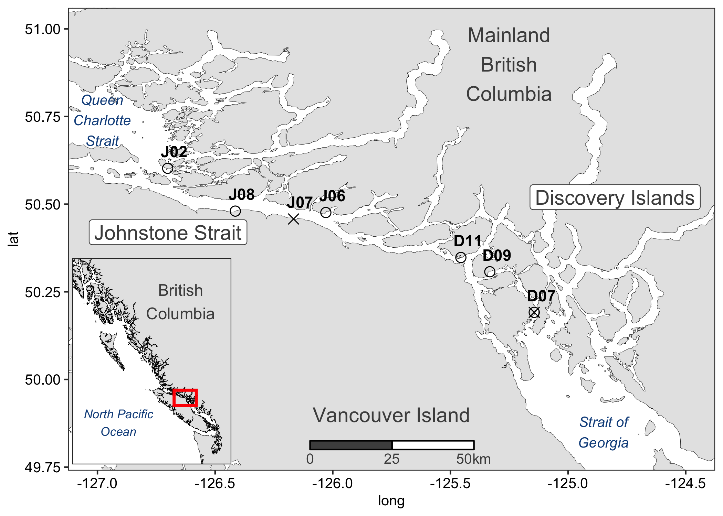

Figure 1.1 Combined thesis study sites in Discovery Islands and Johnstone Strait. Chapter 2’s spatial sites are shown as circles, and Chapter 3’s temporal diet sites are marked by X’s. Note: D07 samples in mid-June 2016 is included in both chapters, shown by the circle with an X.



Figure 1.2 Conceptual diagram of thesis aims to compare juvenile pink and chum salmon diets under good and poor feeding conditions in stratified (“STRAT.”) and mixed ocean conditions. Stratified waters only occur in southern Discovery Islands, but other listed conditions occur in both Discovery Islands and Johnstone Strait regions, according to previous research. Species interactions of salmon is included in both chapters, and Chapter 2 is space, and Chapter 3 is time. The chapters build off each other, as Chapter 3 includes both region and date components.

## Juvenile pink and chum salmon divide prey resources in response to poor foraging conditions

### Introduction

Pacific salmon (*Oncorhynchus* spp.) are irreplaceable to the cultures, food security and ecosystems within the Pacific Northwest, migrating from freshwater to the Pacific Ocean then returning to their natal habitats, thereby bringing important nutrients into multiple environments

(Marushka et al., 2019; Quinn, 2018; Wyllie de Echeverria & Thornton, 2019). While pink (*O. gorbuscha*) and chum salmon (*O. keta*) currently have the highest abundance and biomass (respectively) of all salmon species in the North Pacific, there have been regional declines of these salmon stocks in British Columbia (Malick & Cox, 2016; Ruggerone & Irvine, 2018). Commercial fisheries for salmon have decreased in response to declining stocks and traditional harvest for many B.C. First Nations have also been greatly reduced (Garner & Parfitt, 2006; Healey, 2009). Despite ongoing research on salmon, predictions of adults returning to spawn are highly variable, often lower than expected, and salmon fisheries have become increasingly difficult to manage (Beamish 2017).

Chum and pink salmon are species who leave freshwater soon after fry emerge, heading straight towards the estuary and the ocean at a relatively small size (Groot & Margolis, 1991). Salmon juveniles must contend with the physiological challenges of smoltification, multiple potential predators, and a new foraging environment (Levings, 2016). Mortality for salmon smolts can be high, and research has shown that growth during their early marine phase is an important determinant of the cohort strength during their first winter at sea and the likelihood of adult survival (Beamish & Mahnken, 2001).

Prey availability and salmon foraging behaviour are important factors for the rapid growth of salmon during their early marine life (Brodeur, 1990). Patchiness of zooplankton in the ocean leads to relatively generalist salmon feeding (Osgood et al., 2016). However, there are energetic trade-offs and decisions regarding effort required to capture prey, leading to species-specific trophic niches (Gill, 2003). Indeed, salmon species have unique foraging behaviour and preferences, allowing them to portion available prey resources (Healey, 1991). For example, pink, chum and sockeye salmon are planktivorous during early marine life, with often high dietary overlap, whereas chinook and coho salmon are more piscivorous than the other species (Daly et al., 2019; Osgood et al., 2016).

Pink and chum diets vary in response to prey availability, size, intra- and interspecific competition (Beamish et al., 2003). Small pink and chum salmon often forage in the nearshore coastal environment, consuming prey such as harpacticoids (Godin, 1981; Healey, 1979), shifting to larger calanoids, decapods, *Oikopleura*, amphipods and euphausiids as salmon size increases (Manzer, 1969; Perry et al., 1996). Pink and chum salmon therefore have the potential to compete for food or occupy different trophic niches to reduce competition. Niche can be defined as a combination of the conditions that allow a given species to satisfy their minimum requirements for survival and the impact of that species on ecosystem processes (Chase & Leibold, 2003). Therefore, the “trophic niche” of a salmon species can be identified as prey resources consumed to meet energetic demands and the effect of salmon foraging on the zooplankton community and other species (Jenkins, 2011). Essentially, trophic niche is an organism’s role within the food web; it can be dynamic over time and coexisting species cannot occupy the same niche as this leads to a competitive exclusion (Hardin, 1960). Previous studies have shown that prey availability and climate forcing may influence competition and trophic niches of juvenile pink and chum salmon. When under poor feeding conditions, species tend to have high diet overlap by competing for the same resources (Gulbransen, 2014; Jenkins, 2011).

Adult pink salmon in the ocean are an example of dominant competitors for food resources. They actively feed on crustacean zooplankton and in high abundance years can cause trophic cascades (Batten et al., 2018; Ruggerone & Nielsen, 2004). Emerging studies on competition have shown adult pink salmon to negatively affect the growth and survival of other salmonids, herring, sea birds and killer whales (Beamish et al., 2010; Pearson et al., 2012; Ruggerone et al., 2019; Springer et al., 2018). Chum salmon, on the other hand, have more flexible feeding strategies, with the tendency to prey shift towards gelatinous zooplankton in response to competition or limited food resources (Johnson & Schindler, 2009; Tadokoro et al., 1996). Chum salmon have a substantially larger stomach than other salmon, which enables them to specialize on large gelatinous prey to meet their energetic requirements (Welch, 1997). While these foraging trends for pink and chum salmon have been shown in adults, similar research is limited for outmigrating juveniles.

The zooplankton communities migrating salmon encounter are largely supported by bottom up processes such as ocean mixing, nutrients, temperature, salinity, and phytoplankton productivity (Mackas et al., 2001). In southern British Columbia, the majority of pink and chum salmon originate from the Fraser River and the juveniles migrate northward through the Strait of Georgia, a seasonally stratified and productive region (DFO, 2020; Harrison et al., 1983). North of the Strait of Georgia are the complex and tidally mixed areas of the Discovery Islands and Johnstone Strait, which differ in oceanographic properties and zooplankton communities (Khangaonkar et al., 2017; Mahara et al., 2021). Specifically, The Discovery Islands are characterized as warmer and fresher, with small zooplankton and meroplankton dominating, relative to Johnstone Strait, which is cooler and more saline, with higher proportions of larger calanoid copepods (Mahara, 2018). Recent studies have hypothesized these regions to be a “trophic gauntlet” for juvenile salmon, and sockeye salmon have indeed been demonstrated to be food limited in these tidally mixed waters, with gut fullness < 0.5% of their body weight (James et al., 2020; McKinnell et al., 2014). Salmon then migrate through Queen Charlotte Strait, where they may be able to forage successfully and recover from the food shortages experienced in Discovery Islands and Johnstone Strait (McQueen & Ware, 2006). Therefore, salmon are able to survive this challenging route of Discovery Islands and Johnstone Strait since it is book-ended with productive feeding conditions in the northern Strait of Georgia and Queen Charlotte Strait. Since pink and chum salmon have similar foraging and migration patterns to sockeye, they are also exposed to the trophic gauntlet potentially increasing competition for resources and affecting juvenile growth and survival (Healey, 1991).

The conditions salmon encounter in this region of B.C. are representative of environments encountered by early marine phase juvenile salmon in other regions of the Northeast Pacific (Brodeur et al., 2007). For example, Southeast Alaska has a similar coastal oceanography, with inlets, channels, archipelagos, and high amounts of tidal mixing that can influence salmon diets (Weingartner et al., 2009). In Icy Strait, Southeast Alaska, juvenile pink and chum salmon diets comprised calanoid copepods, euphausiids, *Oikopleura* spp. and amphipods (Orsi et al., 2004; Sturdevant et al., 2004). Juvenile pink and chum diets in Icy Strait have been shown to be somewhat correlated to ocean conditions such as temperature, salinity and wind (Fergusson et al., 2020). Therefore, not only does the Discovery Islands and Johnstone Strait region represent an important section of the salmon migration route, but it is a microcosm of coastal conditions experienced by juvenile pink and chum salmon along the Northeast Pacific coast. Salmon therefore migrate through complex areas of patchy foraging conditions, which may cumulatively impact survival. As a result, research is needed on how these conditions may fluctuate under shifting ocean conditions to gain a more holistic and integrated view on salmon.

This study addressed a knowledge gap in the foraging biology of juvenile pink and chum salmon across contrasting feeding conditions in tidally mixed waters during coastal migration. Specifically, this study aimed to (a) quantify and compare juvenile pink and chum salmon diets and trophic niches in areas of contrasting foraging conditions; (b) assess the foraging success of juvenile pink and chum salmon in the Discovery Islands and Johnstone Strait, southern B.C. and (c) describe the potential interspecific competition between juvenile pink and chum salmon under contrasting feeding conditions. The prediction was that low prey availability would lead to juvenile pink and chum salmon competition and separation by niche.

### Methods

#### Field sampling

The Hakai Institute’s Juvenile Salmon Program was established in 2015 as a collaboration between the Hakai Institute, the University of British Columbia, Simon Fraser University, the University of Toronto and Salmon Coast Field Station. This ongoing program annually samples juvenile salmon as they migrate through the Discovery Islands and Johnstone Strait during the main outmigration period (May to July). The objective of the program was to improve understanding of the early marine phase of Pacific salmon, particularly the factors contributing to salmon health and survival (Hunt et al., 2018). This study focused on 2016, which had the largest spatial sampling coverage in an effort to resolve the primary migration pathways through the region. The previous year, 2015, had similar spatial sampling coverage but there was an expected and observed lower pink abundance, due to their biennial life patterns.

In the Discovery Islands, 12 sites were sampled in 2016, and in Johnstone Strait, 10 sites were sampled, to provide coverage of all possible salmon migration routes through these regions (Hunt et al., 2018). Sample coverage extended from the northern Strait of Georgia, multiple routes in the Discovery Islands, through Johnstone Strait to the beginning of Queen Charlotte Strait. For this study, 6 sites (three from each region) were selected, in order to obtain a sample size of 10 pink and 10 chum per set (n=120 total) while still acquiring sufficient coverage for each region, focusing on the central pathway of Discovery Islands through Okisollo Channel (Figure 2.1). The entire length of the sample area encompasses 140 km, with the distance between sites ranging from 15 to 30 km and distance between the two regions was around 50 km. Samples for this analysis were selected from mid-June (Table 2.1) to align with the peak out-migration of salmon, when 50% of a species migrates through the area (Johnson et al., 2019). The peak outmigration was June 10th, 2016 for both juvenile pink and chum salmon and average outmigration during 2015-2019 was for pink, June 17th, and chum salmon, June 14th (Table A.1).

Salmon were captured from a small research boat using a purse seine net with bunt dimensions of 27 m × 9 m with 13 mm mesh and tow area dimensions of 46 m × 9 m with 76 mm mesh. Once arrived at a site, weather and sea state were recorded, followed by a visual survey of salmon surface activity. The purse seine net was then set on a targeted school of fish and loosely cinched up to facilitate collection while keeping salmon in the water to limit stress. Up to 30 sockeye, 10 pink and 10 chum salmon were retained, and the remaining salmon were counted and released (Hunt et al., 2018). All retained fish were individually euthanized with tricaine methane sulfonate (MS-222) upon removal from the seine net, lengths and weights recorded, and preserved at -196 oC with liquid nitrogen in a dry shipper until the salmon samples were stored in the -80 oC freezer at the lab. All salmon were collected under DFO license number and ‘XR 92 2016’ with approval from UBC’s Animal Care Committee (Protocol A19-0025).

A YSI instrument (model #15B102233 and 15C100324) was used to measure temperature and salinity at the surface and 1-meter depth, recorded while salmon were held for processing in the net. Once the purse seine set had been completed, zooplankton were sampled aboard the research vessel with a 50 cm diameter ring net with 250 μm mesh net, towed horizontally at the surface for one minute or until clogged. A General Oceanic flowmeter was attached to the zooplankton net to calculate volume filtered for each sample tow. The zooplankton collected were then preserved in 4% formaldehyde for subsequent analysis.

#### Zooplankton and salmon stomach content analysis

In the lab, zooplankton samples were poured over sieves and separated into 250 μm, 1000 μm and 2000 μm size fractions before being weighed and analyzed. Wet weights were measured to the nearest 0.1 mg on an analytical balance, with non-gelatinous and gelatinous groups weighed separately. If necessary, each size fraction of zooplankton was subsampled with a Motodo plankton splitter. Zooplankton were identified to life stage and the finest taxonomic resolution possible, each group was then enumerated and measured with an ocular micrometer.

Wet weight and fork length were recorded for juvenile salmon before dissection to remove their stomachs, which were preserved in 95% ethanol. Prior to analysis, salmon stomachs were removed from ethanol and soaked for 30 minutes in tap water to reduce the brittleness of the sample. The stomach was then dissected open and the food contents removed. The entire food bolus was weighed on an analytical balance and wet weight recorded to the nearest 0.1 mg. The bolus was then placed on a petri dish with water added, and prey rearranged by species, size, life stage and digestive state. Digestive states were defined as 1) fresh prey, intact, 2) semi-fresh prey, with lost appendages or color, 3) semi-digested prey, only identifiable to group, and 4) fully digested prey, unidentifiable. If prey could not be identified to species, it was identified to the most detailed taxonomic group possible, e.g., Ctenophora and Cnidaria jellyfish, collectively grouped as “gelatinous” hereafter. For each prey group, minimum and maximum lengths were measured with an ocular micrometer, individuals were counted, and the group wet weight recorded to nearest 0.1 mg. If a stomach sample had over 1,000 prey of similar size, a ¼ subsample was processed, after removing and recording large and/or rare prey.

#### Data analysis

The spatial variation in prey composition was analyzed using a multivariate approach. Prior to the analysis, rare taxonomic prey categories (occurring in less than three stomachs) were combined into higher level groupings, ignoring “digested food.” Fish stomach content wet weight was multiplied by 1.54 to correct weights for water loss after storage in ethanol (James, 2019). Relative prey biomass for each stomach was calculated and arcsine square root transformed before calculating Bray-Curtis dissimilarity. The dissimilarity matrix was used for non-metric multidimensional scaling (NMDS) ordination and agglomerative hierarchical clustering (AHC). Outlier samples that were excluded from the NMDS ordination were determined from single clusters in the AHC that had >95% dissimilarity to all other samples.

In addition to the multivariate statistics, various indices were calculated from the raw data. Gut fullness indices (GFI) were calculated for each fish, expressed as percent body weight:

GFI = (food bolus weight / fish weight) * 100

Fulton’s condition factor K comparing length-weight relationships of salmon was calculated as:

K = 100,000 * fish weight / (fish fork length)3

Weight was measured in grams and fork length in millimetres, K=1 indicates average condition, >1 means relatively healthy and <1 was poor condition (Beamish et al., 2012; Jones et al., 1999). The Schoener percent similarity index (PSI) for species diet overlap was calculated for each site:

PSI = [Σ (minimum preyip, preyic)] * 100

Where preyip was the proportion by weight of prey *i* in pink salmon stomachs and preyic was the proportion by weight of prey *i* in chum salmon stomachs (Chipps & Garvey, 2006; Krebs, 2013).

The empty stomachs (those with no identifiable prey) in this study were excluded from the multivariate dissimilarity calculations but were included in the calculation of the above indices. The prey taxonomic detail was retained in analyses, but for summary tables and figures, “other” was prey grouped together that does not contribute substantially to diets (<10% weight), e.g., fish larvae/eggs, cyclopoids, barnacle larvae, bivalve larvae, cladocerans, pteropods, and polychaetes. Diet richness was determined through cumulative prey curves for juvenile pink and chum salmon stomachs. All analyses were performed in R (v4.0.2.), using the *vegan* package v2.5-6 (Oksanen et al., 2019; R Core Team, 2020).

### Results

#### Environmental conditions and zooplankton

The environment of Discovery Islands was characterized as warmer and fresher and Johnstone Strait was colder and more saline (Table 2.1). The site nearest the northern Strait of Georgia, D07, had high freshwater influence (salinity = 24.9) and warmest temperature (17oC), potentially indicative of stratified conditions (Table 2.1; Figure 2.1). The other Discovery Islands sites (D09 and D11) were cooler (< 12oC) and saltier (> 28.5‰), indicating that they were in the tidal mixing zone. In Johnstone Strait and near Queen Charlotte Strait, the sites were consistently cold and saline due to mixing, with temperatures ranging from 9.9-10.4oC and salinities from 30.9-32.2‰ (Table 2.1).

Different zooplankton communities by biomass (wet weight) characterized Discovery Islands and Johnstone Straight waters, with more zooplankton in Discovery Islands (326 mg/m3 on average) compared to Johnstone Strait (139 mg/m3; Table 2.1). The zooplankton biomass throughout this area were mostly composed of small zooplankton, in the 250 μm size fraction (mean 197 mg/m3) or gelatinous zooplankton from the 2000 μm size fraction (mean 48 mg/m3). At D07, there were similar amounts of small (250 μm: 130 mg/m3) and gelatinous (2000 μm: 117 mg/m3) zooplankton biomass, whereas only 250 μm zooplankton comprised D09 (569 mg/m3). At D11 and J06, there were similar amounts of 250 μm (29-31 mg/m3) and 2000 μm gelatinous (56-57 mg/m3) zooplankton and at J08, the composition was dominated by small 250 μm zooplankton (109 mg/m3; Table 2.1). At sites D11, J06, and J08, there were 1000 μm and 2000 μm non-gelatinous zooplankton present but the biomass never exceeded 10 mg/m3 (Table 2.1).

The zooplankton community composition varied regionally in both the Discovery Islands and Johnstone Strait. While calanoids always dominated zooplankton counts across the region, the highest proportions of calanoids (59.3-77%) were observed in Johnstone Strait (J06 and J08; Table 2.2). Conversely, the Discovery Islands were characterized by a higher proportional abundance of *Oikopleura* spp. (8.6-10.9%) compared to Johnstone Strait (< 3%). Also, there was higher amounts of bivalve veliger larvae at D07 (30.3%) and a dominance of small cyclopoid copepods at J02 (54.4%; Table 2.2). There were often high amounts of ‘other’ prey, which included small zooplankton such as barnacle larvae and cladocerans.

#### Salmon diet composition

At the first DI site location D07, near the northern Strait of Georgia, chum salmon had predominately consumed *Oikopleura* spp. (91% of diet by weight), whereas pink salmon diets were more diverse including calanoid copepods (19.8%), decapod larvae (28.4%) and ‘other’ small prey (21.1%; Table 2.3). Further north, at the Discovery Islands sites D09 and D11, both salmon species continued to consume calanoids and *Oikopleura* spp., in different proportions: where chum salmon had a high contribution of *Oikopleura* (44.2-64.6%) and pink salmon consistently preyed upon calanoids (30.2-57.2%; Figure 2.2). At site D09, pink salmon had consumed 25.1% harpacticoid copepods and 12.3% insects, which indicated nearshore feeding.

At the first Johnstone Strait site (J06) chum salmon diets were comprised almost entirely by gelatinous prey (96.2%), while pink salmon diets had a high contribution of nearshore prey, such as harpacticoids (19.3%) and arachnids (16.7%; Table 2.3; Figure 2.2). At Johnstone Strait site J08, chum salmon diets still had a high contribution of gelatinous prey (76.1%) but, in addition, had higher amounts of large calanoid copepods (15.7%), while pink salmon predominantly ate calanoids (85.5%). There was a complete diet shift at the most northerly Johnstone Strait site (J02), where both salmon species consumed, albeit in different proportions, calanoids (pink 61.9%, chum 18.7%), chaetognaths (pink 5.5%, chum 21.3%) and euphausiids (pink 29.6%, chum 53.5%; Table 2.3; Figure 2.2).

The NMDS plot demonstrated that the diet composition of salmon was largely influenced by differences between the two regions (Figure 2.3). Within each region, differences were apparent between both site and salmon species. In the Discovery Islands, juvenile salmon diets had a higher degree of separation between species than between sites. In contrast, Johnstone Strait showed a clear relationship between species and site. The most southern Johnstone Strait site, J06 had high species-specific diet dissimilarity, at J08 species separated to a lesser degree, and at J02 (near Queen Charlotte Strait), dissimilarity between species was lowest (Figure 2.3).

The cluster analysis largely supported the NMDS results (Figure 2.4). Diets from Johnstone Strait and Discovery Islands mostly separated at the ~ 85% level of dissimilarity. In the Discovery Islands, sites tended to group together within clusters, and with a few exceptions, chum salmon diets were in one cluster with less than 50 % dissimilarity to one another (Figure 2.4). Pink salmon in the Discovery Islands within D09 and D11 were highly variable, spread over multiple clusters, which also had overlap and similarity to site J06. Conversely, D07 (near the northern Strait of Georgia) pink salmon group together within one cluster (< 60% dissimilarity), with the exception of one outlier cluster with 96% dissimilarity. In Johnstone Strait, the separation between sites was more distinct. There was one cluster for both pink and chum diets in J02, near Queen Charlotte Strait (< 60% dissimilarity). Conversely, for the other Johnstone Strait sites pink and chum salmon clustered separately. At J08, diets had < 55% dissimilarity within species, but 82% between species. At J06, there was high dissimilarity within pink salmon diets (> 79%), while chum diets had < 55% dissimilarity (Figure 2.4).

#### Salmon biology, gut fullness, and condition

Pink and chum salmon samples collected for analysis were shown in Table 2.1, with length and weight information in Table 2.4. Mean (± SE) fork length was 103.4 ± 0.3 mm for chum salmon and 105.1 ± 0.2 mm for pink salmon in the Discovery Islands. In Johnstone Strait, chum salmon mean fork lengths were 118.8 ± 0.3 mm and pink salmon, 113.4 ± 0.2 mm. Wet weight (mean ± SE) of juvenile salmon was also lower in Discovery Islands (10.5 ± 0.1 g pink; 10.9 ± 0.1 g chum), compared to Johnstone Strait (14.1 ± 0.1 g pink; 17.4 ± 0.1 g chum). Juvenile pink salmon condition was poor throughout most of the region, with a mean K value of < 1 at all sites except J02, near Queen Charlotte Strait (Figure 2.5). Chum salmon were overall in better condition than pink and had a mean K of > 1 at each end of the study area, D07 and J02, and poorer condition throughout the other sites, with high variability (Figure 2.5).

Gut fullness was consistently low throughout the Discovery Islands and Johnstone Strait, with the exception of full and distended stomachs at the last site, in southern Queen Charlotte Strait (Figure 2.6). Gut fullness indices (GFI) for both species were generally below 0.5% body weight throughout the Discovery Islands, and J06, the most southerly Johnstone Strait site. At the mid-Johnstone Strait site J08, the GFI increased to ~ 1% body weight (pink 1.13% ± 0.06, chum 1.28% ± 0.04). At J02, GFI increased to ~ 7% body weight GFI at site J02 (pink 7.46% ± 0.19, chum 6.20% ± 0.11). Microplastics and other non-digestible objects (glass, a rock) were found in 10% of all juvenile pink salmon stomachs, observed in salmon from all three Discovery Islands sites and J06, the sites with the lowest GFI, but no chum salmon were found to have eaten any non-food objects.

Empty stomachs were found throughout the Discovery Islands and the first Johnstone Strait site (Table 2.4). Empty stomachs were recorded for pink salmon at D07 (20%) and J06 (40%), and for chum salmon at D09 (30%) and D11 (30%). There were no sites where empty stomachs occurred for both pink and chum salmon simultaneously. By region, 7% of pink salmon stomachs were empty and 20% of chum salmon in the Discovery Islands, while in Johnstone Strait no empty stomachs were recorded for chum salmon compared to 13% for pink salmon. Ten percent of all juvenile salmon stomachs analysed in this study were found empty.

#### Diet overlap between pink and chum salmon

Dietary overlap between pink and chum salmon was relatively low and consistent in the Discovery Islands and shifted from low to high levels in Johnstone Strait (Figure 2.6). At the first site of the migration route, D07, dietary overlap reached 24.9%. This increased to 33.0% at D09 and then decreased to 21.7% at D11. The lowest dietary overlap, 4.8%, was observed at J06 (Figure 2.6). Dietary overlap at mid-Johnstone Strait J08 was 14.1% and the final site near the entrance to Queen Charlotte Strait J02 had the highest diet overlap of 59.8%. In summary, the Schoener overlap index showed consistently low to modest diet overlap between juvenile pink and chum salmon at all sites with the exception of J02 (Figure 2.6).

The dietary richness or number of taxa found in the stomachs, demonstrated that pink salmon had a broader range of prey in the diets than chum salmon at every location (Figure 2.7). The site with the highest prey richness for both salmon species was the most northerly site, J02, and the lowest diet richness occurred at J06 for chum salmon and D11 for pink salmon. Johnstone Strait generally had higher diet richness than Discovery Islands, likely due to the diversity of small and large calanoid copepods. Overall, pink salmon diets were about twice as rich as chum salmon (Figure 2.7).

### Discussion

This study examined juvenile pink and chum salmon stomachs to characterize diets during the 2016 peak outmigration through the Discovery Islands and Johnstone Strait routes. Contrasting ocean conditions were observed in the temperature and salinity properties of the regions and the zooplankton biomass was higher in the Discovery Islands than Johnstone Strait (James et al., 2020). The aims of this research were to compare (a) diets, (b) niches, (c) foraging success, and (d) competition, of pink and chum salmon under these varying foraging conditions. The regional differences in oceanography and zooplankton resulted in clear diet separation for both pink and chum salmon in the two regions of study. The dietary overlap between pink and chum salmon varied from low to high overlap of prey composition in relation to stomach fullness, with low overlap when fullness was low, indicating resource partitioning. These specific points are discussed in detail below.

#### Pink and chum salmon niches and competition

Diet composition of salmon species and their competitive interactions shifted quite dramatically along the migratory route. In strongly mixed tidal waters, pink and chum salmon had low stomach fullness, showed prey and niche partitioning between species, with chum occupying a gelatinous plankton feeding niche and pink feeding on meroplankton, generally close to the littoral. Although, the northern most site of J02 was shown to be a foraging hot spot for juvenile pink and chum salmon, with high diet overlap between species and the highest diet richness. Chum salmon diets were characterized by *Oikopleura* spp. in the Discovery Islands and Cnidaria in Johnstone Strait and switched trophic niches to euphausiids near the end of this route. Pink salmon diets were more variable and encompassed by decapod larvae in southern Discovery Islands, harpacticoid and calanoid copepods in both areas, and also shifted to euphausiids at J02.

Zooplankton biomass was considerably low throughout Discovery Islands and Johnstone Strait in June 2016 when juvenile pink and chum salmon were migrating through these regions. Most zooplankton samples in this study were < 250 mg/m3, with all samples < 600 mg/m3, compared to the productive Strait of Georgia, with winter minimum values around 4,000 mg/m3 and average summer peaks which can reach 9,000 mg/m3 (Mackas et al., 2013). The zooplankton community composition was not closely reflected in the stomach contents, due to surface net tows unable to capture all relevant salmon prey such as epibenthic harpacticoid copepods, or fish and euphausiids that tend to avoid zooplankton nets. However, the zooplankton captured did include *Oikopleura* in the Discovery Islands and calanoid copepods in Johnstone Strait, which were reflected heavily in the dietary compositions. The most representative way of capturing what prey were available for salmon at each location, was through the diets themselves, viewing salmon as “plankton sampling gear” for the ideal prey type and size. An alternative possibility is the potential for a feeding effect, where salmon or other predators are exerting top down controls on the zooplankton communities, and in years of high pink salmon abundance, this has been shown in other areas (Batten et al., 2018). Although, trophic cascades caused by pink salmon had only been shown for adults, it is unlikely juveniles in 2016 had such a large impact since their abundance was not exceptionally high in 2016 compared to other years (Johnson et al., 2019).

Prey quality is an important factor for juvenile salmon diets and growth during the early marine phase, and fatty acid contents is a good measure of prey quality. Recent research in the Strait of Georgia on zooplankton quality found large copepods, euphausiids, chaetognaths and hyperiid amphipods to have high fatty acids contents (Costalago et al., 2020). In comparison, meroplankton, small zooplankton, and gelatinous zooplankton were lower in nutritional content, and poorer quality prey (Boldt, 2001). Therefore, both the amount of food consumed by salmon and the prey types are important for salmon growth and survival (Weil et al., 2020). In this study, salmon consumed higher quality prey (euphausiids, large calanoids, and chaetognaths) at the most northern site near Queen Charlotte Strait and lower quality prey throughout the other sites.

The trophic niche of juvenile salmon in the Discovery Islands and Johnstone Strait can also be related to the habitat niche when pink salmon forage in the nearshore and chum salmon in the pelagic environment, on gelatinous or crustacean prey. Each sampling set captured salmon likely travelling within the same school(s), however nearshore prey items were found more frequently and in higher proportions in pink salmon diets, including higher prey richness of harpacticoids, insects, arachnids, barnacle larvae, cumaceans, caprellid and gammarid/corophiid amphipods. Pink and chum salmon may consume smaller or lower quality prey when better prey is not available since they need to constantly feed in order to achieve growth rates of up to 3.5-7% body weight per day (Beamish et al., 2003; LeBrasseur & Parker, 1964). Since gelatinous prey are often lower in nutritional content than other zooplankton, chum salmon have evolved larger stomachs than other salmon to consume more biomass of jellyfish to benefit off that specific prey source (Welch, 1997). Therefore, it seemed pink and chum salmon were genetically predisposed to littoral and gelatinous niches (respectively) when food was scarce. However, niche switching occurred, when foraging conditions improved and higher quality prey, such as large calanoids and euphausiids, became more readily available. This adaptive flexibility of the trophic and habitat niches of juvenile salmon could be an area for future research and should be investigated further. For example, niche flexibility of other species, in other areas, at different life phases, and compared across seasons and years to understand better its benefits and to include into life-history models of salmon species.

Pink salmon consumption of microplastic pieces, glass, and rocks may have also reflected nearshore feeding. These foreign objects were found in 5% of all salmon stomachs analyzed. These objects were found at sites D07, D09, D11 and J06, the four sites with empty stomachs. The objects were likely too small (0.3-2.8 mm) to block the digestive tracts, but these foreign items may have been mistaken for food in poor feeding conditions as prey encounters were low. Further research is needed on whether plastic debris is more common in this area or there is less consumption of plastics by salmon in areas with improved zooplankton feeding opportunities. Other studies have found Chinook salmon to have consumed microplastic fibers (Collicutt et al., 2019), none of which were present in this study. The microplastic pieces in salmon stomachs in the Discovery Islands and Johnstone Strait were irregularly shaped, which had been shown to impact the fitness of other fish species (Choi et al., 2018). This study suggests that plastic consumption may be greater in areas of poor foraging, which may cumulatively impact salmon.

#### Feast or famine: salmon feeding and condition

Juvenile pink and chum salmon were found to have extreme values of stomach fullness in the Discovery Islands and Johnstone Strait, relative to other locations along the coastal migration routes in the Pacific Northwest. For example, juvenile pink and chum mean gut fullness was found to be 2-4% body weight (BW) in the nearby Broughton Archipelago in 2003 and 2006 (Gulbransen, 2014), 1% BW in northern B.C. in 2000-2002 (Brodeur et al., 2007), 1-4% BW in Southeast Alaska in 2001 (Sturdevant et al., 2002), and 1.7-1.9% BW in the eastern Gulf of Alaska (Daly et al., 2019). Comparatively, in this study juvenile pink and chum salmon gut fullness averaged < 0.5 % BW in the first five sites (0.35% pink; 0.40% chum; sites: D07, D09, D11, J06, J08) and > 5% BW in Queen Charlotte Strait (7.5% pink; 6.2% chum; site: J02). Therefore, the results of this study indicate the area of Discovery Islands and Johnstone Strait as a prolonged migratory challenge for juvenile salmon with significantly poor feeding conditions. Previous research demonstrated support for the trophic gauntlet hypothesis for juvenile sockeye salmon (James et al., 2020), and this study provided evidence on pink and chum in this gauntlet. Future research is recommended to quantify the challenges for other species, such as herring, chinook and coho salmon, as these conditions are expected to impact their growth and survival.

The foraging refuge at the confluence between Queen Charlotte Strait and Johnstone Strait may help juvenile salmon meet their energetic demands for outmigration after a period of potential food limitation and poor food quality. The same location was found to be productive for juvenile sockeye salmon in 2015 (James et al., 2020), however, chum salmon experienced much lower stomach fullness (~1%) elsewhere in Queen Charlotte Strait in 2015 (unpublished data). Therefore, there was likely a physical oceanographic front, where mixed and stratified water masses meet, thereby accumulating upwelled zooplankton to form this forage “hot spot” (Franks, 1992; Perry et al., 1983). However, if ocean conditions change and these refuge areas become unproductive, it can have devastating effects on salmon survival (Beamish et al., 2012; McKinnell et al., 2014). If juvenile salmon experience an extended starvation period of two weeks, they will not be able to fully recover afterwards (Kuzmenko et al., unpublished thesis). It’s possible these unique foraging hot spots are instrumental to the survival of salmon cohorts, and more research along the coast is needed to further characterize these small-scale fluctuations.

The migration time to pass through these regions was around 11 days for sockeye salmon (James et al., 2020), and pink and chum are likely comparable but have not been studied yet. According to peak outmigration dates, they may take an average of 22 days to migrate (Table A.1). In this study, salmon size differed between regions, as Johnstone Strait is further north than Discovery Islands, however, chum salmon occupied a wider range of sizes, which potentially indicated longer residence periods or multiple stocks. Further studies on the stock migration timing and pathways of pink and chum salmon in this area are required to investigate benefits and costs of quick or long migrations on salmon health in areas of food gauntlets and hot spots.

In addition to stomach fullness being low for migrating juvenile salmon in the Discovery Islands and Johnstone Strait, Fulton’s condition factor K was also low throughout both regions. There was a higher condition factor for D07 chum salmon that indicated good feeding in the northern Strait of Georgia, although this was not seen in the stomach fullness at this site. The difference in K between pink and chum salmon conditions at D07 may also indicate differing residence times in the Strait of Georgia, with pink salmon moving more quickly through the area. The good condition (for chum salmon) in D07, poor feeding and condition in other Discovery Islands and Johnstone Strait sites, followed by good feeding and condition in Queen Charlotte Strait for pink and chum salmon, was mirrored by the study done on juvenile sockeye salmon in the same area in 2015, which found food limitations and similar foraging hot spots (James et al., 2020). Another study on the growth of juvenile salmon found that pink and chum salmon experienced poor growth in Johnstone Strait and Queen Charlotte Strait areas during the 2012 – 2014 outmigration (Journey et al., 2018). It may be speculated that the low growth might have occurred due to poor feeding opportunities but juvenile pink and chum salmon diets in this area had never been analyzed until this current study. This current study confirms that the low growth through the region can be attributed to poor foraging conditions. Furthermore, 2012 – 2014 were cooler years than 2015 – 2016, suggesting these limitations may persist despite shifts in climate.

In other areas with similar coastal conditions, pink salmon had been found to be nearshore foragers upon small crustaceans, while chum salmon often prey switch from crustacean to gelatinous plankton (Godin, 1981; Tadokoro et al., 1996). Previous studies have found harpacticoid and calanoid copepods as primary prey items for both pink and chum salmon (Chebanova et al., 2018; Godin, 1981; Healey, 1979). Recently, a study that was conducted simultaneously to this one showed that sockeye salmon diets were dominated by *Oikopleura* spp. in the Discovery Islands (James, 2019), which is similar to what was observed here for chum salmon. Furthermore, larger calanoids were dominant sockeye prey in Johnstone Strait (James, 2019), similar to observed pink salmon diet composition in this study. Therefore, when all three species are compared, pink and chum have the lowest overlap in both the Discovery Islands and Johnstone Strait regions. Other research that investigated dietary overlap of multiple species has found that pink salmon diets tend to be more similar to sockeye than chum (Daly et al., 2019).

#### Species competition or coexistence?

Juvenile pink and chum salmon had similar diets when prey availability was high but utilized different foraging strategies under low prey availability, indicating resource partitioning. Through most study sites, chum salmon appeared to forage in the gelatinous predator niche, while pink salmon switched to the littoral niche utilizing nearshore insects, harpacticoids and amphipods. These niche strategies shifted with foraging intensity, where at the Queen Charlotte Strait site with ~ 7% body weight stomach fullness, both species fed similarly. Therefore, pink and chum salmon were observed to both consume similar and likely higher quality prey, such as euphausiids and large calanoids, in regions of high prey availability but clearly portioned the resource space when prey was limited. This strategy would be expected to limit any potential competition but had not yet been explored in nearshore coastal environments for young salmon.

There was an interplay between species-specific differences in diet and the prey available for juvenile salmon at each location within the Discovery Islands and Johnstone Strait. It appears that chum salmon tended to specialize on gelatinous prey, *Oikopleura spp.* in the Discovery Islands and Cnidarians in Johnstone Strait, with low prey richness of other species. Whereas pink salmon were more generalist feeders in comparison, with much higher prey richness by both prey species and taxonomic groups. Other research has also reflected chum salmon’s tendency to specialize whereas pink salmon often feed more broadly (Graham, 2020).

In those poor foraging conditions, juvenile pink and chum salmon were likely competing for limited resources and employed species-specific strategies in response to the challenging conditions. Chum salmon had been shown to adapt and switch prey in response to inter-specific competition with pink salmon at the adult phase (Kaga et al., 2013; Tadokoro et al., 1996). This study indicated that chum salmon prey switching may occur as early as the juvenile stage. The specialization under poor foraging conditions was reflected in the low prey richness, low stomach fullness and low dietary overlap between pink and chum salmon along the Discovery Islands and Johnstone Strait route. In contrast, the site at Queen Charlotte Strait had the opposite trend, with high prey richness, high gut fullness and high dietary overlap between species, indicating a lack of competition likely due to high prey availability (Graham, 2020). Therefore, salmon species potential to compete for limited food resources during early marine migration was dynamic, may shift over time and requires further in-depth research.

#### Limitations and future directions

One limitation is the potential effect of predators on salmon distribution and foraging behaviour, since prey choice is mediated by energetic trade-offs and risk in foraging habitats. Predators may cause salmon to shelter in certain habitats, but there were no data on predators in this area, it is unclear the extent to which they affect salmon. Although, studies have shown satiation to affect predation risk, more so in pink salmon than chum salmon, where hungry salmon risked exposure to predators to attain food resources (Magnhagen, 1988). Sea lice infection has also been shown to increase levels of “boldness” of juvenile salmon toward predator exposure in order to capture prey, in both pink and chum salmon (Krkošek et al., 2011). Therefore, despite potential predation on juvenile salmon by sea birds, marine mammals or other fish, it is unlikely that predator avoidance is a large factor in salmon distribution in this study region where salmon experienced low gut fullness and high parasite loads from fish farms (Brookson et al., 2020). Predation is likely a source of high mortality for juvenile salmon, which may partly be mediated by foraging success, size and condition of salmon (Tucker et al., 2016).

This research study focused on a snapshot of juvenile salmon feeding in June 2016 and the next step is to investigate trends with seasonal and interannual components. The dynamics of each of these regions may shift over time, especially the Discovery Islands which was naturally more variable due to freshwater influence on ocean conditions. This study characterized salmon species interactions in good and poor foraging scenarios, but other factors may have contributed, such as feeding differences by salmon stock or competition with other species not included in the study. More accurate descriptions of these regions require a longer time series on salmon feeding during the outmigration period and across years, which was the focus of the next data chapter.

### Conclusion

Juvenile pink and chum diets appeared to be influenced by the availability of prey and the overlap between salmon species shows a clear relationship to feeding intensity. While it is intuitive that zooplankton prey determines diet composition, it is somewhat counterintuitive that competition would decrease with increased diet similarity between salmon species. When high quality food becomes scarcer, it seems juvenile salmon have strategies to fall back on, where pink salmon focus efforts in nearshore environments and chum salmon shift to planktonic gelatinous prey. These salmon species could potentially be used as ecosystem indicators, where pink salmon can track changes in the zooplankton community as generalist predators and chum salmon diet composition can indicate the overall feeding conditions available for other species.

The diversity of conditions encountered by salmon migrating through this area shows how species can coexist by utilizing different trophic niches to partition their prey resources. Since pink salmon had the potential to outcompete other species for high quality prey such as large calanoid copepods, chum salmon require a different strategy in order to survive. Salmon species occupied distinct trophic niches from one another, and this relationship shifted across the migration route relative to the foraging intensity, prey types, and the environmental conditions.

Salmon migrated through warm and fresh surface waters as they entered the Discovery Islands, then they encountered tidally mixed waters, with a high prevalence of meroplankton and *Oikopleura* prey throughout the region. Subsequently, salmon migrated into the cool and saline surface waters of Johnstone Strait, with mainly jellyfish or calanoids as their available prey. Finally, at the end of this challenging section of their migration, salmon found improved foraging conditions where upwelled coastal water trapped large amounts of euphausiids and chaetognaths. Salmon therefore experienced a suite of coastal conditions within this region, where poor feeding opportunities were bookended by good prey availability, which likely supported salmon survival. In this difficult area, conditions should be monitored into the future, as poor feeding in the Strait of Georgia or Queen Charlotte Strait could devastate a cohort of juvenile salmon along this route.

### Tables

Table 2.1 **Survey dates, salmon sample sizes, dates, environmental surface data, and zooplankton biomass by size fraction.**



Table 2.2 **Zooplankton relative abundance (expressed as percent) at each site, summarized by the main groups.**



Table 2.3 Diet composition summary by average relative wet weight (expressed as percent) of the main groups of prey for pink (PI) and chum (CU) salmon at each site.



Table 2.4 Salmon biological data including wet weight (WW), fork length (FL), gut fullness index (GFI), showing mean and standard error, the number of empty stomachs, and percent dietary overlap between pink and chum salmon at each site.



### Figures



Figure 2.1 Map of salmon survey stations in the Discovery Islands and Johnstone Strait. Inset map (left) shows the British Columbia coast with the study region highlighted in red.



Figure 2.2 Average relative biomass of the main prey groups for juvenile pink (top) and chum salmon (bottom), at each site along the migration route. The ‘Other’ group includes prey such as cyclopoids, fish, polychaetes and pteropods.

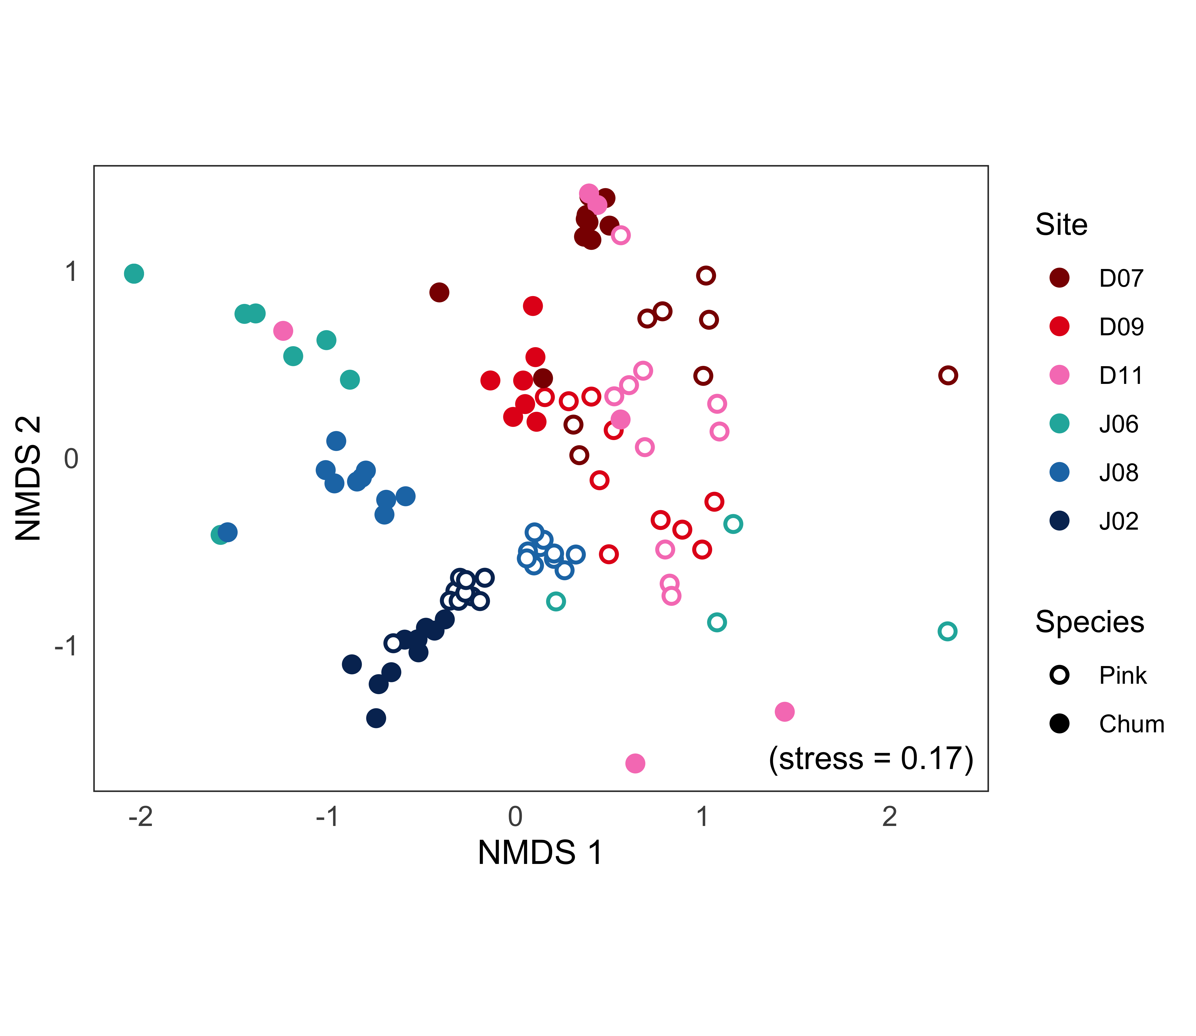

Figure 2.3 Non-metric multidimensional scaling (NMDS) ordination of juvenile pink and chum salmon diet composition. Each point represents one salmon stomach, colored by site, where open circles represent pink and filled circles, chum. “Stress” indicates how well the distances between points were retained when displayed in two-dimensions and for this plot, stress was 0.17.



Figure 2.4 Cluster analysis of juvenile pink and chum diet composition (average linkage clustering and Bray-Curtis dissimilarity).



Figure 2.5 Boxplot of pink and chum salmon condition factor K across the study sites. Box plots show the mean (black bar), interquartile range (boxes), 1.5*inter-quartile range (whiskers), and points indicate extreme values of salmon condition. The red dotted line separates fish in good condition (high weight to length ratio, > 1) and in poor condition (low weight to length, < 1).



Figure 2.6 Gut fullness index (GFI) of juvenile pink and chum salmon. Box plots show the mean (black bar), interquartile range (boxes), 1.5*inter-quartile range (whiskers), and points indicate extreme values of salmon GFI. The overlaid dark red line indicates dietary overlap between pink and chum salmon (secondary y-axis).



Figure 2.7 Cumulative prey taxonomic richness curves for juvenile pink and chum, salmon at each site location. Note: All sampling events included 10 salmon, but not all stomachs had prey in them (n = 12 empty stomachs total).

## Salmon trophic interactions shift with prey phenology and migration timing

### Introduction

The early marine phase for pink and chum salmon is incredibly important, as these species spend less time in freshwater systems, compared to sockeye, chinook or coho (Groot & Margolis, 1991). Research has shown the early marine phase to be a likely bottleneck in survival of chinook and coho salmon, mediating individual and cohort success during the first ocean winter (Beamish et al., 2004; Duffy & Beauchamp, 2011). Understanding the fundamental biology of salmon during this crucial early marine life phase is therefore essential to properly manage these species. However, modern research is somewhat more limited on the early marine feeding ecology and survival of sockeye, pink and chum salmon in British Columbia (Beamish et al., 2003). Pink and chum diets in British Columbia have been studied quite thoroughly prior to the 2000’s (Healey, 1991; Landingham et al., 1998; Manzer, 1969; Osgood et al., 2016; Perry et al., 1996), but more research is needed on pink and chum foraging responses to shifting coastal conditions in B.C. However, researchers in other areas of the North Pacific continue to study pink and chum diets (Armstrong et al., 2005; Bollens et al., 2010; Chebanova et al., 2018; Moss et al., 2009; Nagata et al., 2007) and survival trends (Agler et al., 2013; Cross et al., 2008; Honda et al., 2017; Malick et al., 2011; Miller et al., 2012; Saito et al., 2009; Yasumiishi et al., 2016). Foraging conditions experienced by juvenile salmon is expected to vary spatially across the north east Pacific dues to the wide range of oceanographic conditions (Mueter et al., 2005), seasonally due to plankton production cycles (Schweigert et al., 2013; Tommasi et al., 2013), and interannually due to climate driven shifts on ocean conditions (von Biela et al., 2019). Pink and chum salmon are two species of salmon who spend most of the life cycle in the marine environment and juveniles must grow quickly to avoid size-selective predation risks. Whether or not pink and chum salmon achieve sufficient growth in the early marine phase is an important question that remains to be answered in potentially food limited migration pathways. Early marine growth of salmon is determined largely by prey quality and quantity, which varies significantly across spatial scales, due to variable productivity regimes and coastal conditions (Malick et al., 2015). Another important factor is how zooplankton phenology and salmon migration timing interact to influence salmon foraging success, which may be further compounded by potential competitive interactions between species, which will be explored during salmon outmigration in this study.

The prey which salmon encounter in different habitats along the migration route depends on bottom-up processes that drive productivity, such as temperature, salinity, mixing, and nutrients. The ocean environment in northern latitudes depends on the seasonal cycles of surface layer stratification for phytoplankton growth that stimulates upper trophic levels. Differences in ocean mixing, temperature, freshwater inputs and nutrient levels vary on spatial and temporal scales. The previous chapter of this study found major differences in zooplankton consumed by pink and chum salmon across the dynamic migration route of the Discovery Islands and Johnstone Strait. Productive areas such as the Strait of Georgia have been shown to positively impact salmon feeding (Harrison et al., 1983; Osgood et al., 2016), and similarly, areas where mixed and stratified waters meet have been shown to be productive due the “fertilization effect” when nutrient depleted stratified waters are replenished (Mahara, 2018). However, areas such as Johnstone Strait with deep tidally mixing, cause phytoplankton to be mixed below the photic zone and hence be light limited, preventing the development of a significant seasonal spring bloom (McKinnell et al., 2014; Thomson, 1976). The zooplankton communities are characterized by euphausiids and calanoid copepods in the Northern Strait of Georgia, meroplankton in the mixed areas within the Discovery Islands and small < 2 mm copepods in Johnstone Strait (Mahara et al., 2021). These habitat mosaics of differing productivity regimes may have large effects on juvenile salmon health by mediating prey available, and these regional productivity differences may also shift over time with the season and climate causing changes in cumulative foraging experience.

The prey available to juvenile salmon is further mediated by zooplankton phenology. Seasonal timing can affect both the quantity and the size of prey available for migrating juvenile salmon. Over time, evolution has selected for spring outmigration run timing that coincides with ideal foraging conditions, as genetic lineages of fish migrating through optimal zooplankton blooms will survive more than earlier or later migrating counterparts (Asch et al., 2019; Schweigert et al., 2013). However, climate change shifts seasonal cycles due to increase in ocean temperatures and freshwater discharge, which can lead to a mismatch of predators and prey (Edwards & Richardson, 2003). Spring bloom timing has shown to be a stronger predictor of salmon survival than overall mean chlorophyll-a values (Malick et al., 2015), and salmon migrations in Auke Creek, Alaska have shifted earlier for both juveniles and spawning adults (Kovach et al., 2013). Normally, phytoplankton blooms are followed in succession by increased amounts of herbivorous small zooplankton, then the omnivorous and carnivorous zooplankton populations will expand. However, when the onset of phytoplankton bloom timing shifts or the community composition is dominated by small phytoplankton, smaller, short-lived zooplankton likely benefit and larger zooplankton with fixed life spans may decline (Mackas et al., 2007). Pink and chum salmon tend to migrate slightly earlier than sockeye and chinook, and therefore are vulnerable to potential mismatches in timing as the environment increases in temperature.

The size of salmon in relation to size of their prey is another important factor in foraging success, influenced by zooplankton phenology (James et al., 2020; Moss & Beauchamp, 2007). The size of prey available to juvenile salmon is influenced by salmon size at ocean entry and growth rate during the first few months at sea. The ideal size of prey for juvenile salmon depends on salmon size and mouth gape, therefore large prey may be available in the water column but unavailable as a prey choice for certain salmon. Conversely, if only small zooplankton are available, it may not be energetically beneficial for larger salmon to spend energy capturing prey that will not provide sufficient energy in return.

Prey quality can be inferred through the lipids or fatty acid compositions essential to the nutrition of predators. Generally, small zooplankton (<2 mm) and jellyfish are low in nutritional quality, whereas euphausiids, polychaetes, chaetognaths, insects, fish, and large copepods species are known to have a higher quality (Boldt, 2001; Costalago et al., 2020). Quality, size and amounts of prey can have significant impacts on salmon growth and survival, through impacting fish condition and physiological fitness to survive in competitive conditions.

Salmon are broadly opportunistic feeders and their diets have been found to be incredibly variable over time and therefore prey choice and interspecific competition can shift in response to these seasonal and interannual changes. Juvenile pink and chum salmon diets in the Broughton Archipelago were shown to shift between high and low overlap due to ocean conditions and prey availability (Gulbransen, 2014). Chapter 2 of this study demonstrated that interspecific competition and trophic niches differed under good and bad foraging opportunities across spatial scales. Specifically, Chapter 2 found that juvenile chum salmon consumed *Oikopleura* spp. in the Discovery Islands, Cnidaria prey in Johnstone Strait proper, and euphausiids near Queen Charlotte Strait. Pink salmon diets differed from chum salmon throughout the Discovery Islands and Johnstone Strait, where pink consumed more calanoids and nearshore harpacticoids under poorer feeding conditions. The location with the highest diet similarity between species (Queen Charlotte Strait), also had the greatest gut fullness of salmon. These trophic interactions may indeed persist over time.

Competition or separation of trophic niches may be caused by low productivity or high densities of salmon, or a combination of both. Chum salmon growth has been observed to decrease as a result of high densities of pink, chum, and sockeye salmon, and competitive interactions may be exacerbated by periods of poor food availability (Debertin et al., 2017; Morita & Fukuwaka, 2020). Furthermore, adult pink salmon in the Gulf of Alaska have demonstrated feeding effects on zooplankton standing stocks and trophic cascades (Batten et al., 2018), which in turn affects the prey available to other species, including chum salmon. However, to date the competitive interactions between pink and chum salmon have only be studied in adults and are less extensive for juveniles. Many research projects on juvenile pink and chum salmon describe diet composition without in-depth comparisons between species and substantial prey switching tendencies of chum salmon. Chapter 3 will address this knowledge gap by investigating the persistence of the interaction dynamics observed spatially in Chapter 2 over the seasonal cycle and between years.

Previous studies in coastal British Columbia have shown Discovery Islands to be very seasonally and tidally dynamic, whereas Johnstone Strait is more consistent with minimal seasonality (Mahara et al., 2021). Until the current study, there has been limited research on juvenile pink and chum salmon for the entirety of the outmigration period in tidally mixed waters. Other studies in comparable tidally mixed waters are Southeast Alaska, however studies sampled monthly or only studied chum salmon (Orsi et al., 2004; Sturdevant et al., 2004, 2012). In these areas, pink and chum salmon diet overlap also varied and prey switching was utilized, shifting mainly between euphausiids, larvaceans (*Oikopleura* spp.) and calanoids (Fergusson et al., 2020; Sturdevant et al., 2004). Another study investigated juvenile pink and chum diets in the Broughton Archipelago in 2003 and 2006 from April to May (salmon fork length range: 25 - 70 mm), and found interannual variation in dietary overlap between the species (Gulbransen, 2014). While the Broughton Archipelago is located close to the strong tidal currents of Johnstone Strait, the freshwater influence leads to stratified surface waters in the archipelago, that will likely influence salmon diets differently (Pearsall, 2008). Therefore, more research is required to fully explore the intricacies of juvenile pink and chum salmon interactions in oceanographically dynamic regions during their early marine phase, especially if this could be further complicated by competition with co-migrating sockeye juveniles as well.

This study will investigate the seasonal dynamics of the relationships between juvenile pink and chum salmon foraging and the zooplankton community composition during early outmigration. The main research question of this study is: how did pink and chum salmon respond to shifts in prey availability during their outmigration? This study would a) quantify juvenile pink and chum salmon diets and their seasonal and interannual interactions in southern coastal B.C.; b) describe how salmon species condition and foraging success vary over time; and c) compare juvenile salmon size with zooplankton prey sizes consumed across regions and years.

### Methods

#### Field sampling

The Hakai Institute’s Juvenile Salmon Program was established in 2015 as a collaboration between the Hakai Institute, the University of British Columbia, Simon Fraser University, the University of Toronto and Salmon Coast Field Station. This ongoing program annually samples juvenile salmon as they migrate through the Discovery Islands and Johnstone Strait during the main outmigration period (May to July). The objective of the program was to improve understanding of the early marine phase of Pacific salmon, particularly the factors contributing to health and survival (Hunt et al., 2018). This study focused on 2015 and 2016, which had good seasonal coverage of pink and chum salmon from late May to around early July.

During 2015 and 2016, 12 and 10 sites were sampled in Discovery Islands and Johnstone Strait, respectively, to provide coverage of all possible salmon migration routes through these regions (Hunt et al., 2018). While each site was sampled weekly, included in this study were bi-weekly sampling events. For this study, 2 sites, one from each region, were selected (the distance between the sites was ~ 95 km), in order to obtain a sample size of 10 pink and 10 chum per set (Figure 3.1). However, 2015 was lower in pink salmon abundance due to biennial life patterns and the absence of Fraser River pink salmon (n=212 total). Samples for this analysis were selected from late May, early/mid-June, and late June or early July (Table 3.1) to capture the early, peak, and late stages of salmon out-migration, respectively (Johnson et al., 2019).

Salmon were captured from a small research boat using a purse seine net with bunt dimensions of 27 m × 9 m with 13 mm mesh and tow area dimensions of 46 m × 9 m with 76 mm mesh. Once arrived at a site, weather and sea state were recorded, followed by a visual survey of salmon surface activity. The purse seine net was set on a targeted school of fish and loosely cinched up to facilitate collection while keeping salmon in the water to limit stress. Up to 30 sockeye, 10 pink and 10 chum salmon were retained, and the remaining salmon were counted and released (Hunt et al., 2018). All retained fish were individually euthanized with tricaine methane sulfonate (MS-222) upon removal from the seine net, lengths and weights recorded, and preserved at -196 oC with liquid nitrogen in a dry shipper until the salmon samples were stored in the -80 oC freezer at the lab. All salmon were collected under DFO license number ‘XR 42 2015’ and ‘XR 92 2016’ with approval from UBC’s Animal Care Committee (Protocol A19-0025).

A YSI instrument (model #15B102233 and 15C100324) was used to measure temperature and salinity at the surface and 1-meter depth, recorded while salmon were held for processing in the net. Once the purse seine set had been complete, zooplankton were sampled with a 50 cm diameter ring net with 250 μm mesh net, towed horizontally at the surface. A General Oceanic flowmeter was attached to the zooplankton net to calculate volume filtered for each tow. Zooplankton collected were then preserved in 4% formaldehyde for future analysis.

#### Zooplankton and salmon stomach content analysis

In the lab, zooplankton samples were poured over sieves and separated into 250 μm, 1000 μm and 2000 μm size fractions before being weighed and analyzed. Wet weights were measured to the nearest 0.1 mg on an analytical balance, with non-gelatinous and gelatinous groups weighed separately. If necessary, each size fraction of zooplankton was subsampled with a Motodo plankton splitter. Zooplankton were identified to life stage and the finest taxonomic resolution possible, each group was then enumerated and measured with an ocular micrometer.

Wet weight and fork length were recorded for juvenile salmon before dissection to remove their stomachs, which were preserved in 95% ethanol. Prior to analysis, salmon stomachs were removed from ethanol and soaked for 30 minutes in tap water to reduce the brittleness of the sample. The stomach was then dissected open and the food contents removed. The entire food bolus was weighed on an analytical balance and wet weight recorded to the nearest 0.1 mg. The bolus was then placed on a petri dish with water added, and prey rearranged by species, size, life stage and digestive state. Digestive states were defined as 1) fresh prey, intact, 2) semi-fresh prey, with lost appendages or color, 3) semi-digested prey, only identifiable to group, and 4) fully digested prey, unidentifiable. If prey could not be identified to species, it was identified to the most detailed taxonomic group possible, e.g., Ctenophora and Cnidaria jellyfish, collectively grouped as “gelatinous” hereafter. For each prey group, minimum and maximum lengths were measured with an ocular micrometer, individuals were counted, and the group wet weight recorded to nearest 0.1 mg. If a stomach sample had over 1,000 prey of similar size, a ¼ subsample was processed, after removing and recording any large and/or rare prey present.

#### Data analysis

The temporal variation in prey composition was analyzed using a multivariate approach. Prior to the analysis, rare taxonomic prey categories (occurring in less than three stomachs) were combined into higher level groupings, ignoring “digested food.” Fish stomach content wet weight was multiplied by 1.54 to correct weights for water loss after storage in ethanol (James, 2019). Relative prey biomass for each stomach was calculated and arcsine square root transformed before calculating Bray-Curtis dissimilarity. The dissimilarity matrix was used for non-metric multidimensional scaling (NMDS) ordination and agglomerative hierarchical clustering (AHC). For the NMDS plot, taxonomic group vectors were overlaid as arrows to visualize the direction and magnitude of prey driving differences in samples, which were calculated by a modified BIO-ENV method (Clarke & Ainsworth, 1993). Indicator value (INDVAL) analysis was performed on clusters at the 65% dissimilarity level to determine prey species differences between clusters (Dufrêne & Legendre, 1997). The transformed data was also input into two-way crossed analysis of similarity (ANOSIM) to compare the effects of region and year, and similarity percentages (SIMPER) analysis was calculated separately for pink and chum salmon to determine which prey species or taxa drove the differences between regions.

The diet composition was also calculated according to prey size classes (<1, 1-2, 2-5, 5-10 and >10 mm) for each salmon sample, only taking into consideration fresh (DS1) prey items. Digested zooplankton were excluded since reliable lengths could not be measured when the prey was degraded, crustaceans were often broken, and soft-bodied prey were especially poor quality. Relative biomass was calculated for each salmon then averaged by each sample date, region, and species to create a prey size bar graph similar in layout to the taxonomic diet composition figure. Average fresh prey size was compared to salmon size (fork lengths) for each species, region and year through linear models, where the mean prey size per stomach was weighted by the biomass.

In addition to the multivariate statistics, various indices were calculated from the raw data. Gut fullness indices (GFI) were calculated for each fish, expressed as percent body weight:

GFI = (food bolus weight / fish weight) * 100

Fulton’s condition factor K comparing length-weight relationships of salmon was calculated as:

K = 100,000 * fish weight / (fish fork length)3

Weight was measured in grams and fork length in millimetres, K=1 indicates average condition, >1 means relatively healthy and <1 was poor condition (Beamish et al., 2012; Jones et al., 1999). Condition for study fish (n=212) was analyzed with a multi-way ANOVA to investigate any interactions and differences between years, regions, and species, after reciprocal transformation to meet the assumptions of normality and heterogeneity of variance (Keppel & Wickens, 2004).

The Schoener percent similarity index (PSI) for species diet overlap was calculated for each site:

PSI = [Σ (minimum preyip, preyic)] * 100

Where preyip was the proportion by weight of prey *i* in pink salmon stomachs and preyic was the proportion by weight of prey *i* in chum salmon stomachs (Chipps & Garvey, 2006; Krebs, 2013).

The empty stomachs (those with no identifiable prey) in this study were excluded from the multivariate dissimilarity calculations but were included in the calculation of the above indices. The prey taxonomic detail was retained in analyses, but for summary tables and figures, “other” was prey grouped together that does not contribute substantially to diets (<10% weight), e.g., mysids, amphipods, cyclopoids, harpacticoids, bivalve larvae, pteropods, and polychaetes, etc. Diet richness was determined through cumulative prey curves for juvenile pink and chum salmon stomachs. All analyses were performed in R (v4.0.2.), using the *vegan* package v2.5-6 (Oksanen et al., 2019; R Core Team, 2020), except ANOSIM, calculated in PAST (Hammer et al., 2001).

All of the above data analyses were calculated on the 212 salmon used in the study (95 pink salmon and 117 chum salmon samples total). However, average peak migration timing and salmon size (fork lengths) for pink and chum was also determined for all samples collected by the Hakai Juvenile Salmon Program, for 2015-2019 (n = 5765 for migration, n = 2650 for size). Outmigration peak was assumed to be the point when 50% of salmon passed through the area, which was calculated for each species and year, see Johnson et al., 2019 for more information.

### Results

#### Environmental conditions and zooplankton

In the Discovery Islands, the temperature and salinity of the surface waters were variable during the salmon outmigration periods, and often warm and fresh (Table 3.1), in both 2015 (mean ± standard error: 15.8 ± 0.6 oC, 27.2 ± 0.4 ‰) and 2016 (15.5 ± 0.7 oC, 25.8 ± 0.3 ‰). In contrast, the surface temperature and salinity of Johnstone Strait remained consistent during the salmon outmigration periods in 2015 (10.4 ± 0.2 oC, 28.8 ± 0 ‰) and 2016 (10.3 ± 0.2 oC, 31 ± 0.2 ‰). The zooplankton biomass was higher overall in 2016 than in 2015 in both regions (mean ± standard error: 338 ± 59 mg/m3 in 2015; and 853 ± 72 mg/m3 in 2016; Table 3.1). The zooplankton biomass composition by size class was dominated by either the 250 μm or 2000 μm size fraction. The latter was dominated by gelatinous zooplankton. In 2015, the Discovery Islands had low overall zooplankton biomass, with the exception of June 5th, 2015, which had the highest biomass (1245 mg/m3) during the study. The Discovery Islands had more 1000 μm size fraction biomass in mid-season in both years (72-89 mg/m3), compared to Johnstone Strait, which had less 1000 μm zooplankton through the study period (0.5-16 mg/m3; Table 3.1). The biomass of non-gelatinous zooplankton from the 2000 μm size fraction was very low throughout both regions and years (0.2-8 mg/m3; Table 3.1). Therefore, zooplankton biomass differed by year and region, with overall low biomass in 2015, and large contributions of gelatinous zooplankton in Johnstone Strait and small zooplankton in Discovery Islands in 2016.

In the Discovery Islands, there was a high prevalence of cladocerans captured early and mid-season in both 2015 and 2016 (ranging from 32.3-75.1% of total abundance), shifting to more numerous calanoid composition in mid-June (40.1-52.9%; Table 3.2). In Johnstone Strait, calanoids (15.4-59.6%) and zooplankton eggs (25.1-77.7%; Table 3.2) were the two main types of zooplankton in 2015 and late June 2016. Cladocerans (27.3%) and `other` (Cyclopoida, 15.8% and Pteropoda, 10.8%) were also prominent in early June 2016 in Johnstone Strait (Table 3.2).

#### Salmon diet composition

In late May and early June 2015 in the Discovery Islands, juvenile pink and chum salmon both consumed *Oikopleura* spp. (16.9-97.7% of diet by weight for pink; 59.3-79.3%, chum). Early in the season in 2015, diets were quite diverse and included Balanomorpha barnacle larvae (0.2-43.6% pink; 2-14.7% chum), cladocerans (0.2-22.3% pink; 2.9-3.6% chum), and juvenile fish (sand lance, *Ammodytes hexapterus*, 20.4% chum), as well as small amounts of Calanoida, Decapoda, and `other` (Figure 3.2; Table 3.3). Later in June 2015, the Discovery Islands salmon diets shifted and both species consumed Calanoida (53.4% pink; 33.4% chum), Chaetognatha (39.3% pink; 46.4% chum), and chum also consumed adult Euphausiidae (10%; Figure 3.2).

The 2016 diets of salmon in the Discovery Islands were comprised of different prey than in 2015. *Oikopleura* spp. were still common prey in 2016 for both pink (18.2-27.7%) and chum (34.4-91%) salmon throughout the outmigration season (Figure 3.2; Table 3.3). However, in late May 2016, Euphausiidae eggs were the main prey type (44.2% pink; 55.3% chum), and in early June, Echinodermata larvae were the most dominant prey for pink salmon (36.1%; chum, 6.8%; Figure 3.2). Finally, in mid-June 2016, chum salmon diets were dominated by *Oikopleura* (91%) and pink salmon diets shifted to Decapoda (28.3%), `other` (29.1%, e.g., Amphipoda, Pteropoda, Cyclopoida, see Table 3.3) and Calanoida (19.8%). In Johnstone Strait, the diets of pink and chum salmon were consistent in the main groups of prey consumed, with chum salmon primarily feeding on gelatinous prey (68.4-96.5%) and pink salmon on calanoids (63.3-99.4%; Figure 3.2).

The clear partitioning of species feeding in Johnstone Strait was also reflected in the NMDS ordination of diets, where pink and chum salmon occupied separate groups (Figure 3.3). Furthermore, the NMDS showed variable diets, particularly for pink salmon, in the Discovery Islands. Pink salmon in the Discovery Islands had the greatest spread in the ordination and could not be characterized by a single prey type, but were influenced by `other`, meroplankton (Decapoda, Echinodermata and Balanomorpha larvae), Cladocera, and Euphausiidae eggs (Figure 3.3). The grouping of chum salmon in the Discovery Islands was mostly driven by *Oikopleura* spp. diets, however, there was one unique sampling event with high amounts of Chaetognaths (June 13, 2015) that grouped closer to Johnstone Strait diets, for both species.

The cluster analysis revealed the same trends, with diet composition separated by region and further subdivided by salmon species and date (Figure 3.4). The separation between pink and chum was strongest in Johnstone Strait. In the Discovery Islands, there were seven subclusters: two outlier clusters of chum salmon (May 2015), three pink salmon clusters separated by date, both salmon species in May 2016, and chum salmon clustered regardless of date (Figure A.1). The other main cluster included mostly Johnstone Strait samples with some occurrences of Discovery Islands diet similarity as well (Figure A.2). The five subclusters in the Johnstone Strait included: chum salmon for most dates, chum salmon in mid-June 2016, pink salmon in early June 2016, both species from Discovery Islands (mid-June 2015), and most pink salmon. Outside of these two main clusters, there were also more extreme outliers (~ 95% dissimilarity), including a pink salmon from Johnstone Strait (mid-June 2016), a pink salmon from Discovery Islands (mid-June 2016), and chum salmon from Discovery Islands (mid-June 2016; Figure 3.4). Regardless of region, pink salmon diets had higher within-group variability than chum salmon.

The indicator value analysis revealed the prey species characterizing each subcluster. Small prey defined the pink salmon diets in the Discovery Islands, such as barnacle nauplii, cladocerans, echinoderm larvae and euphausiid eggs (Table A.2). Chum salmon in the Discovery Islands also consumed euphausiid eggs, as well as *Ammodytes hexapterus* and *Oikopleura* spp. In Johnstone Strait, chum salmon mainly consumed Cnidaria, along with *Acartia longiremis*, with the exception of mid-June 2016 being characterized by Ctenophora prey. Pink salmon diets in Johnstone Strait were characterized entirely by copepods, mainly *Calanus marshallae*, except early June 2016, when pink consumed *Pseudocalanus*, *Tortanus discaudatus,* and *Harpacticus*. The unique pink and chum diets of Discovery Islands on June 13, 2015 grouped with Johnstone Strait and were defined by *Tomopteris septentrionalis*, chaetognaths, and *Calanus pacificus* prey.

The two-way analysis of similarity (ANOSIM) revealed a strong difference in the diet compositions by region (R=0.6145, p=0.001) and a weak yet significant difference by year (R=0.1244, p=0.001). The similarity percentage (SIMPER) analysis determined that the main prey types of chum salmon driving these differences by region were *Oikopleura* (explained 29% of dissimilarity) in the Discovery Islands, as well as Cnidaria (23%) and *Calanus marshallae* (5%) in Johnstone Strait (Table 3.4). The top three prey driving differences between regions in pink salmon diets were *Calanus marshallae* (12% dissimilarity) and digested calanoids (5%) in Johnstone Strait, and *Oikopleura* spp. (9%) in Discovery Islands. Other important prey in the SIMPER analysis for pink salmon were other calanoid species in Johnstone Strait, such as *Calanus* *pacificus*, *Aetideus* *divergens*, *Pseudocalanus* spp. and *Epilabidocera longipedata*. The characteristic prey for pink salmon in the Discovery Islands were meroplankton and small zooplankton, e.g., barnacle nauplii and cyprids (*Balanus* *crenatus* and *B.* *glandula*), brachyuran larvae and echinoderm larvae, euphausiid eggs and cladocerans (see Table 3.4 for more details).

#### Diet diversity and overlap between juvenile salmon

Pink salmon had higher diet diversity than chum salmon in both regions and years (Figure 3.7). The difference between species diet richness was more pronounced in 2016, with pink salmon consuming over 20 types of taxa more than chum salmon throughout both regions. There was a higher difference between regional diet diversity in 2015, where Discovery Islands had high richness for both species (80 taxa) and Johnstone Strait had low diet richness (40 taxa). Comparing within species diets, Discovery Islands had higher observed richness than Johnstone Strait, with the exception of 2016 pink salmon, when regions had similar richness (Figure 3.7).

Dietary overlap between juvenile pink and chum salmon was highly variable throughout the study period and regions, with lowest overlap in Johnstone Strait (< 45%). In the Discovery Islands, 2015 had an increase in overlap from 22.4% on May 21st to 60.5% on June 13th, and a decrease in 2016, from 80.8% to 24.9% (May 19th to June 16th; Figure 3.5). Overall, mean diet overlap between salmon species was higher in Discovery Islands (48.1-53.9%) than Johnstone Strait (9.9-16.7%) and higher in 2015 (Table 3.5).

#### Salmon health

Salmon gut fullness indices (GFI) were consistently low in Johnstone Strait during 2015 (mean GFI: pink salmon 0.45%; chum salmon 0.63%) and 2016 outmigration (pink salmon 0.56%; chum 0.99%; Table 3.5). In the Discovery Islands, GFI was highly variable, having a mean of between 0.89-3.02% and 0.13-3.29% for pink in 2015 and 2016 respectively, and 1.73-3.28% and 0.23-3.92% for chum salmon in the same years (Figure 3.5). Chum salmon generally had slightly higher mean GFI than pink salmon, and in 2015 Discovery Islands, chum salmon also had higher variation in the GFI.

Empty stomachs were not very prevalent in this study, with 4% of all juvenile salmon having no food items present in the stomachs (n=8, Table 3.5). Empty stomachs were more common for pink salmon (6% of pink stomachs; n=6) than chum salmon (2% of chum stomachs; n=2). The distribution of empty stomachs also differed between species, empty pink salmon stomachs occurred in each region but only in 2016, and chum salmon had empty stomachs only in the Discovery Islands.

For the 212 salmon in this study, condition was higher in 2015 than in 2016 (Figure 3.6). The 3-way ANOVA on condition revealed significant differences by year (p < 0.001), species (p = 0.01), and interaction of species and year (p = 0.013), but region was not significant (p = 0.84). The species differed in condition significantly in 2016 (p < 0.001), but not for 2015 (p = 0.8). For 2015, both species were found in average condition in both regions (mean 1-1.02 K), but in 2016, pink salmon were in poorer condition (0.9-0.93) than chum salmon (0.96-0.97; Table 3.5).

There was a total of 25 microplastics or other objects (macroplastic, glass) found in 8.5% of all the salmon stomachs included in this study (n=18 salmon). These foreign objects were consumed by both pink and chum salmon, mostly in the Discovery Islands (at least one for each date except June 16th, 2016), compared to Johnstone Strait (mostly from July 5th, 2016). The size of the plastics/objects ranged from 0.3 mm to 5.8 mm, and included two pieces of glass, 11 micro-plastic fibers, 9 hard microplastic pieces, 1 microplastic film, 1 microplastic clothing tag fastener and 1 macroplastic piece that was likely a broken straw piece. Furthermore, the macroplastic found in a juvenile pink salmon stomach in the Discovery Islands, constituted 41.1% of the “prey” biomass and appeared to be larger than the fish’s sphincter (Figure A.3).

#### Salmon and prey size

The size of juvenile salmon prey varied across regions, species, season and years, but the dominant size class by weight was often 2-5 mm (Figure 3.8). Chum salmon consumed larger or similar sized prey in the Discovery Islands compared to pink salmon, and smaller or similar prey in Johnstone Strait (although “gelatinous” was excluded due to the digested nature of the prey). There were interannual differences in prey size consumed by both species, where 2015 included more larger prey than 2016, this difference was especially pronounced in the Discovery Islands. Size increased somewhat across the outmigration season in Discovery Islands in both 2015 and 2016, however Johnstone Strait prey size classes were more consistent without much seasonality.

The seasonal trend in prey size was correlated with an increase in salmon size in the Discovery Islands and this predator-prey relationship was most apparent for chum (Figure 3.9). In the Discovery Islands in 2015, pink salmon had a moderate relationship to prey size (y=-12.4+0.16x, R2=0.55, p < 0.001), and chum salmon had a strong correlation (y=-16.2+0.21x, R2=0.71, p < 0.001; Figure 3.9). For the Discovery Islands in 2016, there was a moderate relationship between chum salmon and prey size (y=-2.5+0.05x, R2=0.46, p < 0.001), but not for pink (y=0.6+0.01x, R2=-0.03, p = 0.64). In Johnstone Strait, there was no relationship between salmon and prey size in 2015 for pink (y=2.0+0.01x, R2=-0.01, p = 0.40) or chum (y=-3.2+0.05x, R2=-0.02, p = 0.47). In Johnstone Strait in 2016, there was a weak but significant size effect for pink salmon (y=-2.8+0.05x, R2=0.34, p = 0.001), but not chum (y=4.9-0.01x, R2=0.03, p = 0.20).

The size of salmon also differed between years, regions and species, in 2015 the salmon were larger than in 2016, larger in Johnstone Strait since it is further along the migration route, and chum salmon were generally slightly larger than pink salmon (Table 3.5). Compared to more recent years (2017-2019), 2015 salmon were still relatively large and 2016 salmon, small (Figure 3.10). Migration timing was comparable between 2015 and 2016 for pink and chum salmon, with 2016 being slightly earlier and pink salmon generally a little bit later than chum salmon (Table A.1). Compared to other years of outmigrating pink and chum salmon, 2015 and 2016 were early migrants, with peak outmigration of June 10th, 2016 for both species, and June 17th, 2015 for pink salmon (average peak migration date) and June 12th, 2015 for chum salmon (2 days early).

### Discussion

This study aimed to quantify juvenile pink and chum salmon a) diets, interactions, b) condition and c) size relationships between salmon and their prey during the outmigration period of 2015 and 2016. It was found that diets and species interactions were variable in the Discovery Islands but were consistent in Johnstone Strait. Salmon condition was significantly higher in 2015 relative to 2016, likely due to the presence of larger and more nutritious prey in the Discovery Islands in June 2015. The spatial patterns in foraging observed in Chapter 2 were reflected across the outmigration season, when juvenile pink and chum salmon fed on similar prey during periods of high food availability and partitioned resources when food was limited.

#### Oceanographic seasonality and prey phenology

The two regions of Discovery Islands and Johnstone Strait were very different from each other, in oceanographic conditions, diet composition of pink and chum salmon, and seasonality. The Discovery Islands increased in temperature and became fresher as the season progressed, although, later in 2015, there was also a drop in temperature and increased salinity, which potentially indicated a mixing event due to wind (James, 2019). While the oceanography in Johnstone Strait was more consistently well-mixed with low temperatures and high salinity, 2015 had slightly fresher surface water than 2016.

While the zooplankton samples showed some seasonal shifts from barnacle larvae and cladocerans to calanoid copepods in Discovery Islands, there was low interannual variability. Zooplankton biomass appeared higher in 2016 relative to 2015, although, small zooplankton and gelatinous zooplankton dominated in the Discovery Islands and Johnstone Strait, respectively. These findings were comparable to a concurrent study that included more frequent weekly sampling (James, 2019). However, a more detailed analysis of zooplankton communities in Discovery Islands in 2015 and 2016, found a ten-fold higher prevalence of meroplankton and delayed spring phytoplankton and zooplankton bloom timing within 2016 (Mahara et al., 2019).

Zooplankton communities captured by horizontal net tows did not quite match what was found in juvenile salmon diets, demonstrating a need for alternative sampling techniques of prey fields. While the proportions found in diets differed than zooplankton samples, overall trends were somewhat comparable. In 2016, euphausiid eggs and echinoderm larvae were also captured in the zooplankton tows of the Discovery Islands. Johnstone Strait had large amounts of calanoid copepods throughout, as well as zooplankton eggs and cladocerans, although the fish may have been too large to consume such small prey. Since salmon may feed beyond the surface waters and for a longer period than the immediate snapshot of zooplankton sampling, it was possible that either salmon actively selected and avoided different portions of prey available or there was a slight mismatch of zooplankton and diets. Therefore, in the current study, horizontal net tows were considered supplemental data, but the stomach samples themselves were used to assess the feeding conditions and prey availability.

#### Seasonality of salmon diet composition

In the Discovery Islands diets, prey communities appeared to shift seasonally, from small zooplankton and meroplankton such as barnacles and cladocerans, to *Oikopleura*, and later in 2015, to larger calanoids, chaetognaths and euphausiids. However, in 2016 the Discovery Islands dietary community composition had less of a shift, when larval and egg stages of zooplankton remained dominant throughout the season, with high prevalence of euphausiid eggs, echinoderm larvae, and decapod larvae, as well as *Oikopleura*. Prey communities in Johnstone Strait diets had less seasonality than Discovery Islands, and also appeared to be more variable in 2016. Overall, the Discovery Islands diets of pink and chum juveniles were mostly comprised by these meroplankton and *Oikopleura* spp., respectively. In Johnstone Strait, juvenile pink and chum salmon diets were dominated by calanoids and gelatinous prey, respectively. The spatial patterns in diet composition remained relatively constant over time, affirming the findings of Chapter 2, where salmon species’ unique trophic niches were robust throughout both the season and years.

While Johnstone Strait had relatively low seasonal and interannual variability, the taxonomic composition of prey did shift over time, especially in 2016. The most dominant prey types were Cnidaria for chum salmon and *Calanus marshallae* and *C. pacificus* for pink salmon. In Johnstone Strait, pink salmon had consumed a higher diversity of smaller calanoids in 2016, e.g., *Pseudocalanus*, *Tortanus discaudatus* and *Aetideus divergens*, especially early June 2016. Whereas chum salmon prey also shifted to Ctenophora jellyfish in mid-June 2016, which had coincided with lower gut fullness values. Overall, 2016 included more diet variability outliers. Clear preference of gelatinous prey by chum juveniles compared to pink juveniles documented in Johnstone Strait during this study aligns with Chapter 2 and published literature describing chum salmon as gelatinovorous species and pink salmon as generalist foragers, strategies suggested to limit inter-species competition (Brodeur, 1990; Graham, 2020).

Juvenile salmon dietary overlap varied greatly across regions and dates and may be used to infer potential competition between species. It was noted in this study that in the Discovery Islands, overlap depended on prey types available and the high overlap coincided with periods of high feeding activity (judged from GFI values). This was clearly the case during late 2015 and early 2016, when both species consumed similar and high-quality prey. Conversely, during periods of poor feeding activity in the Discovery Islands, chum salmon had specialized on *Oikopleura* spp. and pink salmon on small, nearshore meroplankton. Similarly, in Johnstone Strait, pink specialized on calanoid copepods and chum salmon consumed almost exclusively Cnidaria prey, which resulted in negligible diet overlap throughout outmigration in both years.

#### Interannual variability in prey size

Prey size was considerably larger in 2015 relative to 2016, with higher variation of prey sizes found within the Discovery Islands compared to the evermore consistent Johnstone Strait. This seasonal trend was correlated with an increase in salmon size in the Discovery Islands, potentially indicating a size-based shift to larger prey, while no trend was evident in Johnstone Strait, suggesting larger prey were not available there. These interannual variations in size may be due to delayed spring bloom in 2016, which limited succession of larger zooplankton and led to an abundance of meroplankton in the Discovery Islands (Mahara et al., 2019). Prey size had a stronger relationship with salmon size in 2015 in the Discovery Islands, and for chum salmon this trend was more prevalent, pink salmon generally consumed smaller prey than chum salmon. Therefore, larger salmon only have an advantage when large prey are available, and the absence of large prey through most of the area and time period is likely responsible for the poor feeding. Small prey may have a compounding effect on salmon growth, as small prey both provide less energy and require more energy to capture numerous small prey relative to few larger prey items.

Chum salmon appear to have more beneficial foraging strategies, since they consume larger and higher quality prey than pink salmon when available and tend to specialize on abundant gelatinous zooplankton when ideal food is scarcer. This led to a significant difference in condition between chum and pink salmon in 2016, the year with lower condition than 2015. The gelatinous foraging strategy of chum salmon may be beneficial when either productivity and food supplies are generally low or when density dependent interactions between salmon is high. Future research can further investigate this strategy and use abundant chum salmon as broad ecosystem indicators, and the more generalist pink salmon can reveal available prey species.

#### Salmon health implications

Salmon condition did not vary significantly between regions, but stomach fullness was at times higher in the Discovery Islands than in Johnstone Strait, where it remained low throughout. However, condition was higher in 2015 than 2016 in both regions which indicated better feeding. Stomach fullness appeared to somewhat increase across 2015 in the Discovery Islands, as did prey quality, since calanoids and chaetognaths have higher caloric and fatty acid contents than small prey (Boldt, 2001; Costalago et al., 2020). Whereas, in 2016, both prey size and quality remained low throughout and stomach fullness decreased considerably across the season in the Discovery Islands and salmon health suffered. Furthermore, this likely suggested a mismatch in prey development and outmigration timing. Indeed, pink and chum juveniles in 2016 migrated about one week earlier than the 2015-2019 average migration date. This interannual variability demonstrated the importance of zooplankton timing and community succession in relation to juvenile salmon and should be further investigated with climate shifts.

The low stomach fullness, significantly low salmon condition throughout multiple regions and poor food quality may have negative impacts on salmon survival and returns (Duffy & Beauchamp, 2011; Tucker et al., 2016). Smaller sized zooplankton with low fatty acid and lipid content in low amounts is likely not sufficient for small migrants such as pink and chum salmon during this early marine phase (Costalago et al., 2020; Litz et al., 2017). Regions of significantly improved feeding further north (site “J02”, Chapter 2) are likely crucial to salmon survival in areas of consistently low or incredibly variable regions along the migration. Future research should focus on the areas where salmon may recover from these poor conditions and monitor quality and amount of zooplankton prey types available to help reduce competition.

There were anomalously warm conditions in 2015 and 2016, due to the warm “blob” in the North Pacific, which originated in 2014, which was compounded by a strong El Niño in 2016 (Bond et al., 2015; Jackson et al., 2018). These warm ocean conditions may have influenced the earlier spring bloom timing, poor feeding and depressed condition of juvenile salmon in 2016. Pink salmon condition was significantly lower than chum salmon condition in 2016, and when adult pink salmon returned to the Fraser River in 2017, they had experienced one of the poorest returns on record of less than 5 million, compared to the average of 12.4 million (DFO, 2018). These generalist foragers are potentially more vulnerable to the zooplankton prey availability relative to chum salmon, who employ an opportunistic specialist strategy, and take advantage of large and nutritious prey when it becomes available and rely on gelatinous when it is necessary. Cooler years in this migration area may improve conditions regarding zooplankton community composition and phenology timing with salmon migration, although future research is needed.

Microplastics were not the focus of this study but they were found in 8.5% of juvenile salmon stomachs, and a macroplastic was found to be > 40% weight of a pink salmon stomach. The 6 mm macroplastic had the shape, color and texture of a broken straw piece and appeared larger than the sphincter could potentially pass, which would likely reduce survival for that fish. Impacts of plastics on salmon and occurrence with poorer feeding, with potential for cumulative effects, must be researched further to better understand the complex multiple threats salmon face.

### Conclusion

Migration timing of juvenile salmon and zooplankton size and community composition appears to be connected to salmon species foraging opportunities and competitive interactions. Seasonality in diets, size and interactions were more pronounced in dynamic areas such as the Discovery Islands, where tidally mixed Johnstone Strait had low species diet overlap throughout. Chum salmon consumed gelatinous prey, either *Oikopleura* spp. or Cnidaria, in all but two time points, when abundant euphausiid eggs or calanoids and chaetognaths led to a shift in prey types. In those periods of increased feeding, pink and chum salmon diets overlapped, otherwise pink salmon foraged more generally, on small meroplankton and copepods with high dietary richness.

In 2015, there was zooplankton community succession that aligned ideal prey size with migrating juvenile salmon, in mid-June, pink and chum salmon diets consisted of quality prey. This resulted in pink and chum salmon being fatter and in better condition as compared to 2016. There was a mismatch of prey in 2016, with small zooplankton available throughout the season and lower gut fullness throughout, except late-May when early migrants fed on euphausiid eggs. This was comparable to juvenile sockeye salmon diets in the same time and place (James, 2019), therefore it reflected feeding conditions available to other planktivores, such as herring and birds.

Zooplankton availability for juvenile salmon is largely driven by bottom-up effects and timing of migration and plankton blooms is critically important for salmon survival to adulthood. However, in the context of climate change, salmon migration timing may shift since they utilize temperature cues, and plankton bloom timing may also shift from weather and freshet conditions. Therefore, salmon interactions under differing scenarios of zooplankton community timing are needed to further understand how salmon may cope and adapt to challenging early life histories. Juvenile pink and chum experience food-limitation in southern British Columbia and the species have evolved strategies to coexist by either utilizing generalist or specialist feeding, respectively. Further studies on multiple species interactions during salmon outmigration is recommended to comprehend challenges and strengths of different species in response to environmental hardship.

### Tables

Table 3.1 Sampling details for study: Site ID for the Discovery Islands (D07) and Johnstone Strait (J07), sampling date and year, number of pink and chum salmon stomachs analyzed, temperature (Temp.), salinity (Sal.) and size fractionated and total zooplankton biomass. The 2000 μm size fraction biomass values were divided by non-gelatinous (Non-Gel.) and gelatinous (Gel.) zooplankton.



Table 3.2 Zooplankton relative abundance (expressed as percent) by major groups.



Table 3.3 Diet composition summary (% wet weight) of juvenile salmon by date and year.



Table 3.4 SIMPER results of prey taxa driving differences between regions of A) pink salmon diet composition and B) chum salmon diet composition (by transformed relative wet weights). Group classification is included to the left of species or highest taxonomic resolution of prey, DI is relative biomass in the Discovery Islands, and JS is relative biomass in Johnstone Strait. Average is the average contribution to dissimilarity and Sum is the cumulative contribution of prey to region dissimilarity, only taxa contributing to 70% of dissimilarity were included.





Table 3.5 Summarized salmon biological data for 2015-2016 in DI-JS: fork length (FL), wet weight (WW), condition factor K, gut fullness (GFI), number of empty stomachs, diet overlap of species, and richness (number of prey taxa), expressed as mean ± standard deviation.



### Figures



Figure 3.1 Map of sampling sites for Discovery Islands (D07) and Johnstone Strait (J07) during May to July 2015-2016. Inset map (left) shows B.C. coast with study location in red.

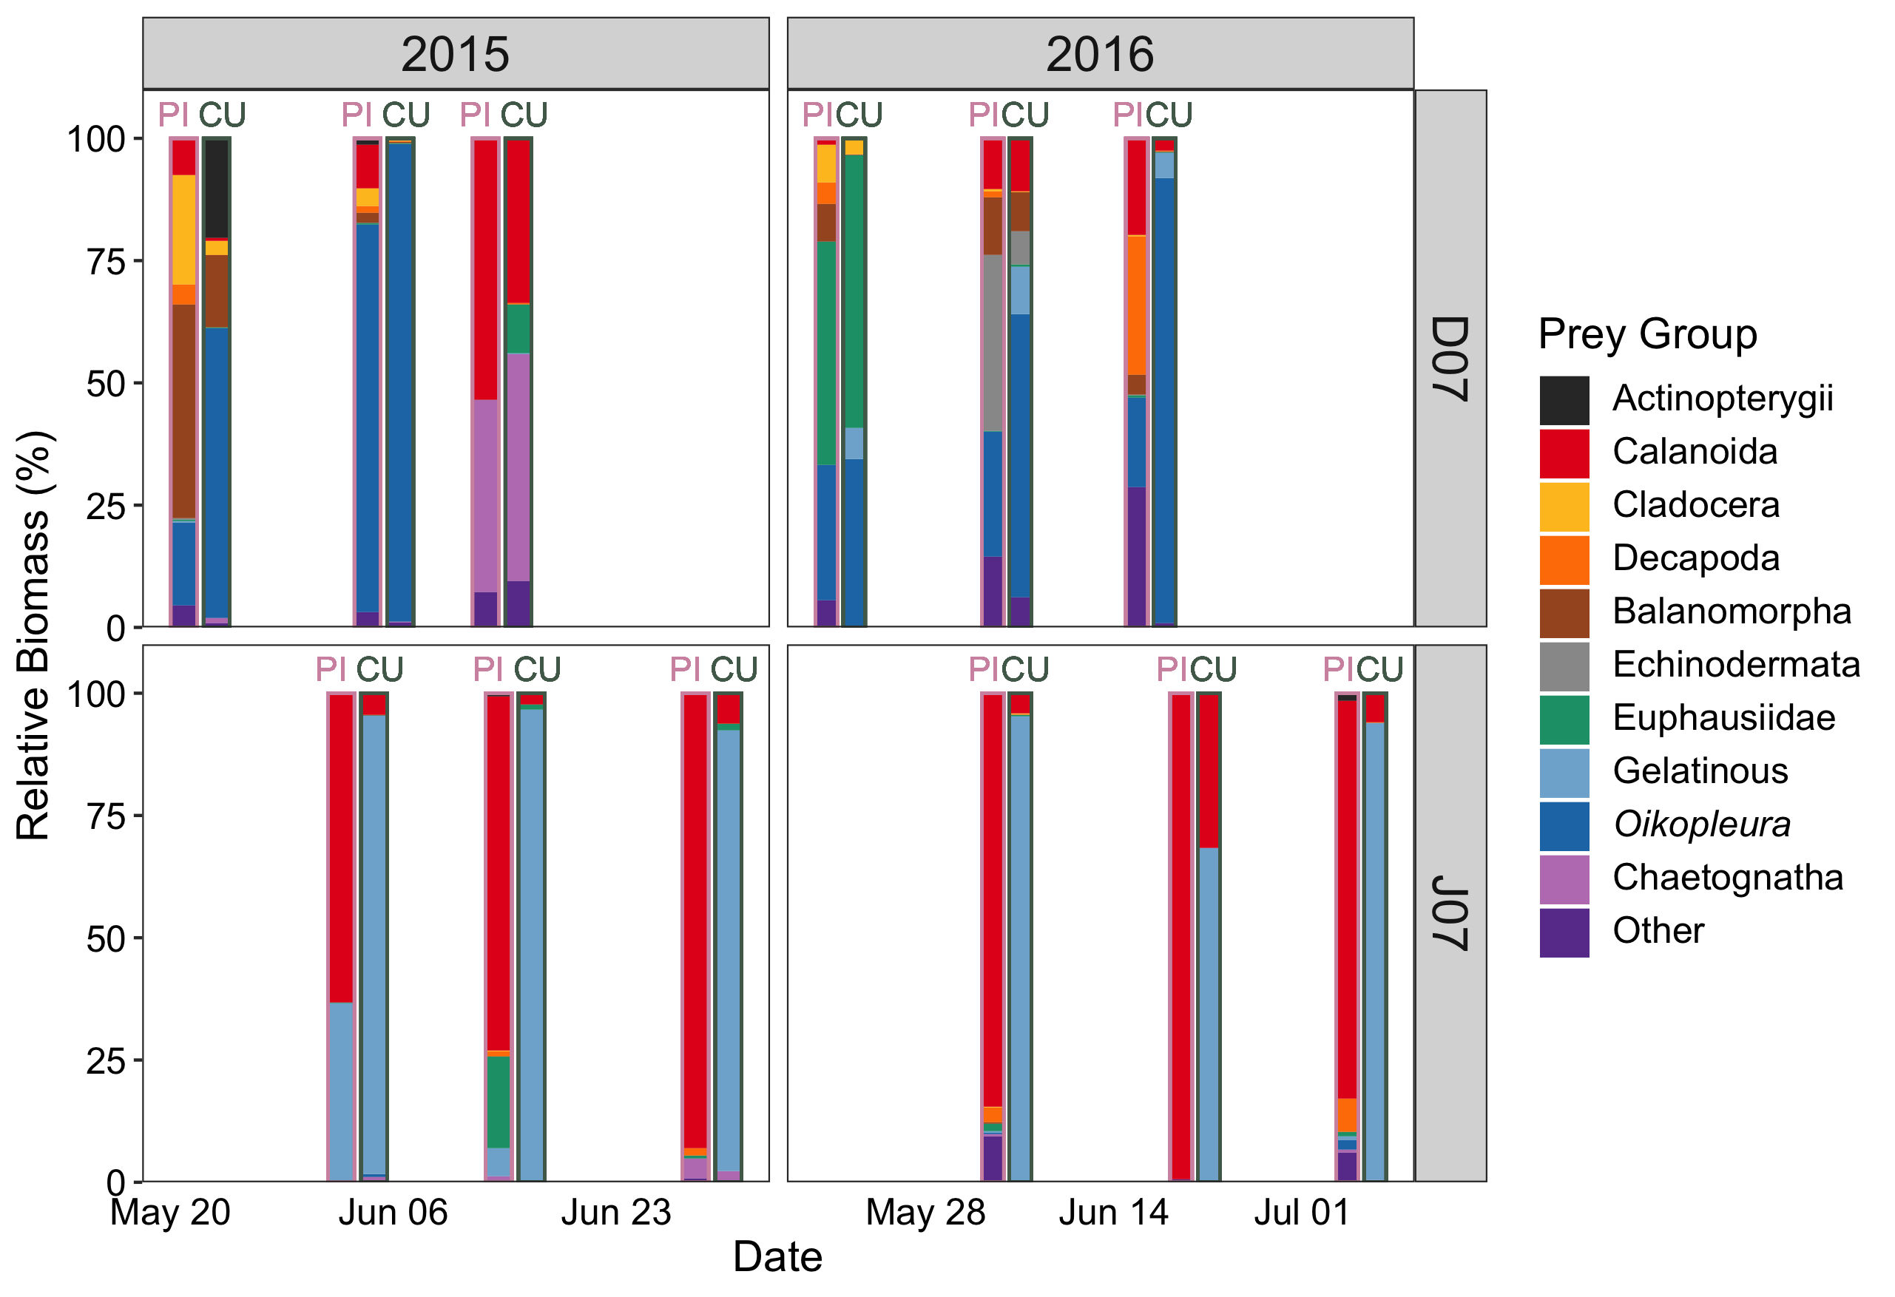

Figure 3.2 Diet composition of major prey groups by relative biomass of juvenile pink (“PI”, outlined in pink) and chum (“CU”, outlined in dark green) salmon during outmigration in 2015-2016 at the Discovery Islands site D07 and Johnstone Strait site J07.

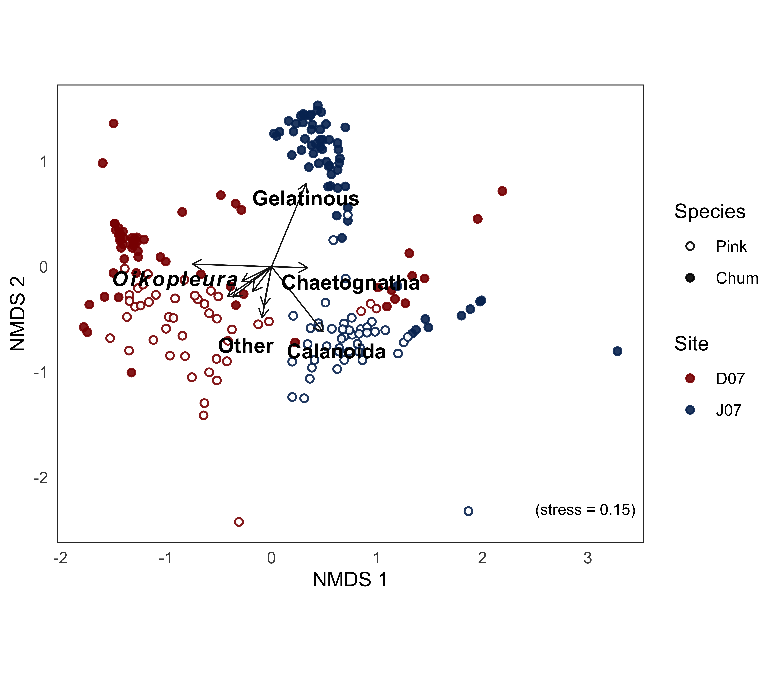

Figure 3.3 Non-metric multidimensional scaling (NMDS) ordination plot of diet composition of pink (open circles) and chum (filled circles) salmon in Discovery Islands (red) and Johnstone Strait (blue) during outmigration (May to July) of 2015 and 2016. Vectors were overlaid to show direction and magnitude of main taxonomic prey groups driving dissimilarity, overlapping labels not shown (Euphausiidae, Balanomorpha, Echinodermata, Cladocera, Decapoda).

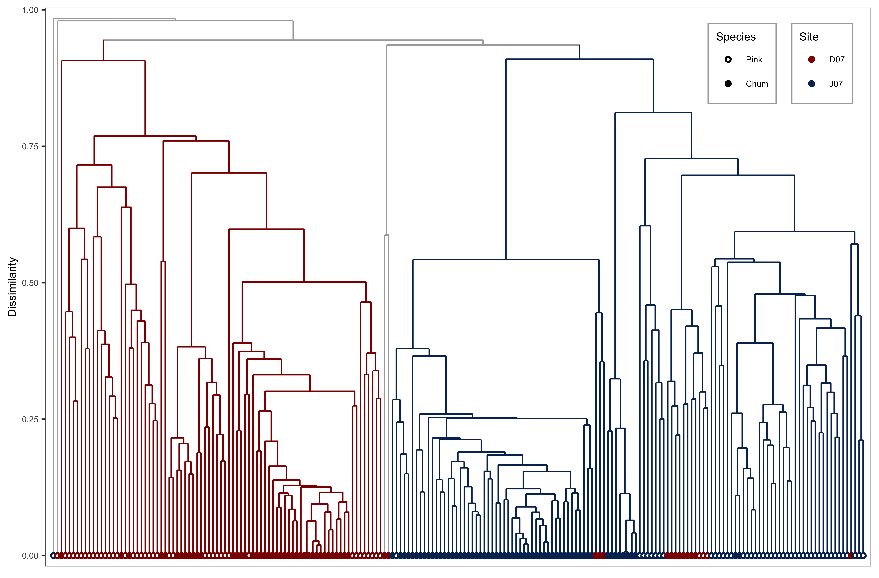

Figure 3.4 Cluster dendrogram of temporal diet data, with outliers in grey and main clusters colored by region (details in appendix).

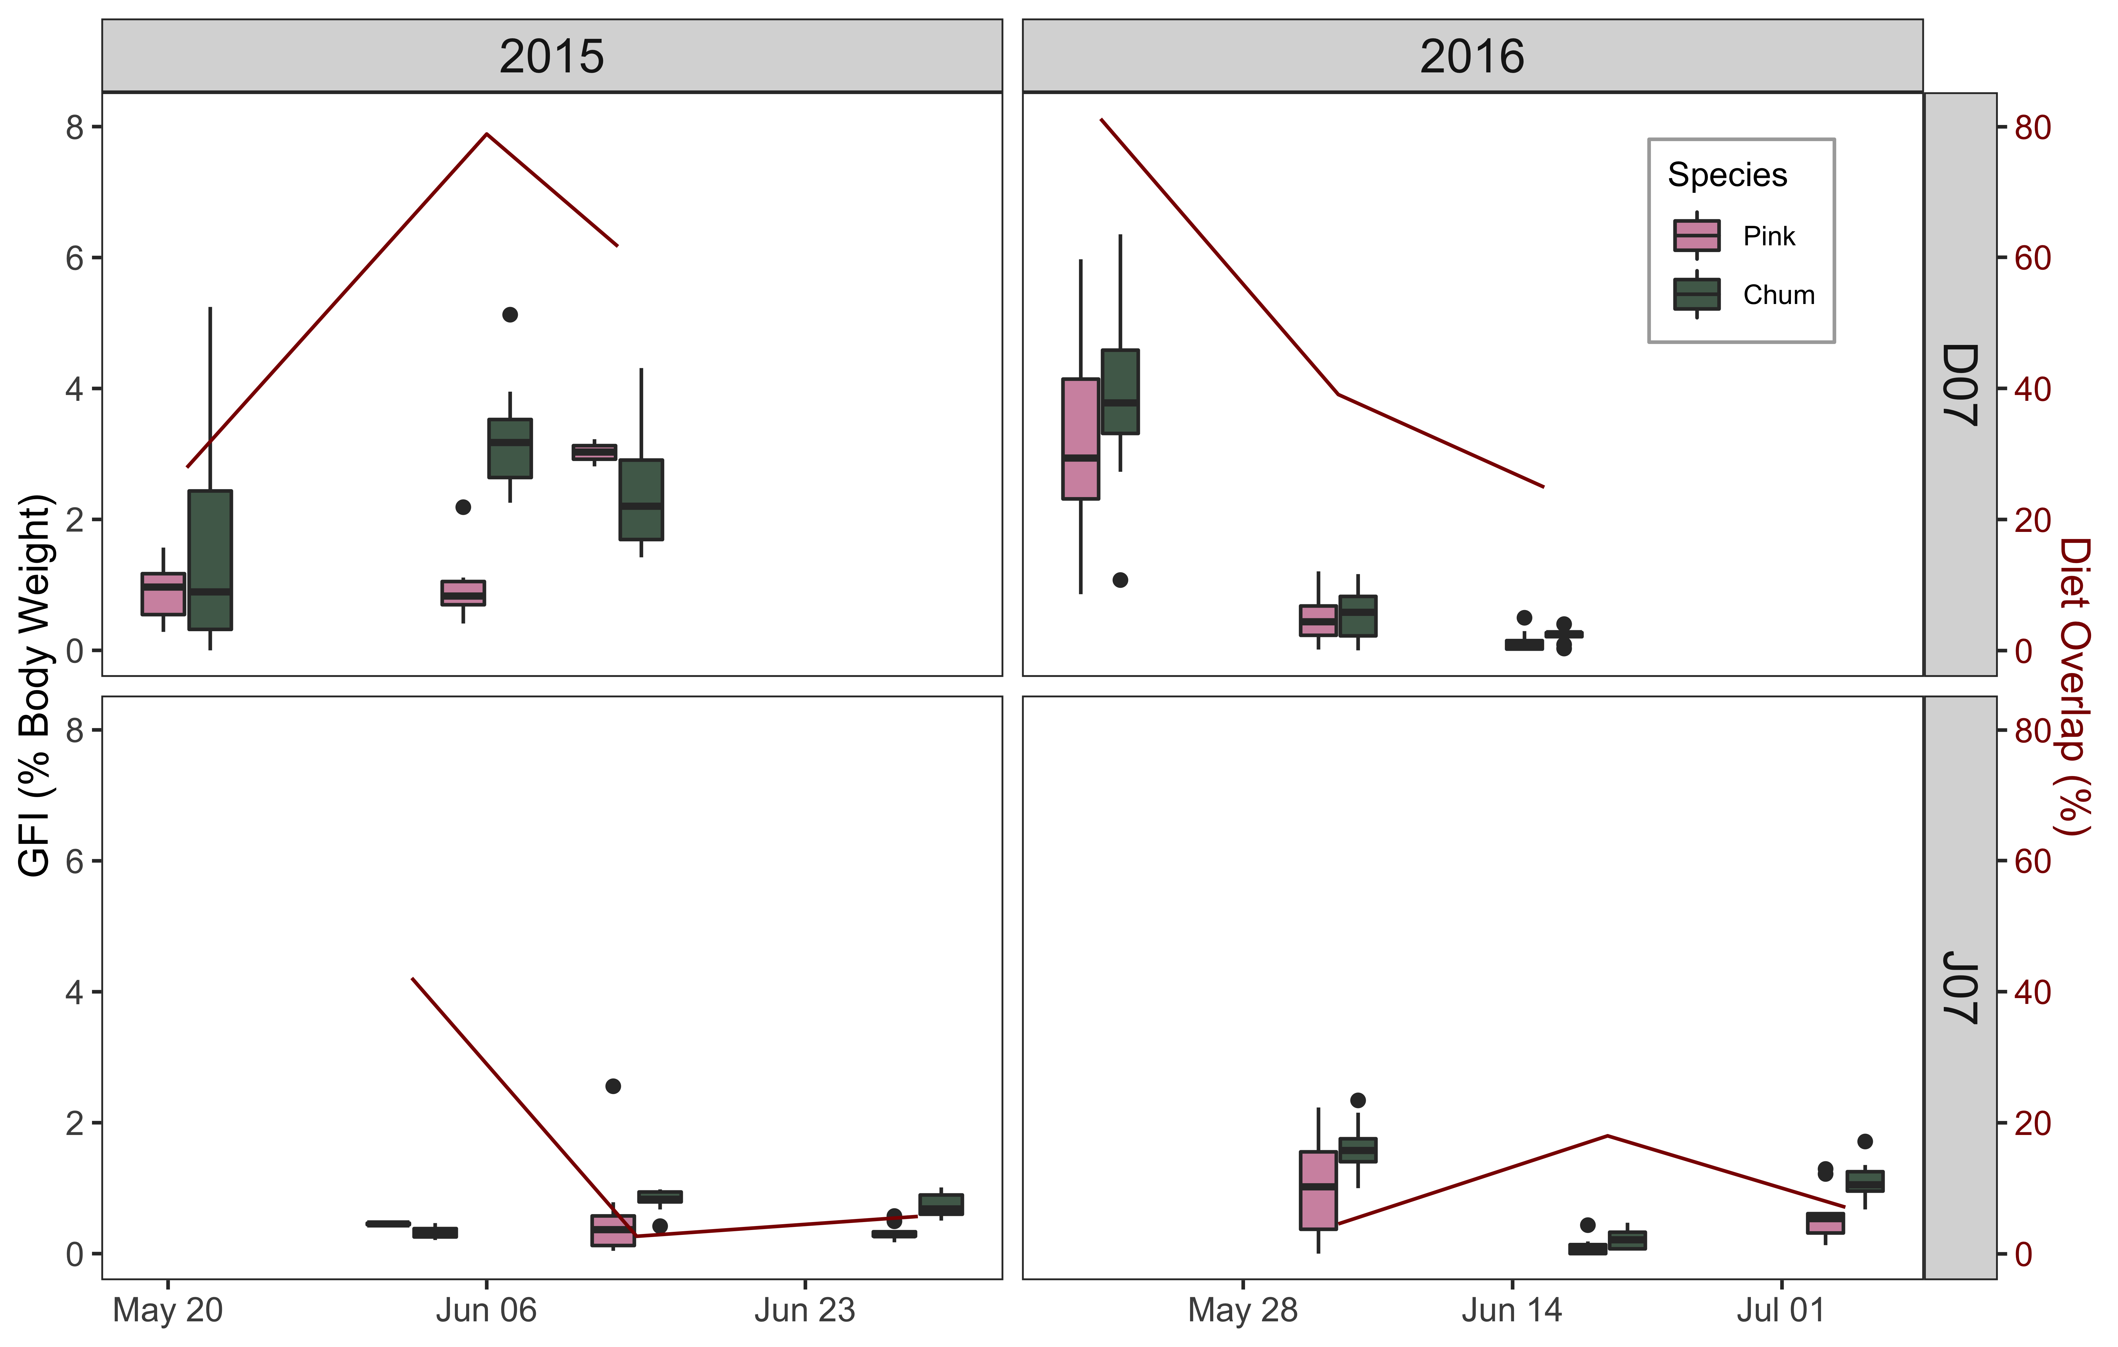

Figure 3.5 Gut fullness indices (GFI) for juvenile pink and chum salmon in DI-JS, 2015-2016, with overlap shown in dark red.

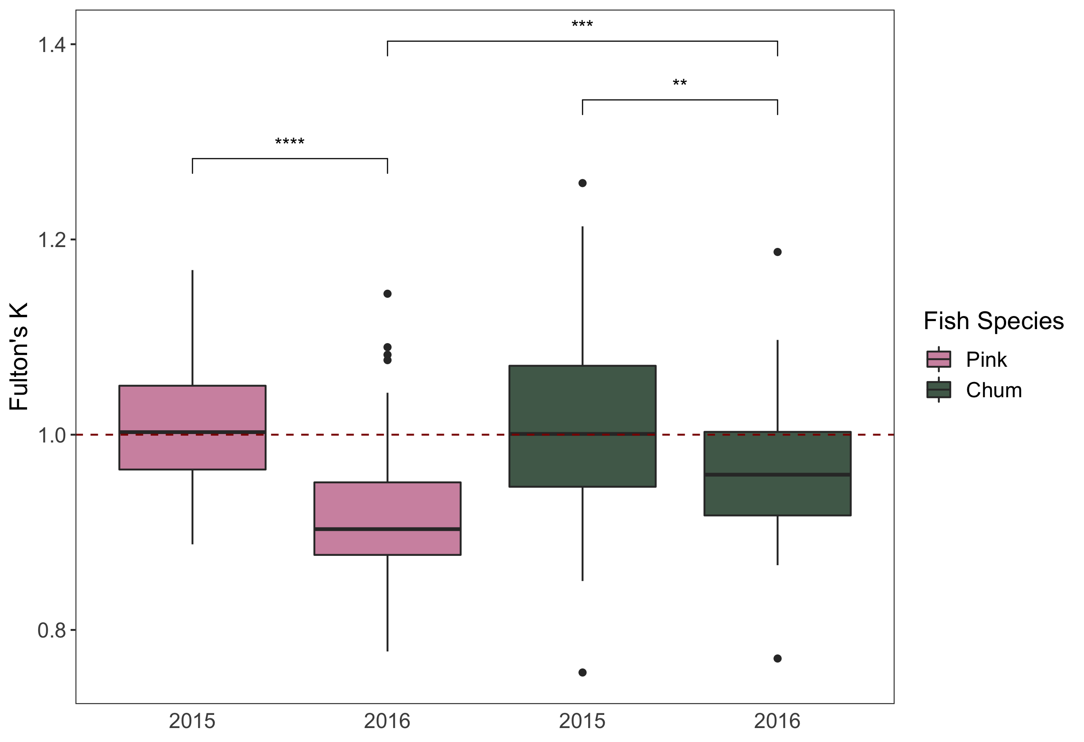

Figure 3.6 Juvenile salmon condition during outmigration in 2015-2016 for Discovery Islands and Johnstone Strait combined. The red dotted line separates fish in good condition (high weight relative to length, >1) and fish in poor condition (low weight relative to length, <1). Significant differences are indicated by ** p < 0.01, *** p < 0.001 and **** p < 0.0001 for species and years.

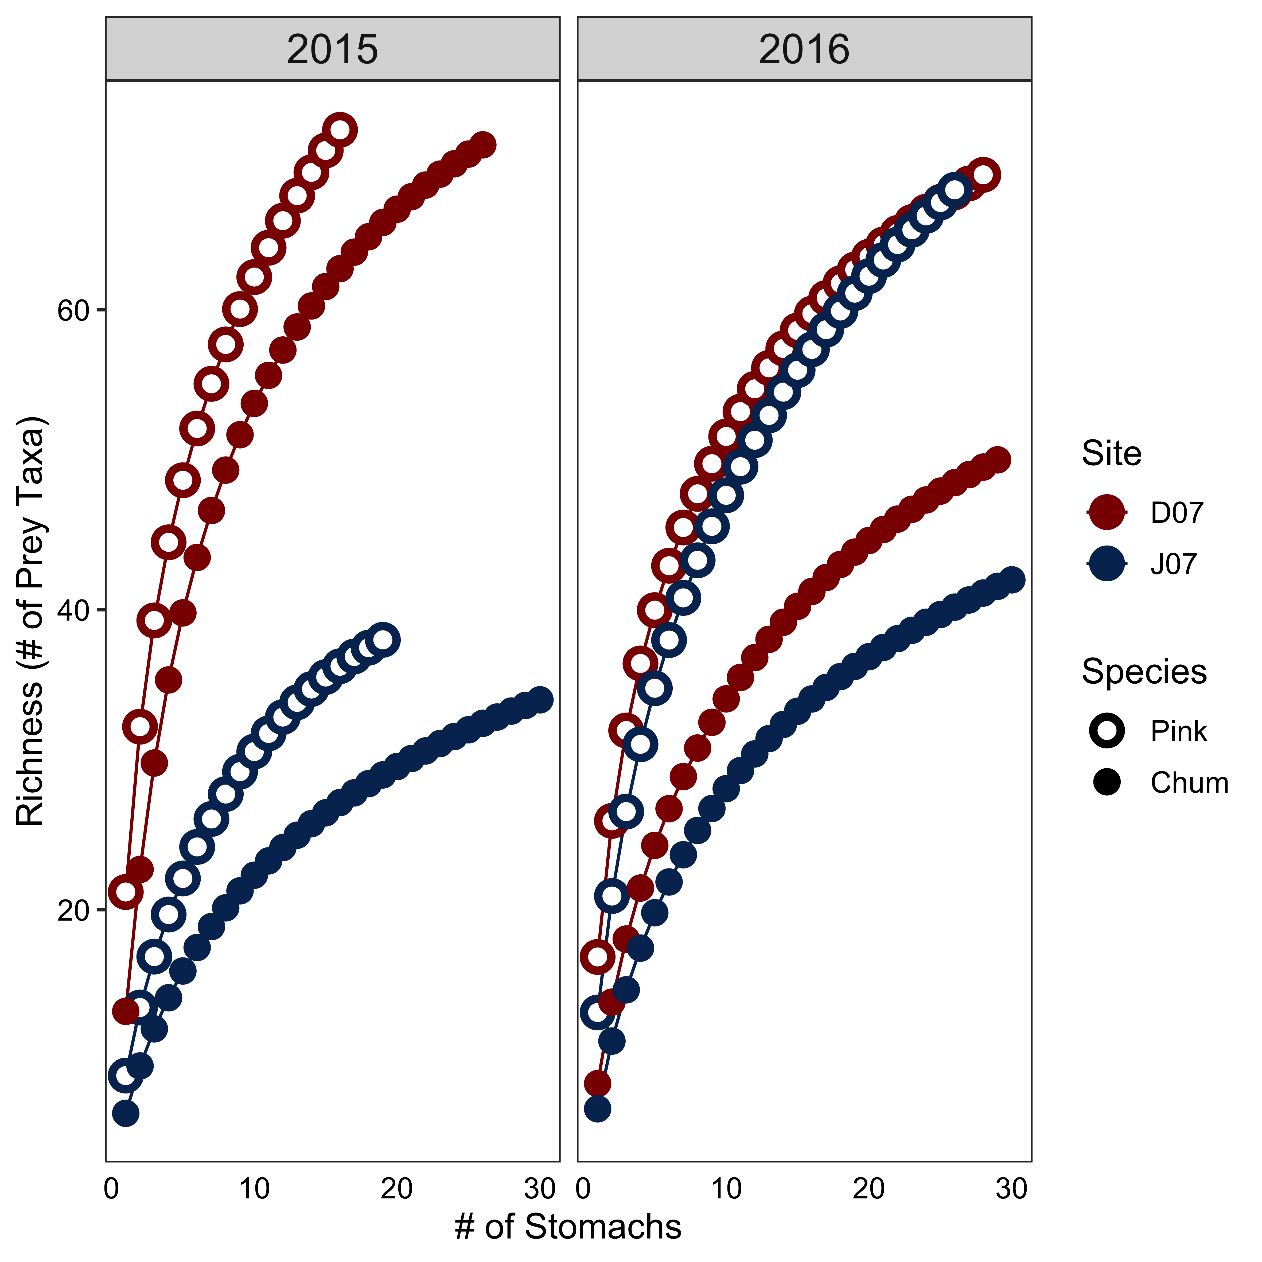

Figure 3.7 Cumulative prey curves for Discovery Islands (red) and Johnstone Strait (blue) juvenile pink (open circles) and chum salmon (closed circles) during 2015 and 2016.

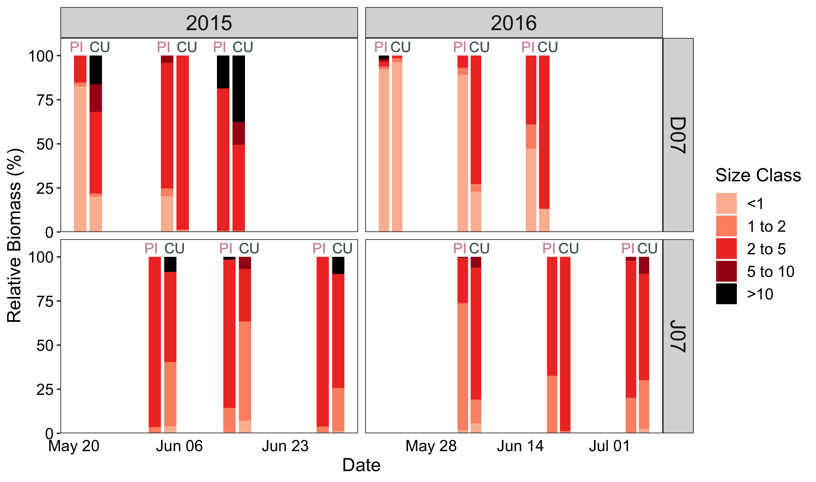

Figure 3.8 Juvenile salmon diet composition by prey size class (mm). Only digestive state 1 “fresh” zooplankton prey were included to calculate mean relative biomass by date and species. For each sampling event, “PI” is pink on the left, and “CU” is chum on the right.

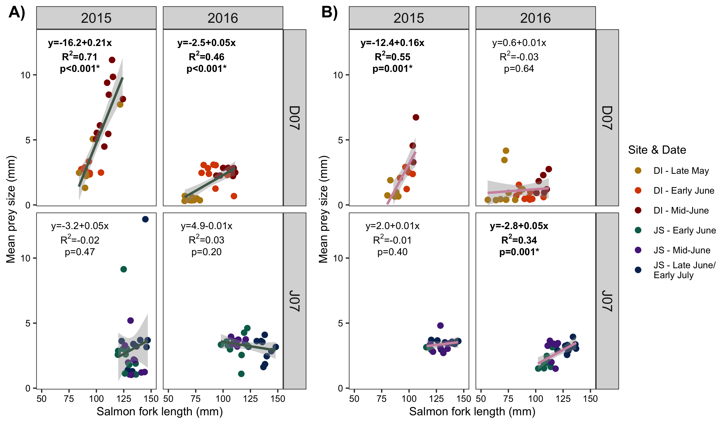

Figure 3.9 Predator and prey size relationships by species, date and region. A) chum salmon predator prey relationships, colored by sampling date (light is early season and dark is late season) and B) pink salmon predator prey relationships, colored by sampling date.

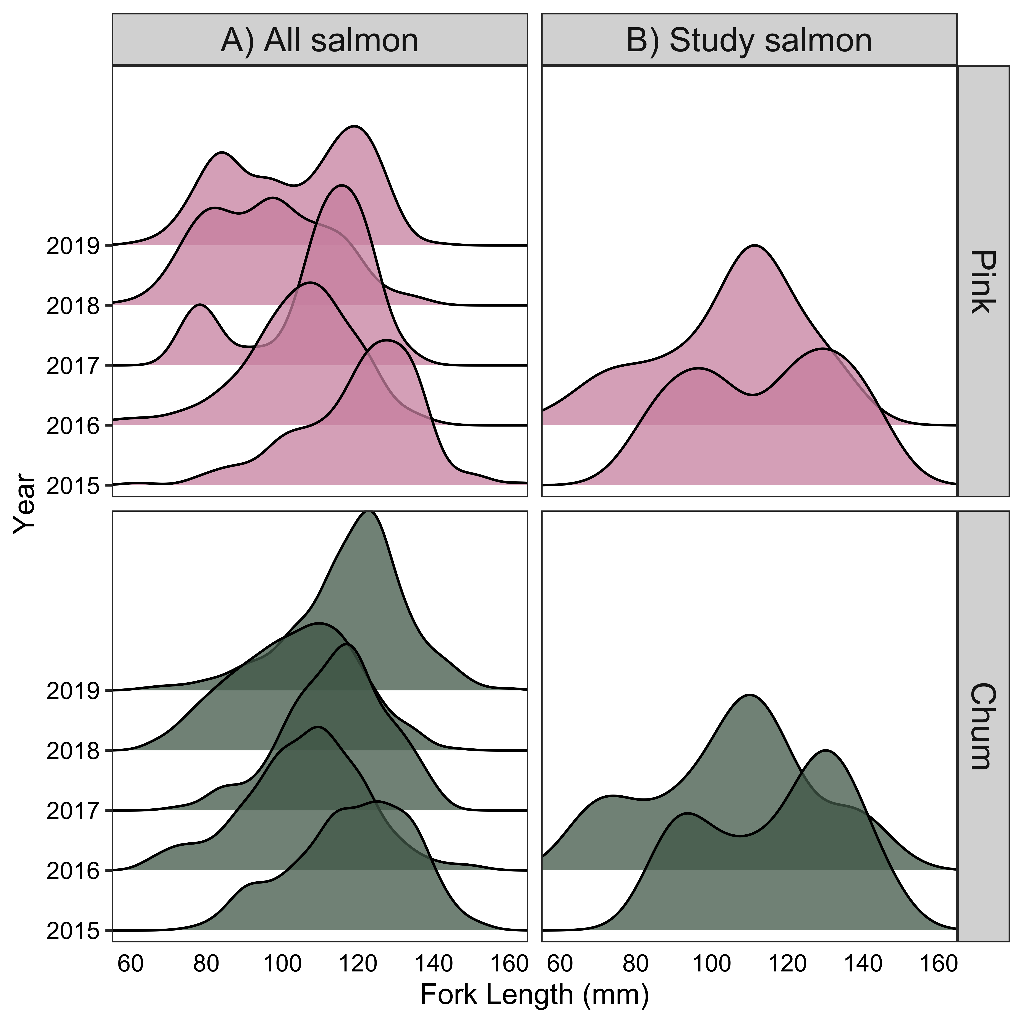

Figure 3.10 Fork length distributions of A) all pink and chum salmon collected throughout 2015-2019 and B) study salmon in 2015-2016.

## Conclusion

### Knowledge gap of juvenile pink and chum salmon competition

The health of salmon populations, as recognized keystone species in marine, freshwater and terrestrial environments, is related to the health and wellbeing of humans and ecosystems.

Pink and chum salmon are two species who are severely underappreciated, in the scientific and fisheries communities, despite their importance to ecosystems and in historical Indigenous diets. Sockeye, chinook and coho salmon have high economic value as well as conservation interest, whereas modern pink and chum salmon have received far less research and are less valued by fishers overall. However, pink and chum salmon are the most abundant and the least threatened of the salmon. Understanding the strategies that make them successful can provide important insights into the declines of other salmon, while their interactions with other salmon species may potentially be a contributing factor in those related declines. They bring a substantial amount of nutrients to terrestrial environments and apex predators and had incredibly high importance in pre-contact diets of Indigenous peoples such as the Haida (Haggan et al., 1999). This research aims to emphasize the ecological role of pink and chum salmon as co-migrators with the “iconic” sockeye salmon and immense value as study subjects for juvenile salmon biology. Pink and chum salmon foraging strategies provided insights into how adaptability during early migration is necessary for survival and hopefully this project can help to shift our perspectives.

### Diets of juvenile pink and chum salmon in contrasting foraging conditions

This study investigated juvenile pink and chum salmon diets and feeding strategies across the Discovery Islands and Johnstone Strait migration pathway from May–July in 2015 and 2016. Firstly, Chapter 2 analyzed the migration route during the peak outmigration (mid-June) in 2016 and identified extended areas of poor feeding conditions and prey availability where resource partitioning between salmon species occurred. Chapter 3 investigated seasonal and interannual variability of diets within the regions, which described varying species interactions depending on the zooplankton community succession. Specifically, both species had greater foraging success in 2015 compared to 2016, when the prey size in the Discovery Islands was larger later in the 2015 season, and in other areas and times, prey was small. Therefore, the spatial (Chapter 2) and temporal (Chapter 3) data chapters reflect juvenile pink and chum salmon diets shifting with prey availability, where species will differ in prey types to limit their competition (Figure 4.1). Pink salmon were more generalist feeders, with high diet diversity and variability, and frequently consumed calanoids throughout the two regions, as well as nearshore prey and meroplankton. Conversely, chum salmon relied heavily on the gelatinous prey available in both regions, except when prey switching from improved foraging conditions, when they consumed large crustaceans. Overall, this study found that species-specific foraging behaviour in response to competitive pressures persisted across time and space in poor feeding conditions; and under good feeding conditions, larger salmon benefitted in seasonally dynamic Discovery Islands and all salmon successfully foraged in the zooplankton front hot spot near Queen Charlotte Strait (Figure 4.1).

### Trophic interactions of pink and chum salmon during outmigration

The relationships between juvenile pink and chum salmon appear to fluctuate with the changing ocean conditions along their coastal outmigration. These species coexist by utilizing different strategies, either resource partitioning or complete trophic niche separation when food availability is low, and species consume the same resources when food is more plentiful. The separation of trophic niches for pink and chum salmon is a strategy to limit competition and share the environmental space to survive under challenging conditions in the early marine period. Pink salmon tended to consume the higher quality prey whenever possible, actively seeking out calanoids, even in the Discovery Islands where calanoids were rarer than in Johnstone Strait. Conversely, chum salmon in Johnstone Strait preyed upon lower quality jellyfish, however chum salmon have evolved strategies to benefit off this prey more than other salmonids. For example, chum salmon have larger, thicker stomachs and more pyloric caeca to aid in quick digestion, and thus, chum salmon may rely on an under-utilized niche to meet energy demands (Azuma, 1995).

The sympatric coevolution of Pacific salmonids led to 6 anadromous species with diverse life histories, feeding strategies and distributions, persisting today in spite of many challenges. Salmon species adapted behavioural and physiological differences to occupy distinct habitats, trophic niches or migration timing from one another, through evolutionary selection processes. The anadromous life cycle of salmon through complex habitats with cumulative stressors poses challenges to salmon scientists and conservationists aiming to understand these elusive species. Despite these logistical hurdles, Pacific salmon are well-studied overall, with researchers filling knowledge gaps and intellectual niches on each phase and aspect of salmon species life histories. Salmon provide unique case studies for investigating sympatric evolution and ecology of marine animals through dynamic areas and how species interactions shift with conditions encountered. This study demonstrated the tendency of chum salmon to fill the gelatinous predator niche under food limitation as early as the juvenile phase, with pink salmon relying on smaller zooplankton. One question to research in the future includes, where does this leave juvenile sockeye salmon? Sockeye salmon may compete with pink salmon in years of high abundance if occupying similar niches, distinct from chum, coho, chinook and steelhead, which may influence sockeye survival.

Furthermore, one theory that has not yet been explored, is that perhaps chum salmon are preying upon the easier to catch jellyfish while also benefiting off the jellyfish’s captured prey. In most of the chum salmon stomachs with jellyfish present in this study, calanoid prey, such as *Acartia longiremis*, were often inside the jellyfish, thereby increasing the quality of prey eaten. Future experiments can be done on chum salmon prey selection to determine under exactly what concentrations of jellyfish and calanoids will they consume which and determine if chum salmon actively select jellyfish that have calanoids inside their tentacles, using them as a capture system. While this has not yet been shown for calanoids, some hyperiid amphipods are found exclusively living commensally or parasitically on jellyfish and are consumed by salmon (Weil et al., 2020). Further research or meta-analyses should investigate pink and chum salmon diets under differing conditions, since previous work underappreciated the gelatinous prey of chum salmon, likely due to difficulty identifying soft-bodied prey, which was often classified as “other” (Graham, 2020).

The foraging strategies utilized by juvenile pink and chum, encompassing both generalist and specialist zooplankton consumption, indicate that these species can be used as ecosystem samplers to track ecosystem change. The juvenile salmon stomach fullness reflected the changes in prey availability and foraging opportunities during coastal outmigration, and diet composition gave more detailed information. Therefore, juvenile pink and chum salmon diets can be utilized to study the foraging conditions available to other species such as sockeye salmon or herring and find any hot spots and gauntlets. Both pink and chum salmon prey groups and quality of prey tended to match stomach fullness and fish condition, where small meroplankton or gelatinous prey indicated their poor feeding and conversely, large calanoid, euphausiid and chaetognath prey demonstrated improved conditions. Thus, future ecosystem modelling research should incorporate species-specific salmon diet data.

### Lessons and calls to action

In Indigenous worldviews, salmon are often seen as supernatural beings who provide us with teachings on how to be in a meaningful relationship with the world around us (CHN, 2011). It seems that the lessons to be learned from chum and pink salmon specifically, is to be adaptable and resilient, utilize strengths to better coexist with others, and be active in getting what we need. The entire life cycle of salmon is all about giving back to the next generations through spawning and sacrificing their lives to enhance natal habitats with energy they spent their lives gathering. Salmon hold a wealth of information that scientists are constantly trying to gain knowledge from, but reciprocity to that which sustains them is an important reminder to us to give back to salmon. For complex species who are up against human and environmental pressures at each life phase, the science is intertwined with management and we must save salmon to sustain our ecosystems.

Therefore, a potential recommendation to improve significantly poor feeding conditions in the Discovery Islands and Johnstone Strait regions is to focus on coastal habitat restoration. Special consideration should also be given to the pollution and open-net pen aquaculture in the region, where juvenile salmon are negatively affected by pollution and sea lice from fish farms. The impacts of plastic pollution on fish are still emerging in the literature, but this study found a relatively high occurrence of micro- and macro-plastic in juvenile salmon stomachs (Figure A.3). However, the negative effects of sea lice and pathogens such as piscine orthoreovirus (PRV) on juvenile salmon have been well documented (Morton et al., 2017), with increased parasite loads decreasing the foraging success of sockeye salmon (Godwin et al., 2017). Given that industry releases untreated effluent into salmon migration pathways and underreports sea lice data (Godwin et al., 2020; Price et al., 2013), continued research is required to quantify the impacts on the health of wild salmon. While this thesis study did not focus on sea lice, the findings did clearly demonstrate general food limitations of juvenile salmon in this region. Alternative to the costly and uncertain nature of restoration, one cost-effective method to protect salmon and habitats is to limit further damaging development projects and industry (Walsh et al., 2020).

Climate change will further exacerbate these impacts during every phase of the salmon life cycle. Therefore, if salmon stocks are to continue to survive into the future generations, intervention is urgently required to halt the cumulative pressures that provide critical barriers to salmon health. Since salmon must contend with stressors in both freshwater (droughts, high temperatures, dams, habitat loss, pollution) and the ocean, each phase of the life cycle is important for determining resilience in subsequent phases and understanding each phase is crucial for salmon management. As temperatures increase, the food web structure and salmon distribution and metabolic needs shift. Understanding the fundamental biology and ecology of salmonids is needed to help preserve the biodiversity and productivity of salmon stocks, for them to be resilient in a rapidly changing environment. Once we gain an understanding of what salmon require to survive through their arduous migrations, we can better predict how stocks may fluctuate and implement adaptive management strategies. In order to accomplish this gigantic task of amassing salmon knowledge into conservation action, collaboration across disciplines and groups is necessary to collate complex knowledge systems. Often, salmon are studied in isolated systems, with limited impact into preserving these species. Therefore, everyone should be engaged in salmon conservation, from citizens to policy makers. As salmon scientists, we have a responsibility to pass on what we know to the next generation and ease stressors salmon face so they may flourish and keep contributing to coastal ecosystems. Furthermore, major effort should be made to slow the rate of the changing climate, thus giving salmon more time to adapt.

In addition to preventing or reversing damaging conditions for juvenile salmon, there is also a need to improve survival and ease the competitive pressures that exist for salmon species. Another recommendation is to restore eelgrass nursery and foraging grounds as salmon habitats. Eelgrass habitats in this area have decreased over the past several decades (Cullis-Suzuki, 2007), and restoration would provide habitat for salmon and invertebrate prey, such as harpacticoids. Specifically, the area on Quadra Island near Heriot Bay docks, has had eelgrass beds decrease in size, biomass, and quality of eelgrass habitat (Cullis-Suzuki, 2007). Other areas in Discovery Islands and Johnstone Strait showed positive responses to restoration efforts, e.g., Campbell River and Salmon River (Levings & MacDonald, 1991; Pellett, 2010). This study revealed considerable amounts of harpacticoid copepods in the diets of pink salmon, as well as other invertebrates typically found in eelgrass habitats, such as gammarid amphipods. Another study from 2016, found juvenile pink and chum salmon in eelgrass habitats had richer diets and higher stomach fullness when compared to non-eelgrass habitats (unpublished data). Potential habitat restoration would also benefit species other than salmon, with eelgrass invertebrate communities supporting diverse fish assemblages with shelter and food (Chalifour et al., 2019). Furthermore, a study found that traditional harvesting methods utilized by the Kwakwaka’wakw peoples stimulated growth of healthy eelgrass, and restoration efforts should be co-developed with the Nations whose traditional territories encompass this part of the salmon migration route (Cullis-Suzuki, 2007). Traditional knowledge of the pre-colonization habitats would provide in-depth insights into the best locations to restore eelgrass habitats and other conservation efforts. Therefore, Indigenous sovereignty in this area would benefit both science and conservation, and lead to an increase in healthy systems that support salmon in this challenging food-limited area. Both salmon and eelgrass have shown phenomenal resilience and responses to restoration efforts, which provides a lot of hope for salmon, who continue to uphold the foundations of our society.

### Figures



Figure 4.1 Conceptual diagram of combined thesis results on juvenile salmon diet variability. Stratified surface conditions from the southern Discovery Islands (D07) are labelled as “Strat.” Mixed ocean conditions with poor feeding are represented by sites D09, D11, J06, J08, and J07. Whereas the good feeding conditions in mixed waters represented J02, northern Johnstone Strait. Diet overlap between species and predator-prey ratios revealed that size was an important factor in stratified conditions, large fish ate larger prey, and species separated niche under poor feeding. No species or size differences were found at the migration route terminus feeding hot spot.

# References

Agler, B. A., Ruggerone, G. T., Wilson, L. I., & Mueter, F. J. (2013). Historical growth of Bristol Bay and Yukon River, Alaska chum salmon (Oncorhynchus keta) in relation to climate and inter- and intraspecific competition. *Deep-Sea Research Part II: Topical Studies in Oceanography*, *94*, 165–177. https://doi.org/10.1016/j.dsr2.2013.03.028

Armstrong, J. L., Boldt, J. L., Cross, A. D., Moss, J. H., Davis, N. D., Myers, K. W., Walker, R. V., Beauchamp, D. A., & Haldorson, L. J. (2005). Distribution, size, and interannual, seasonal and diel food habits of northern Gulf of Alaska juvenile pink salmon, Oncorhynchus gorbuscha. *Deep-Sea Research Part II: Topical Studies in Oceanography*, *52*(1-2 SPEC. ISS.), 247–265. https://doi.org/10.1016/j.dsr2.2004.09.019

Asch, R. G., Stock, C. A., & Sarmiento, J. L. (2019). Climate change impacts on mismatches between phytoplankton blooms and fish spawning phenology. *Global Change Biology*, *25*(8), 2544–2559. https://doi.org/10.1111/gcb.14650

Atlas, W. I., Ban, N. C., Moore, J. W., Tuohy, A. M., Greening, S., Reid, A. J., Morven, N., White, E., Housty, W. G., Housty, J. A., Service, C. N., Greba, L., Harrison, S. A. M., Sharpe, C., Butts, K. I. R., Shepert, W. M., Sweeney-Bergen, E., Macintyre, D., Sloat, M. R., & Connors, K. (2020). *Indigenous Systems of Management for Culturally and Ecologically Resilient Pacific Salmon ( Oncorhynchus spp .) Fisheries*. *XX*(X), 1–19. https://doi.org/10.1093/biosci/biaa144

Azuma, T. (1995). Biological mechanisms enabling sympatry between salmonids with special reference to sockeye and chum salmon in oceanic waters. *Fisheries Research*, *24*(4), 291–300. https://doi.org/10.1016/0165-7836(95)00383-3

Bailey, J. E., Wing, B. L., & Mattson, C. R. (1975). Zooplankton abundance and feeding habits of fry of pink salmon, Oncorhynchus gorbuscha, and chum salmon, Oncorhynchus keta, in Traitors Cove, Alaska, with speculations on the carrying capacity of the area. *Fishery Bulletin*, *73*(4), 846–861.

Batten, S., Ruggerone, G. T., & Ortiz, I. (2018). Pink Salmon induce a trophic cascade in plankton populations in the southern Bering Sea and around the Aleutian Islands. *Fisheries Oceanography*, *27*(6), 548–559. https://doi.org/10.1111/fog.12276

Beacham, T. D. (1993). Competition between juvenile pink (Oncorpynchus gorbuscha) and chum salmon (Oncorhynchus keta) and its effect on growth and survival. *Canadian Journal of Zoology*, *71*(6), 1270–1274. https://doi.org/10.1139/z93-174

Beamish, R. J. (2017). What the past tells us about the future of Pacific salmon research. *Fish and Fisheries*, *18*(6), 1161–1175. https://doi.org/10.1111/faf.12231

Beamish, R. J., & Mahnken, C. (2001). A critical size and period hypothesis to explain natural regulation of salmon abundance and the linkage to climate and climate change. *Progress in Oceanography*, *49*(1–4), 423–437. https://doi.org/10.1016/S0079-6611(01)00034-9

Beamish, R. J., Mahnken, C., & Neville, C. M. (2004). Evidence That Reduced Early Marine Growth is Associated with Lower Marine Survival of Coho Salmon. *Transactions of the American Fisheries Society*, *133*(1), 26–33. https://doi.org/10.1577/t03-028

Beamish, R. J., Neville, C. M., Sweeting, R. M., & Lange, K. L. (2012). The synchronous failure of juvenile pacific salmon and herring production in the strait of georgia in 2007 and the poor return of sockeye salmon to the Fraser river in 2009. *Marine and Coastal Fisheries*, *4*(1), 403–414. https://doi.org/10.1080/19425120.2012.676607

Beamish, R. J., Pearsall, I. A., & Healey, M. C. (2003). A history of the research on the early marine life of Pacific salmon off Canada’s Pacific coast. *NPAFC Bulletin*, *3*(3), 1–40.

Beamish, R. J., Sweeting, R. M., Neville, C. M., & Lange, K. L. (2010). Competitive Interactions Between Pink Salmon and Other Juvenile Pacific Salmon in the Strait of Georgia. *NPAFC Doc. 1284*, *January*.

Boldt, J. L. (2001). *Ecology of juvenile pink salmon in the North Gulf of Alaska and Prince William Sound* [University of Alaska Fairbanks]. http://hdl.handle.net/11122/8602

Bollens, S. M., vanden Hooff, R., Butler, M., Cordell, J. R., & Frost, B. W. (2010). Feeding ecology of juvenile pacific salmon (oncorhynchus spp.) in a northeast pacific fjord: Diet, availability of zooplankton, selectivity for prey, and potential competition for prey resources. *Fishery Bulletin*, *108*(4), 393–407.

Bond, N. A., Cronin, M. F., Freeland, H., & Mantua, N. J. (2015). Causes and impacts of the 2014 warm anomaly in the NE Pacific. *Geophysical Research Letters*, *42*(9), 3414–3420. https://doi.org/10.1002/2015GL063306

Borja, A., Andersen, J. H., Arvanitidis, C. D., Basset, A., Buhl-Mortensen, L., Carvalho, S., Dafforn, K. A., Devlin, M. J., Escobar-Briones, E. G., Grenz, C., Harder, T., Katsanevakis, S., Liu, D., Metaxas, A., Morán, X. A. G., Newton, A., Piroddi, C., Pochon, X., Queirós, A. M., … Teixeira, H. (2020). Past and Future Grand Challenges in Marine Ecosystem Ecology. *Frontiers in Marine Science*, *7*(June). https://doi.org/10.3389/fmars.2020.00362

Brodeur, R. D. (1990). *A synthesis of the food habits and feeding ecology of salmonids in marine waters of the North Pacific*. *(INPFC Doc.) FRI*-*UW*-*9016*, 38 p. https://doi.org/FRI-UW-9016

Brodeur, R. D., Daly, E. A., Sturdevant, M. V., Miller, T. W., Moss, J. H., Thiess, M. E., Trudel, M., Weitkamp, L. A., Armstrong, J. L., & Norton, E. C. (2007). Regional comparisons of juvenile salmon feeding in coastal marine waters off the West Coast of North America. *American Fisheries Society Symposium*, *57*(February 2015), 183.

Brookson, C. B., Krkošek, M., Hunt, B. P. V., Johnson, B. T., Rogers, L. A., & Godwin, S. C. (2020). Differential infestation of juvenile Pacific salmon by parasitic sea lice in British Columbia , Canada. *Canadian Journal of Fisheries and Aquatic Sciences*, *9*, 1–9.

Cajete, G. (2018). Native Science and Sustaining Indigenous Communities. *Traditional Ecological Knowledge*, 15–26. https://doi.org/10.1017/9781108552998.003

Campbell, S. K., & Butler, V. L. (2010). Archaeological evidence for resilience of pacific northwest salmon populations and the socioecological system over the last ~7,500 years. *Ecology and Society*, *15*(1). https://doi.org/10.5751/es-03151-150117

Carothers, C., Sformo, T. L., Cotton, S., George, J. C., & Westley, P. A. H. (2019). Pacific salmon in the rapidly changing arctic: Exploring local knowledge and emerging fisheries in Utqiaġvik and Nuiqsut, Alaska. *Arctic*, *72*(3), 273–288. https://doi.org/10.14430/arctic68876

Chalifour, L., Scott, D. C., MacDuffee, M., Iacarella, J. C., Martin, T. G., & Baum, J. K. (2019). Habitat use by juvenile salmon, other migratory fish, and resident fish species underscores the importance of estuarine habitat mosaics. *Marine Ecology Progress Series*, *625*(September), 145–162. https://doi.org/10.3354/meps13064

Chase, J. M., & Leibold, M. A. (2003). Introduction: History, context, and purpose. In *Ecological Niches: Linking Classical and Contemporary Approaches* (pp. 1–18).

Chebanova, V. V., Frenkel, S. E., & Zelenikhina, G. S. (2018). Relation of feeding in juvenile chum salmon (Oncorhynchus keta) and pink salmon (o. gorbuscha) to abundance of zooplankton in coastal waters of the prostor bay (iturup island). *Journal of Ichthyology*, *58*(5), 741–750. https://doi.org/10.1134/s0032945218050041

Chipps, S. R., & Garvey, J. E. (2006). Assessment of Food Habits and Feeding Patterns. In C. S. Guy & M. J. Brown (Eds.), *Analysis and interpretation of inland fisheries data* (p. 42). American Fisheries Society.

CHN. (2011). *Haida Marine Traditional Knowledge Study Volume 1: Methods and Results Summary* (Vol. 1). papers3://publication/uuid/577CE3E4-BD6E-4E0F-9D34-B4389CDC1E2C

Choi, J. S., Jung, Y. J., Hong, N. H., Hong, S. H., & Park, J. W. (2018). Toxicological effects of irregularly shaped and spherical microplastics in a marine teleost, the sheepshead minnow (Cyprinodon variegatus). *Marine Pollution Bulletin*, *129*(1), 231–240. https://doi.org/10.1016/j.marpolbul.2018.02.039

Clarke, K. R., & Ainsworth, M. (1993). *A method of linking multivariate community structure to environmental variables*. *92*(i), 205–219.

Cohen, B. I. (2012). *The Uncertain Future of Fraser River Sockeye Volume 1 • The Sockeye Fishery* (Vol. 1, Issue October).

Collicutt, B., Juanes, F., & Dudas, S. E. (2019). Microplastics in juvenile Chinook salmon and their nearshore environments on the east coast of Vancouver Island. *Environmental Pollution*, *244*, 135–142. https://doi.org/10.1016/j.envpol.2018.09.137

Costalago, D., Forster, I., Nemcek, N., Neville, C. M., Perry, R. I., Young, K., & Hunt, B. P. V. (2020). Seasonal and spatial dynamics of the planktonic trophic biomarkers in the Strait of Georgia (northeast Pacific) and implications for fish. *Scientific Reports*, *10*(1), 1–12. https://doi.org/10.1038/s41598-020-65557-1

Cross, A. D., Beauchamp, D. A., Moss, J. H., & Myers, K. W. (2009). Interannual Variability in Early Marine Growth, Size-Selective Mortality, and Marine Survival for Prince William Sound Pink Salmon. *Marine and Coastal Fisheries*, *1*(1), 57–70. https://doi.org/10.1577/c08-005.1

Cross, A. D., Beauchamp, D. A., Myers, K. W., & Moss, J. H. (2008). Early Marine Growth of Pink Salmon in Prince William Sound and the Coastal Gulf of Alaska During Years of Low and High Survival. *Transactions of the American Fisheries Society*, *137*(3), 927–939. https://doi.org/10.1577/t07-015.1

Cullis-Suzuki, S. (2007). *Tending the meadows of the sea: Traditional Kwakwaka’wakw harvesting of Ts’áts’ayem (Zostera marina L.; Zosteraceae)* [University of Victoria]. http://hdl.handle.net/1828/293

Daly, E. A., Moss, J. H., Fergusson, E. A., & Debenham, C. (2019). Feeding ecology of salmon in eastern and central Gulf of Alaska. *Deep-Sea Research Part II: Topical Studies in Oceanography*, *165*(June), 329–339. https://doi.org/10.1016/j.dsr2.2019.06.006

Debertin, A. J., Irvine, J. R., Holt, C. A., Oka, G., & Trudel, M. (2017). Marine growth patterns of southern british columbia chum salmon explained by interactions between density-dependent competition and changing climate. *Canadian Journal of Fisheries and Aquatic Sciences*, *74*(7), 1077–1087. https://doi.org/10.1139/cjfas-2016-0265

DFO. (2018). Pre-Season Run Size Forecasts for Fraser River Sockeye (Oncorhynchus nerka) and Pink (Oncorhynchus gorbuscha) Salmon in 2019. In *Fraser Stock Assessment Technical Memo* (Issue February 2018).

DFO. (2020). *Salmon Southern BC Integrated Fisheries Management Plan*. http://www2.mar.dfo-mpo.gc.ca/fisheries/res/imp/2000grndfish.htm

Duffy, E. J., & Beauchamp, D. A. (2011). Rapid growth in the early marine period improves the marine survival of Chinook salmon (Oncorhynchus tshawytscha) in Puget Sound, Washington. *Canadian Journal of Fisheries and Aquatic Sciences*, *68*(2), 232–240. https://doi.org/10.1139/F10-144

Dufrêne, M., & Legendre, P. (1997). Species assemblages and indicator species: The need for a flexible asymmetrical approach. *Ecological Monographs*, *67*(3), 345–366. https://doi.org/10.2307/2963459

Edwards, M., & Richardson, A. J. (2003). Impact of climate change on marine pelagic phenology and trophic mismatch. *Nature*, *4030*(7002), 881.

Farley, E. V., Moss, J. H., & Beamish, R. J. (2007). A review of the critical size, critical period hypothesis for juvenile Pacific salmon. *North Pacific Anadromous Fish Commission Bulletin*, *4*, 311–317. http://scholar.google.com/scholar?hl=en&btnG=Search&q=intitle:A+Review+of+the+Critical+Size+,+Critical+Period+Hypothesis+for+Juvenile+Pacific+Salmon#1

Fergusson, E. A., Miller, T. W., McPhee, M. V., Fugate, C., & Schultz, H. (2020). Trophic responses of juvenile Pacific salmon to warm and cool periods within inside marine waters of Southeast Alaska. *Progress in Oceanography*, *186*(June).

Franks, P. J. S. (1992). Sink or swim: accumulation of biomass at fronts. *Marine Eco*, *82*, 1–12.

Garibaldi, A., & Turner, N. (2004). Cultural keystone species: Implications for ecological conservation and restoration. *Ecology and Society*, *9*(3). https://doi.org/10.5751/ES-00669-090301

Garner, K., & Parfitt, B. (2006). First Nations, Salmon Fisheries and the Rising Importance of Conservation. In *Report to the Pacific Fisheries Resource Conservation Council*.

Gill, A. B. (2003). The dynamics of prey choice in fish: The importance of prey size and satiation. *Journal of Fish Biology*, *63*(SUPPL. A), 105–116. https://doi.org/10.1111/j.1095-8649.2003.00214.x

Godin, J.-G. J. (1981). Daily patterns of feeding behavior, daily rations, and diets of juvenile pink salmon (oncorhynchus gorbuscha) in two marine bays of british columbia. *Canadian Journal of Fisheries and Aquatic Sciences*, *38*(1), 10–15. https://doi.org/10.1139/f81-002

Godwin, S. C., Krkošek, M., Reynolds, J. D., & Bateman, A. W. (2020). Bias in self-reported parasite data from the salmon farming industry. *Ecological Applications*, *0*(0), 1–10. https://doi.org/10.1002/eap.2226

Godwin, S. C., Krkošek, M., Reynolds, J. D., Rogers, L. A., & Dill, L. M. (2017). Heavy sea louse infection is associated with decreased stomach fullness in wild juvenile sockeye salmon. *Canadian Journal of Fisheries and Aquatic Science*, *1595*(December 2017), 1587–1595.

Graham, C. (2020). *A compilation and meta-analysis of salmon diet data from the North Pacific Ocean* [University of British Columbia]. https://doi.org/10.14288/1.0394116

Grant, S. C. H., MacDonald, B. L., & Winston, M. L. (2019). State of the Canadian Pacific Salmon: Responses to Changing Climate and Habitats. In *Canadian Technical Report of Fisheries and Aquatic Sciences 3332*.

Groot, C., & Margolis, L. (1991). *Pacific salmon life histories*. University of British Columbia Press.

Groot, C., Margolis, L., & Clarke, W. C. (1995). *Physiological Ecology of Pacific Salmon*. UBC Press.

Gulbransen, C. O. M. (2014). *Feeding in troubled waters: a comparative diet analysis of pink (Oncorhynchus gorbuscha) and chum (O. keta) salmon during their first months at sea in the Broughton Archipelago, British Columbia* [Simon Fraser University]. https://summit.sfu.ca/item/14264

Gustafson, R. G., Waples, R. S., Myers, J. M., Weitkamp, L. A., Bryant, G. J., Johnson, O. W., & Hard, J. J. (2007). Pacific Salmon Extinctions: Quantifying Lost and Remaining Diversity. *Conservation Biology*, *21*(4), 1009–1020. https://doi.org/10.1111/j.1523-1739.2007.00693.x

Haggan, N., Beattie, A., & Pauly, D. (1999). Back to the future: reconstructing the Hecate Strait ecosystem. *Fisheries Centre Research Resports*, *7*(3), 65-. http://fisheries.ubc.ca/sites/fisheries.ubc.ca/files/uploads/FCRR/FCRRsBetterQuality/7-3.pdf

Haggan, N., Turner, N., Carpenter, J., Jones, J. T., Mackie, Q., & Menzies, C. R. (2006). *12,000 years of change: Linking traditional and modern ecosystem science in the Pacific Northwest*.

Halffman, C. M., Potter, B. A., McKinney, H. J., Finney, B. P., Rodrigues, A. T., Yang, D. Y., & Kemp, B. M. (2015). Early human use of anadromous salmon in North America at 11,500 y ago. *Proceedings of the National Academy of Sciences of the United States of America*, *112*(40), 12344–12348. https://doi.org/10.1073/pnas.1509747112

Hammer, O., Harper, D. A. T., & Ryan, P. D. (2001). *Past: Paleontological statistics software package for education and data analysis* (p. 9). Palaeontologia Electronia. http://palaeo-electronica.org/2001_1/past/issue1_01.htm

Hardin, G. (1960). The Competitive Exclusion Principle. *Science*, *131*, 1292–1297.

Harrison, P. J., Fulton, J. D., Taylor, F. J. R., & Parsons, T. R. (1983). Review of the biological oceanography of the Strait of Georgia: pelagic environment. *Canadian Journal of Fisheries and Aquatic Sciences*, *40*(7), 1064–1094. https://doi.org/10.1139/f83-129

Healey, M. C. (1979). Detritus and Juvenile Salmon Production in the Nanaimo Estuary: II. Meiofauna Available as Food to Juvenile Chum Salmon (Oncorhynchus keta). *Journal of the Fisheries Research Board of Canada*, *36*(5), 497–503. https://doi.org/10.1139/f79-073

Healey, M. C. (1991). Diets and Feeding Rates of Juvenile Pink, Chum, and Sockeye Salmon in Hecate Strait, British Columbia. *Transactions of the American Fisheries Society*, *120*, 303–318. https://doi.org/10.1577/1548-8659(1991)120

Healey, M. C. (2009). Resilient salmon, resilient fisheries for British Columbia, Canada. *Ecology and Society*, *14*(1). https://doi.org/10.5751/ES-02619-140102

Herbold, B., Carlson, S. M., Henery, R., Johnson, R. C., Mantua, N. J., McClure, M., Moyle, P., & Sommer, T. (2018). Managing for salmon resilience in California’s variable and changing climate. *San Francisco Estuary and Watershed Science*, *16*(2). https://doi.org/10.15447/sfews.2018v16iss2art3

Honda, K., Kawakami, T., Suzuki, K., Watanabe, K., & Saito, T. (2017). Growth rate characteristics of juvenile chum salmon Oncorhynchus keta originating from the Pacific coast of Japan and reaching Konbumori, eastern Hokkaido. *Fisheries Science*, *83*(6), 987–996. https://doi.org/10.1007/s12562-017-1137-6

Hunt, B. P. V., Johnson, B. T., Godwin, S. C., Krkošek, M., Pakhomov, E. A., & Rogers, L. A. (2018). The Hakai Institute Juvenile Salmon Program : Early Life History Drivers of Marine Survival in Sockeye , Pink and Chum Salmon in British Columbia. *North Pacific Anadromous Fish Commission*, 14.

Jackson, J. M., Johnson, G. C., Dosser, H. V., & Ross, T. (2018). Warming From Recent Marine Heatwave Lingers in Deep British Columbia Fjord. *Geophysical Research Letters*, *45*(18), 9757–9764. https://doi.org/10.1029/2018GL078971

James, S. E. (2019). *Foraging Ecology of Juvenile Fraser River Sockeye Salmon Across Mixed and Stratified Regions of the Early Marine Migration* [University of British Columbia]. https://doi.org/10.1017/CBO9781107415324.004

James, S. E., Pakhomov, E. A., Mahara, N., & Hunt, B. P. V. (2020). Running the trophic gauntlet: Empirical support for reduced foraging success in juvenile salmon in tidally mixed coastal waters. *Fisheries Oceanography*, *29*(3), 0–2. https://doi.org/10.1111/fog.12471

Janetski, D. J., Chaloner, D. T., Tiegs, S. D., & Lamberti, G. A. (2009). Pacific salmon effects on stream ecosystems: A quantitative synthesis. *Oecologia*, *159*(3), 583–595. https://doi.org/10.1007/s00442-008-1249-x

Jeffrey, K. M., Côté, I. M., Irvine, J. R., & Reynolds, J. D. (2017). Changes in body size of Canadian Pacific salmon over six decades. *Canadian Journal of Fisheries and Aquatic Sciences*, *74*(2), 191–201. https://doi.org/10.1139/cjfas-2015-0600

Jenkins, E. S. (2011). *Trophic niche and foodweb dynamics within and among juvenile salmon species in years of contrasting ocean conditions* [University of Victoria]. http://dspace.library.uvic.ca/bitstream/handle/1828/3582/Jenkins_Erica_MSc_2011.pdf

Johnson, B. T., Gan, J., Godwin, S. C., Krkošek, M., & Hunt, B. P. V. (2019). Juvenile Salmon Migration Observations in the Discovery Islands and Johnstone Strait in 2018 Compared to 2015–2017. *Technical Report*, *15*, 31–39. https://doi.org/10.23849/npafctr15/31.39.

Johnson, B. T., Gan, J., Janusson, C. V, & Hunt, B. P. V. (2018). Juvenile Salmon Migration Dynamics in the Discovery Islands and Johnstone Strait. *North Pacific Anadromous Fish Commission*, *April*, 10. http://www.npafc.org

Johnson, S. P., & Schindler, D. E. (2009). Trophic ecology of Pacific salmon (Oncorhynchus spp.) in the ocean: A synthesis of stable isotope research. *Ecological Research*, *24*(4), 855–863. https://doi.org/10.1007/s11284-008-0559-0

Jones, R. E., Petrell, R. J., & Pauly, D. (1999). Using modified length-weight relationships to assess the condition of fish. *Aquacultural Engineering*, *20*(4), 261–276. https://doi.org/10.1016/S0144-8609(99)00020-5

Journey, M. L., Trudel, M., Young, G., & Beckman, B. R. (2018). Evidence for depressed growth of juvenile Pacific salmon (Oncorhynchus) in Johnstone and Queen Charlotte Straits, British Columbia. *Fisheries Oceanography*, *27*(2), 174–183. https://doi.org/10.1111/fog.12243

Kaga, T., Sato, S., Azumaya, T., Davis, N. D., & Fukuwaka, M. (2013). Lipid content of chum salmon oncorhynchus keta affected by pink salmon O. Gorbuscha abundance in the central Bering Sea. *Marine Ecology Progress Series*, *478*, 211–221. https://doi.org/10.3354/meps10179

Keppel, G., & Wickens, T. D. (2004). *Design and Analysis: A Researcher’s Handbook*. Pearson Prentice Hall.

Khangaonkar, T., Long, W., & Xu, W. (2017). Assessment of circulation and inter-basin transport in the Salish Sea including Johnstone Strait and Discovery Islands pathways. *Ocean Modelling*, *109*, 11–32. https://doi.org/10.1016/j.ocemod.2016.11.004

Kimmerer, R. W. (2017). Learning the Grammar of Animacy. *Anthropology of Consciousness*, *28*(2), 128–134. https://doi.org/10.1111/anoc.12081

Kovach, R. P., Joyce, J. E., Echave, J. D., Lindberg, M. S., & Tallmon, D. A. (2013). Earlier Migration Timing, Decreasing Phenotypic Variation, and Biocomplexity in Multiple Salmonid Species. *PLoS ONE*, *8*(1). https://doi.org/10.1371/journal.pone.0053807

Krebs, C. J. (2013). Niche measures and resource preferences. In *Ecological Methodology* (pp. 597–651).

Krkošek, M., Conners, B. M., Ford, H., Peacock, S. J., Mages, P., Ford, J. S., Morton, A., Volpe, J. P., Hilborn, R., Dill, L. M., & Lewis, M. A. (2011). Fish farms, parasites, and predators: implications for salmon population dynamics. *Ecological Applications*, *21*(3), 897–914.

Landingham, J. H., Sturdevant, M. V., & Brodeur, R. D. (1998). Feeding habits of juvenile Pacific salmon in marine waters of southeastern Alaska and northern British Columbia. *Fishery Bulletin*, *96*(2), 285–302.

LeBrasseur, R. J., & Parker, R. R. (1964). Growth Rate of Central British Columbia Pink Salmon (Oncorhynchus gorbuscha). *Journal of the Fisheries Research Board of Canada*, *21*(5), 1101–1128. https://doi.org/10.1139/f64-100

Lepofsky, D., & Caldwell, M. (2013). Indigenous marine resource management on the northwest coast of North America. *Ecological Processes*, *2*(1), 1–13. https://doi.org/10.1186/2192-1709-2-12

Levings, C. (2016). *Ecology of salmonids in estuaries around the world: adaptations, habitats, and conservation*. University of British Columbia Press.

Levings, C., & MacDonald, J. S. (1991). Rehabilitation of Estuarine Fish Habitat at Campbell River. *American Fisheries Society Symposium*, *10*, 176–190.

Litz, M. N. C., Miller, J. A., Copeman, L. A., Teel, D. J., Weitkamp, L. A., Daly, E. A., & Claiborne, A. M. (2017). Ontogenetic shifts in the diets of juvenile Chinook Salmon: new insight from stable isotopes and fatty acids. *Environmental Biology of Fishes*, *100*(4), 337–360. https://doi.org/10.1007/s10641-016-0542-5

Mackas, D. L., Batten, S., & Trudel, M. (2007). Effects on zooplankton of a warmer ocean: Recent evidence from the Northeast Pacific. *Progress in Oceanography*, *75*(2), 223–252. https://doi.org/10.1016/j.pocean.2007.08.010

Mackas, D. L., Galbraith, M. D., Faust, D., Masson, D., Young, K., Shaw, W., Romaine, S., Trudel, M., Dower, J., Campbell, R., Sastri, A. R., Bornhold Pechter, E. A., Pakhomov, E. A., & El-Sabaawi, R. (2013). Zooplankton time series from the strait of georgia: Results from year-round sampling at deep water locations, 1990-2010. *Progress in Oceanography*, *115*, 129–159. https://doi.org/10.1016/j.pocean.2013.05.019

Mackas, D. L., Thomson, R. E., & Galbraith, M. D. (2001). Changes in the zooplankton community of the British Columbia continental margin, 1985-1999, and their covariation with oceanographic conditions. *Canadian Journal of Fisheries and Aquatic Sciences*, *58*(4), 685–702. https://search.proquest.com/docview/219273927?pq-origsite=summon&accountid=14656

Magnhagen, C. (1988). Predation Risk and Foraging in Juvenile Pink (Oncorhynchus gorbuscha) and Chum Salmon (O. keta). *Canadian Journal of Fisheries and Aquatic Science*, *45*, 0–4.

Mahara, N. (2018). *Zooplankton Community Composition Across a Range of Productivity Regimes in Coastal British Columbia* [University of British Columbia]. https://dx.doi.org/10.14288/1.0367779

Mahara, N., Pakhomov, E. A., Dosser, H. V., & Hunt, B. P. V. (2021). How zooplankton communities are shaped in a complex and dynamic coastal system with strong tidal influence. *Estuarine, Coastal and Shelf Science*, *249*(October 2020), 107103. https://doi.org/10.1016/j.ecss.2020.107103

Mahara, N., Pakhomov, E. A., Jackson, J. M., & Hunt, B. P. V. (2019). Seasonal zooplankton development in a temperate semi-enclosed basin: Two years with different spring bloom timing. *Journal of Plankton Research*, *41*(3), 309–328. https://doi.org/10.1093/plankt/fbz016

Malick, M. J., & Cox, S. P. (2016). Regional-scale declines in productivity of pink and chum salmon stocks in western North America. *PLoS ONE*, *11*(1), 1–23. https://doi.org/10.1371/journal.pone.0146009

Malick, M. J., Cox, S. P., Mueter, F. J., & Peterman, R. M. (2015). Linking phytoplankton phenology to salmon productivity along a north-south gradient in the Northeast Pacific Ocean. *Canadian Journal of Fisheries and Aquatic Sciences*, *72*(5), 697–708. https://doi.org/10.1139/cjfas-2014-0298

Malick, M. J., Haldorson, L. J., Piccolo, J. J., & Boldt, J. L. (2011). Growth and survival in relation to body size of juvenile pink salmon in the Northern Gulf of Alaska. *Marine and Coastal Fisheries*, *3*(1), 261–270. https://doi.org/10.1080/19425120.2011.593467

Manzer, J. I. (1969). Stomach Contents of Juvenile Pacific Salmon in Chatham Sound and Adjacent Waters. *Fisheries Research Board of Canada*, *26*, 2219–2223.

Marushka, L., Kenny, T. A., Batal, M., Cheung, W. W. L., Fediuk, K., Golden, C. D., Salomon, A. K., Sadik, T., Weatherdon, L. V., & Chan, H. M. (2019). Potential impacts of climate-related decline of seafood harvest on nutritional status of coastal First Nations in British Columbia, Canada. *PLoS ONE*, *14*(2), 1–24. https://doi.org/10.1371/journal.pone.0211473

McKinnell, S., Curchitser, E., Groot, K., Kaeriyama, M., & Trudel, M. (2014). Oceanic and atmospheric extremes motivate a new hypothesis for variable marine survival of Fraser River sockeye salmon. *Fisheries Oceanography*, *23*(4), 322–341. https://doi.org/10.1111/fog.12063

McQueen, D., & Ware, D. M. (2006). Handbook of Physical, Chemical, Phytoplankton, and Zooplankton Data from Hecate Strait, Dixon Entrance, Goose Island Bank and Queen Charlotte Sound. *Canadian Data Report of Fisheries and Aquatic Sciences*, 133. http://skeenasalmonprogram.ca/libraryfiles/lib_236.pdf

Miller, S. E., Adkison, M., & Haldorson, L. J. (2012). Relationship of water column stability to the growth, condition, and survival of pink salmon (Oncorhynchus gorbuscha) in the northern coastal gulf of alaska and prince william sound. *Canadian Journal of Fisheries and Aquatic Sciences*, *69*(5), 955–969. https://doi.org/10.1139/F2012-031

Minicucci, T. J. (2018). *Determining the effects of Asian pink and chum salmon on western Alaska chum salmon growth* [University of Alaska Fairbanks]. http://hdl.handle.net/11122/9679

Montgomery, D. R. (2000). Coevolution of the Pacific salmon and Pacific Rim topography. *Geology*, *28*(12), 1107–1110.

Morita, K., & Fukuwaka, M. (2020). Intra- and interspecific density-dependent growth and maturation of Pacific salmon in the Bering Sea. *Ecological Research*, *35*(1), 106–112. https://doi.org/10.1111/1440-1703.12065

Morton, A., Routledge, R. D., Hrushowy, S., Kibenge, M., & Kibenge, F. (2017). The effect of exposure to farmed salmon on piscine orthoreovirus infection and fitness in wild Pacific salmon in British Columbia , Canada. *PLoS ONE*, 1–18.

Moss, J. H., & Beauchamp, D. A. (2007). Functional response of juvenile pink and chum salmon: Effects of consumer size and two types of zooplankton prey. *Journal of Fish Biology*, *70*(2), 610–622. https://doi.org/10.1111/j.1095-8649.2007.01340.x

Moss, J. H., Beauchamp, D. A., Cross, A. D., Myers, K. W., Farley, E. V., Murphy, J. M., & Helle, J. H. (2005). Evidence for Size-Selective Mortality after the First Summer of Ocean Growth by Pink Salmon. *Transactions of the American Fisheries Society*, *134*(5), 1313–1322. https://doi.org/10.1577/t05-054.1

Moss, J. H., Murphy, J. M., Farley, E. V., Eisner, L. B., & Andrews, A. G. (2009). Juvenile Pink and Chum Salmon Distribution, Diet, and Growth in the Northern Bering and Chukchi Seas. *North Pacific Anadromous Fish Commission Bulletin*, *5*(5), 191–196.

Mueter, F. J., Pyper, B. J., & Peterman, R. M. (2005). Relationships between Coastal Ocean Conditions and Survival Rates of Northeast Pacific Salmon at Multiple Lags. *Transactions of the American Fisheries Society*, *134*(1), 105–119. https://doi.org/10.1577/t-04-033.1

Nagata, M., Ando, D., Fujiwara, M., Miyakoshi, Y., Sawada, M., Shimada, H., & Asami, H. (2007). A Shift in Pink Salmon Dominance in the Okhotsk Sea of Hokkaido in Relation to Coastal Environments during Early Sea Life. *North Pacific Anadromous Fish Commission*, *Bulletin N*(4), 237–249.

Newell, D. (1993). *Tangled Webs of History: Indians and the Law in Canada’s Pacific Coast Fisheries*. University of Toronto Press.

Nielsen, J. L., Ruggerone, G. T., & Zimmerman, C. E. (2013). Adaptive strategies and life history characteristics in a warming climate: Salmon in the Arctic? In *Environmental Biology of Fishes*. https://doi.org/10.1007/s10641-012-0082-6

NRC. (1996). *Upstream: Salmon and Society in the Pacific Northwest*. National Research Council. https://doi.org/10.17226/4976

Oke, K. B., Cunningham, C. J., Quinn, T. P., & Hendry, A. P. (2019). Independent lineages in a common environment: the roles of determinism and contingency in shaping the migration timing of even- versus odd-year pink salmon over broad spatial and temporal scales. *Ecology Letters*, *22*(10), 1547–1556. https://doi.org/10.1111/ele.13337

Oksanen, J., Guillaume Blanchet, F., Friendly, M., Kindt, R., Legendre, P., McGlinn, D., Minchin, P. R., O’Hara, R. B., Simpson, G. L., Solymos, P., Stevens, M. H. H., Szoecs, E., & Wagner, H. (2019). *vegan: Community Ecology Package*. R package version 2.5-6. https://cran.r-project.org/web/packages/vegan/index.html

Orsi, J. A., Wertheimer, A. C., Sturdevant, M. V., Fergusson, E. A., Mortensen, D. G., & Wing, B. L. (2004). Juvenile chum salmon consumption of zooplankton in marine waters of southeastern Alaska: A bioenergetics approach to implications of hatchery stock interactions. *Reviews in Fish Biology and Fisheries*, *14*(3), 335–359. https://doi.org/10.1007/s11160-004-3813-8

Osgood, G. J., Kennedy, L. A., Holden, J. J., Hertz, E., McKinnell, S., & Juanes, F. (2016). Historical diets of forage fish and juvenile pacific salmon in the strait of Georgia, 1966-1968. *Marine and Coastal Fisheries*, *8*(1), 580–594. https://doi.org/10.1080/19425120.2016.1223231

Pearsall, I. A. (2008). *Broughton Archipelago: A State of Knowledge - 2008*. 651. http://www.llbc.leg.bc.ca/public/PubDocs/bcdocs/438283/BroughtonStateofKnowledgeReport.pdf

Pearson, W. H., Deriso, R. B., Elston, R. A., Hook, S. E., Parker, K. R., & Anderson, J. W. (2012). Hypotheses concerning the decline and poor recovery of Pacific herring in Prince William Sound, Alaska. *Reviews in Fish Biology and Fisheries*, *22*(1), 95–135. https://doi.org/10.1007/s11160-011-9225-7

Pellett, K. (2010). *Salmon River watershed enrichment for fish habitat restoration*.

Perry, R. I., Dilke, B. R., & Parsons, T. R. (1983). Tidal mixing and summer plankton distributions in Hecate Strait, British Columbia (Queens Charlotte Islands). *Canadian Journal of Fisheries and Aquatic Sciences*, *21*(4), 871–887.

Perry, R. I., Hargreaves, N. B., Waddell, B. J., & Mackas, D. L. (1996). Spatial variations in feeding and condition of juvenile pink and chum salmon off Vancouver Island, British Columbia. *Fisheries Oceanography*, *5*(2), 73–88. https://doi.org/10.1111/j.1365-2419.1996.tb00107.x

Price, M. H. H., Morton, A., Eriksson, J. G., & Volpe, J. P. (2013). Fish Processing Facilities: New Challenge to Marine Biosecurity in Canada. *Journal of Aquatic Animal Health*, 290–294. https://doi.org/10.1080/08997659.2013.847871

Quinn, T. P. (2018). *The behaviour and ecology of Pacific salmon and trout* (Second). University of Washington Press.

R Core Team. (2020). *R: A Language and Environment for Statistical Computing*. R Foundation for Statistical Computing. Vienna, Austria. https://www.r-project.org/

Reid, A. J. (2020). *Fish – People – Place: Interweaving Knowledges to Elucidate Pacific Salmon Fate* [Carleton University]. https://doi.org/10.22215/etd/2020-14221

Ruggerone, G. T., & Irvine, J. R. (2018). Numbers and Biomass of Natural- and Hatchery-Origin Pink Salmon, Chum Salmon, and Sockeye Salmon in the North Pacific Ocean, 1925–2015. *Marine and Coastal Fisheries*, *10*(2), 152–168. https://doi.org/10.1002/mcf2.10023

Ruggerone, G. T., & Nielsen, J. L. (2004). Evidence for competitive dominance of Pink salmon (Oncorhynchus gorbuscha) over other Salmonids in the North Pacific Ocean. *Reviews in Fish Biology and Fisheries*, *14*(3), 371–390. https://doi.org/10.1007/s11160-004-6927-0

Ruggerone, G. T., Springer, A. M., Shaul, L. D., & van Vliet, G. B. (2019). Unprecedented biennial pattern of birth and mortality in an endangered apex predator, the southern resident killer whale, in the eastern North Pacific Ocean. *Marine Ecology Progress Series*, *608*(1), 291–296. https://doi.org/10.3354/meps12835

Saito, T., Shimizu, I., Seki, J., & Nagasawa, K. (2009). Relationship between zooplankton abundance and the early marine life history of juvenile chum salmon Oncorhynchus keta in eastern Hokkaido, Japan. *Fisheries Science*, *75*(2), 303–316. https://doi.org/10.1007/s12562-008-0040-6

SARA. (2021). *Species at risk public registry*. https://species-registry.canada.ca/index-en.html#/species?sortBy=commonNameSort&sortDirection=asc&pageSize=10&keywords=oncorhynchus

Schindler, D. E., Scheuerell, M. D., Moore, J. W., Gende, S. M., Francis, T. B., & Palen, W. J. (2003). Pacific Salmon and the Ecology of Coastal Ecosystems. *Frontiers in Ecology and the Environment*, *1*(1), 31. https://doi.org/10.2307/3867962

Schweigert, J. F., Thompson, M., Fort, C., Hay, D. E., Therriault, T. W., & Brown, L. N. (2013). Factors linking Pacific herring (Clupea pallasi) productivity and the spring plankton bloom in the Strait of Georgia, British Columbia, Canada. *Progress in Oceanography*, *115*, 103–110. https://doi.org/10.1016/j.pocean.2013.05.017

Springer, A. M., Van Vliet, G. B., Bool, N., Crowley, M., Fullagar, P., Lea, M. A., Monash, R., Price, C., Vertigan, C., & Woehler, E. J. (2018). Transhemispheric ecosystem disservices of pink salmon in a Pacific Ocean macrosystem. *Proceedings of the National Academy of Sciences of the United States of America*, *115*(22), E5038–E5045. https://doi.org/10.1073/pnas.1720577115

Stearley, R. F., & Smith, G. R. (1993). Phylogeny of the Pacific Trouts and Salmons (Oncorhynchus) and Genera of the Family Salmonidae. *Transactions of the American Fisheries Society*, *122*, 1–33.

Sturdevant, M. V., Fergusson, E. A., Hillgruber, N., Reese, C., Orsi, J. A., Focht, R., Wertheimer, A. C., & Smoker, W. (2012). Lack of trophic competition among wild and hatchery juvenile chum salmon during early marine residence in Taku Inlet, Southeast Alaska. *Environmental Biology of Fishes*, *94*(1), 101–116. https://doi.org/10.1007/s10641-011-9899-7

Sturdevant, M. V., Fergusson, E. A., Orsi, J. A., & Wertheimer, A. C. (2002). Diel Feeding of Juvenile Pink, Chum, and Coho Salmon in Icy Strait, Southeastern Alaska, May–September 2001. *North Pacific Anadromous Fish Commission*.

Sturdevant, M. V., Fergusson, E. A., Orsi, J. A., & Wertheimer, A. C. (2004). Diel feeding and gastric evacuation of juvenile pink and chum salmon in Icy Strait, southeastern Alaska, May--September 2001. *North Pacific Anadromous Fish Commission Technical Report*, *5*(5), 107–109.

Tadokoro, K., Ishida, Y., Davis, N. D., Ueyanagi, S., & Sugimoto, T. (1996). Change in chum salmon (Oncorhynchus keta) stomach contents associated with fluctuation of pink salmon (O. gorbuscha) abundance in the central subarctic Pacific and Bering Sea. *Fisheries Oceanography*, *5*(2), 89–99. https://doi.org/10.1111/j.1365-2419.1996.tb00108.x

Thomson, R. E. (1976). Tidal Currents and Estuarine-Type Circulation in Johnstone Strait, British Columbia. *Journal of the Fisheries Research Board of Canada*, *33*(10), 2242–2264. https://doi.org/10.1139/f76-272

Tommasi, D. A. G., Hunt, B. P. V., Pakhomov, E. A., & Mackas, D. L. (2013). Mesozooplankton community seasonal succession and its drivers: Insights from a British Columbia, Canada, fjord. *Journal of Marine Systems*, *115*–*116*, 10–32. https://doi.org/10.1016/j.jmarsys.2013.01.005

Tucker, S., Hipfner, J. M., & Trudel, M. (2016). Size- and condition-dependent predation: A seabird disproportionately targets substandard individual juvenile salmon. *Ecology*, *97*(2), 461–471. https://doi.org/10.1890/15-0564.1

von Biela, V. R., Arimitsu, M. L., Piatt, J. F., Heflin, B., Schoen, S. K., Trowbridge, J. L., & Clawson, C. M. (2019). Extreme reduction in nutritional value of a key forage fish during the Pacific marine heatwave of 2014 − 2016. *Marine Ecology Progress Series*, *613*, 171–182.

Walsh, J. C., Connors, K., Hertz, E., Kehoe, L. J., Martin, T. G., Connors, B. M., Bradford, M. J., Freshwater, C., Frid, A., Halverson, J., Moore, J. W., Price, M. H. H., & Reynolds, J. D. (2020). Prioritising conservation actions for Pacific salmon in Canada. *Journal of Applied Ecology*, *March*, 1–12. https://doi.org/10.1111/1365-2664.13646

Ward, E. J., Adkison, M., Couture, J., Dressel, S. C., Litzow, M. A., Moffitt, S., Neher, T. H., Trochta, J., & Brenner, R. E. (2017). Evaluating signals of oil spill impacts, climate, and species interactions in Pacific herring and Pacific salmon populations in Prince William Sound and Copper River, Alaska. *PLoS ONE*, *12*(3), 1–24. https://doi.org/10.1371/journal.pone.0172898

Weil, J., Duguid, W. D. P., & Juanes, F. (2020). Fine-scale taxonomic and temporal variability in the energy density of invertebrate prey of juvenile Chinook salmon Oncorhynchus tshawytscha. *Marine Ecology Progress Series*, *655*, 185–198. https://doi.org/10.3354/meps13513

Weingartner, T., Eisner, L. B., Eckert, G. L., & Danielson, S. (2009). Southeast Alaska: Oceanographic habitats and linkages. *Journal of Biogeography*, *36*(3), 387–400. https://doi.org/10.1111/j.1365-2699.2008.01994.x

Welch, D. W. (1997). Anatomical specialization in the gut of Pacific salmon (Oncorhynchus): Evidence for oceanic limits to salmon production? *Canadian Journal of Zoology*, *75*(6), 936–942. https://doi.org/10.1139/z97-112

Whyte, K. P., Brewer, J. P., & Johnson, J. T. (2016). Weaving Indigenous science , protocols and sustainability science. *Sustainability Science*, 25–32. https://doi.org/10.1007/s11625-015-0296-6

Wyllie de Echeverria, V. R., & Thornton, T. F. (2019). Using traditional ecological knowledge to understand and adapt to climate and biodiversity change on the Pacific coast of North America. *Ambio*, *48*(12), 1447–1469. https://doi.org/10.1007/s13280-019-01218-6

Yasumiishi, E. M., Criddle, K. R., Helle, J. H., Hillgruber, N., & Mueter, F. J. (2016). Effect of population abundance and climate on the growth of 2 populations of chum salmon (Oncorhynchus keta) in the eastern north pacific ocean. *Fishery Bulletin*, *114*(2), 203–219. https://doi.org/10.7755/FB.114.2.7

# Appendix

Table A.1 Peak outmigration timing of pink and chum salmon calculated as the date when 50% of fish have passed through the area of Discovery Islands and Johnstone Strait, 2015–2019, as well as average values for both regions and years.



Table A.2 Indicator value (Ind. val.) analysis for temporal (Chapter 3) clusters. Clusters were defined by site, species and dates, with “+” symbol denoted that other samples were also present as well. “Pink/Chum” means both species were well represented within that cluster and “2015/2016” indicated that multiple sampling dates were in the cluster. Only significant values are shown (p < 0.05).



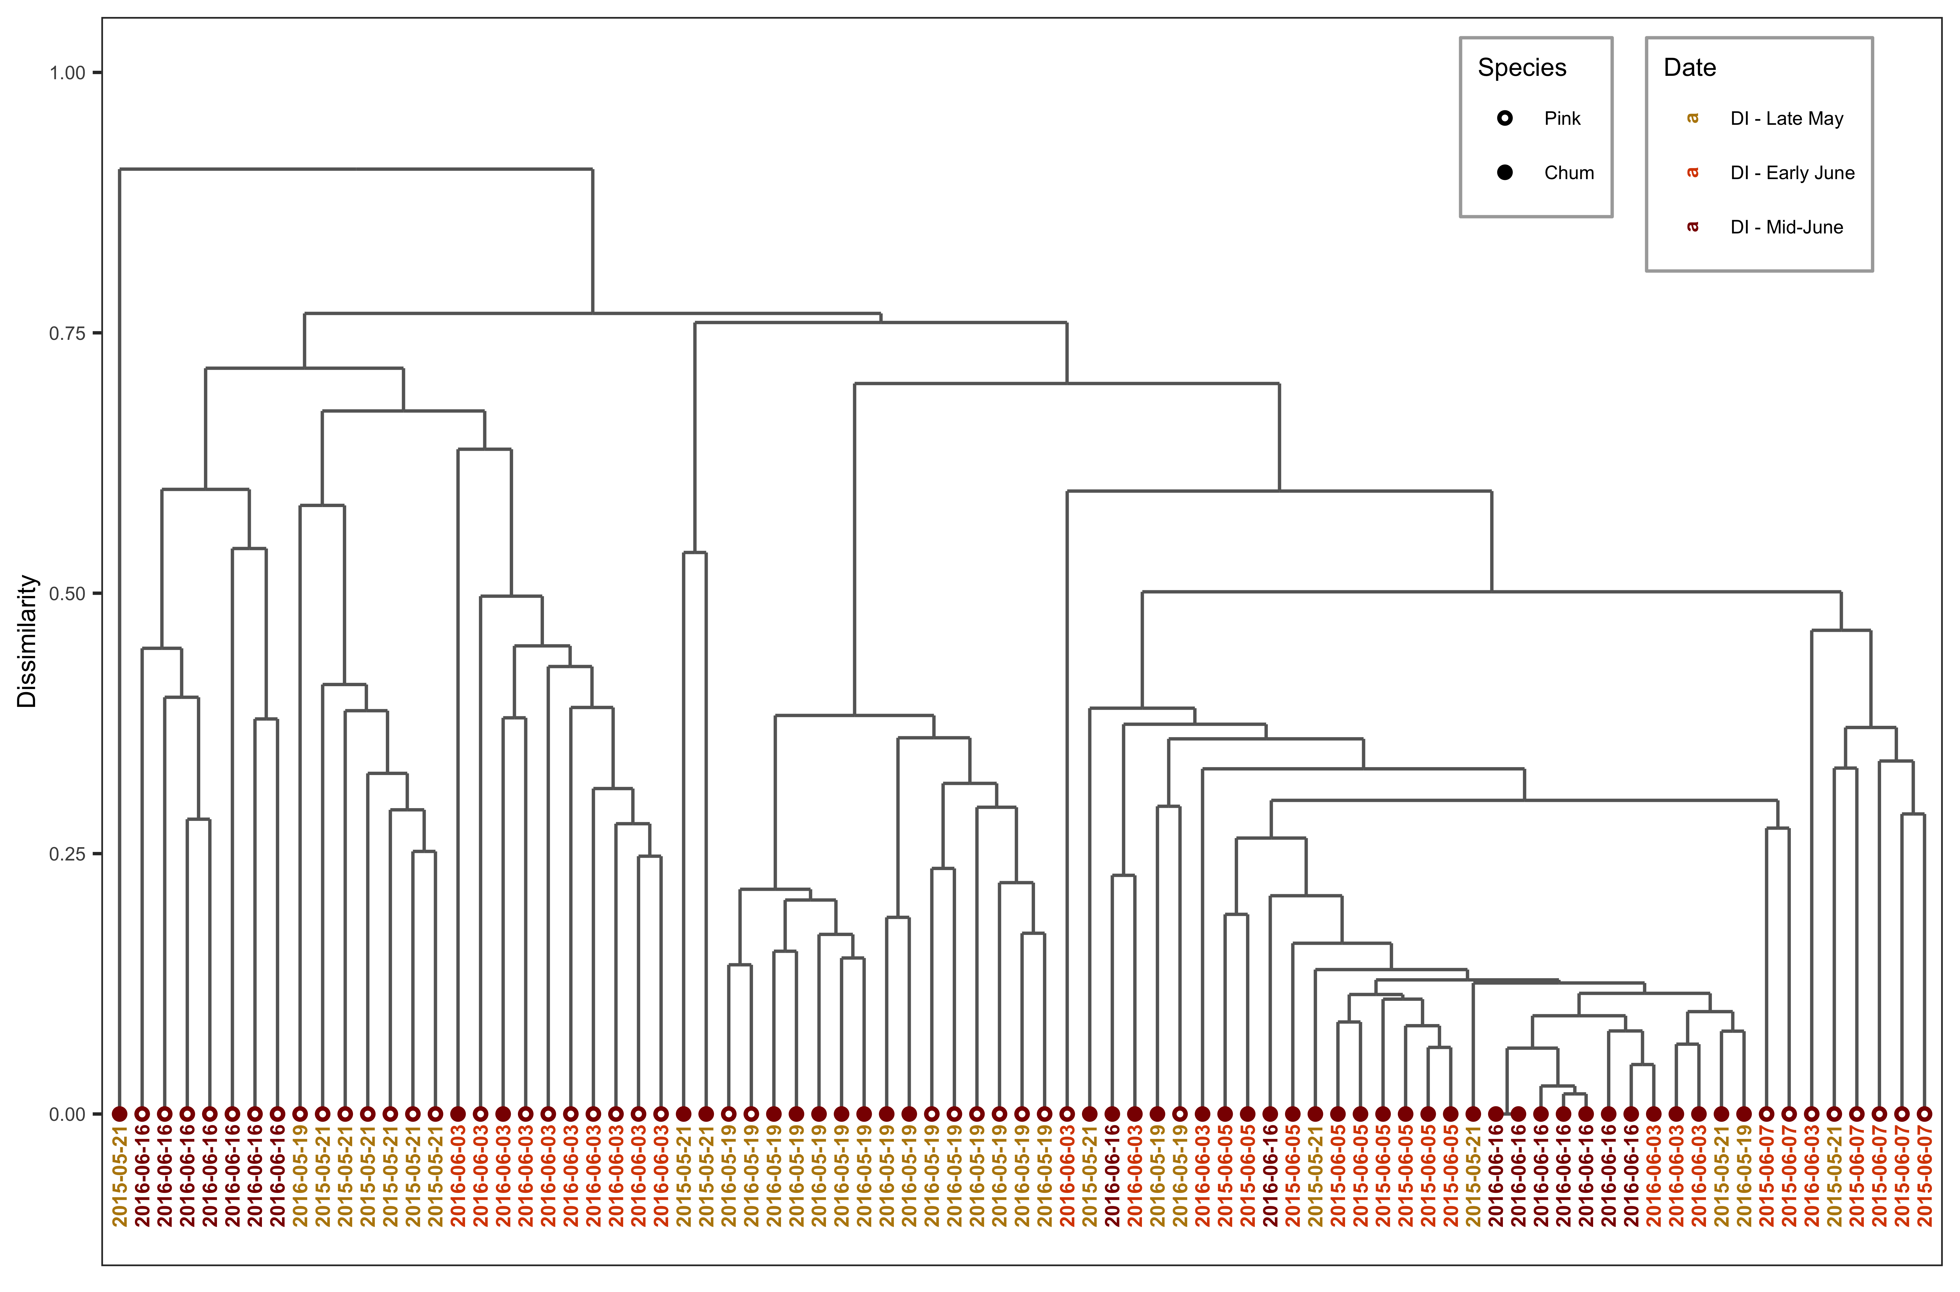

Figure A.1 Discovery Islands subcluster for temporal (Chapter 3) juvenile salmon diets, labelled and colored with survey date.

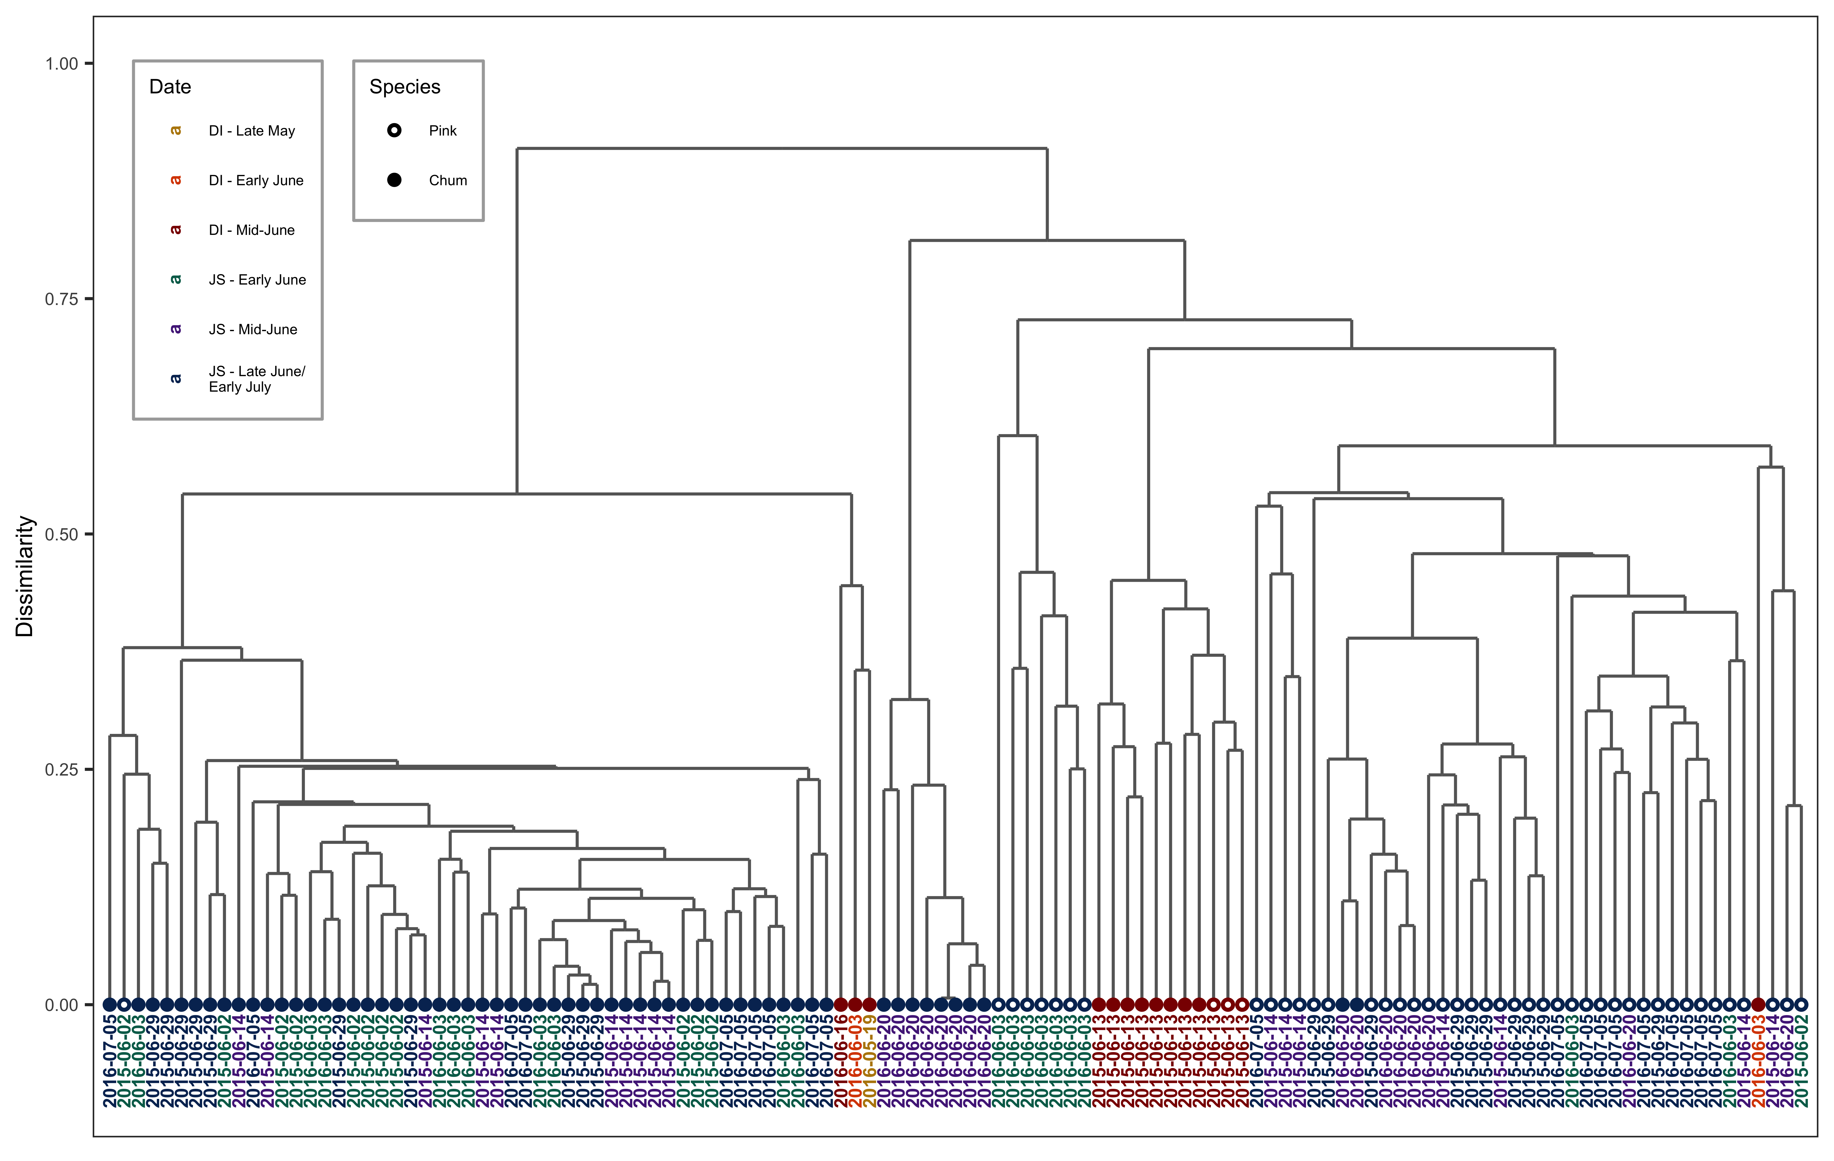

Figure A.2 Johnstone Strait subcluster for temporal (Chapter 3) juvenile salmon diets, labelled and colored with survey date.



Figure A.3 Micrograph of a blue macroplastic (5.8 mm) found in a juvenile pink salmon stomach in the Discovery Islands, before the stomach contents were removed.